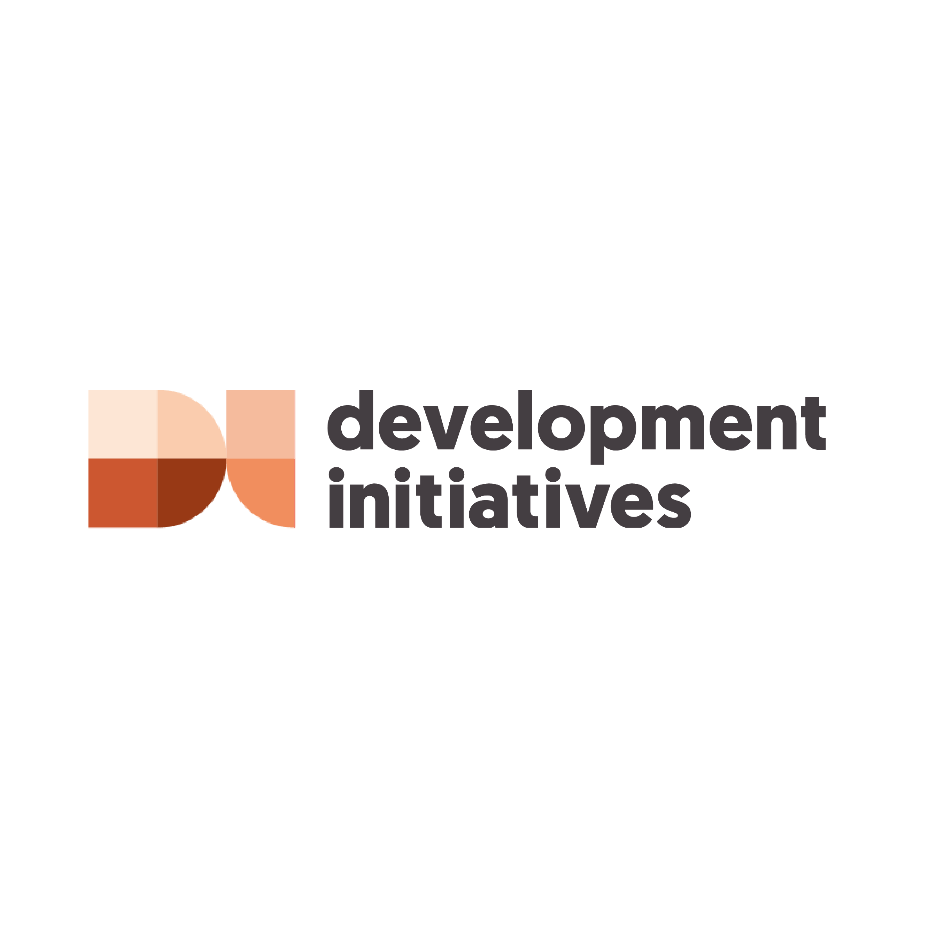Global Humanitarian Assistance Report 2023

June 2023

Accessible Word version

We hope you find this Word version accessible and easy to use. If you have any feedback, please contact us at [publications@devinit.org](mailto:publications@devinit.com).

Contents

Acronyms and abbreviations 7

Foreword 10

Executive summary 12

[Chapter 1 – Key trends in humanitarian   
need and funding: 2022 27](#_Toc138073602)

Summary 27

[What is the scale of crisis and need?   
Risk, vulnerability and protracted crisis 29](#_Toc138073604)

[Was humanitarian funding sufficient?   
Appeals, donors and total assistance 47](#_Toc138073605)

Appeal requirements 52

Funding commitments to appeals 53

Red Cross Red Crescent appeals 55

[Chapter 2 – Characteristics of crisis:   
Need and funding 66](#_Toc138073609)

Summary 66

[Who is receiving humanitarian assistance?   
Gender and age 68](#_Toc138073611)

[Where is humanitarian assistance targeted?   
Recipients and donor priorities 84](#_Toc138073612)

[What are the patterns of funding by   
volume of the largest donors? 91](#_Toc138073613)

[What share of donors’ total country-allocable   
funding do they give to individual crises? 91](#_Toc138073614)

[How do donor contributions to a crisis   
compare to their overall share of global funding? 92](#_Toc138073615)

[How did displacement and food security relate   
to crisis in 2022? 97](#_Toc138073616)

[How many people were forcibly   
displaced in 2022? 97](#_Toc138073617)

[What were the trends in the severity of   
and funding for food insecurity in 2022/23? 102](#_Toc138073618)

[Chapter 3 – A better humanitarian system:   
Locally led action 116](#_Toc138073619)

Summary 116

How is assistance channelled and delivered? 118

What progress has been made towards locally led humanitarian action? Funding and overheads 120

[UN OCHA pooled fund allocations to local   
and national actors 135](#_Toc138073623)

Other humanitarian pooled funds 139

[What progress has been made towards   
delivering cash and voucher assistance? 141](#_Toc138073625)

[Chapter 4 – Beyond humanitarian funding:   
Addressing cycles of crises 146](#_Toc138073626)

Summary 146

[The triple nexus. What is the mix of humanitarian, development and peace funding reaching   
countries in crisis? 148](#_Toc138073628)

[What climate finance is reaching   
countries in crisis? 151](#_Toc138073629)

[How much DRR finance is reaching   
countries in crisis? 163](#_Toc138073630)

Chapter 5 – Methodology and definitions 177

Data sources 190

About this report 194

Notes 197

# Acronyms and abbreviations

|  |  |
| --- | --- |
| Acronym | Full term |
| 3RP | Regional refugee and resilience plan |
| CAR | Central African Republic |
| CBPF | Country-based pooled fund (UN) |
| CCA | Climate change adaptation |
| CCM | Climate change mitigation |
| CERF | Central Emergency Response Fund |
| CRP | Country response plan |
| CRS | Creditor Reporting System |
| CSO | Civil society organisation |
| CVA | Cash and voucher assistance |
| DAC | Development Assistance Committee (OECD) |
| DI | Development Initiatives |
| DPR | Democratic People’s Republic (of Korea) |
| DRC | Democratic Republic of the Congo |
| DREF | Disaster Response Emergency Fund |
| DRR | Disaster risk reduction |
| ECHO | European Civil Protection and Humanitarian Aid Operations |
| FTS | Financial Tracking Service (UN OCHA) |
| GHA | Global Humanitarian Assistance (programme by Development Initiatives) |
| GNI | Gross national income |
| HRP | Humanitarian response plan |
| IASC | Inter-Agency Standing Committee (UN) |
| IATI | International Aid Transparency Initiative |
| ICRC | International Committee of the Red Cross |
| IDA | International Development Association |
| IDMC | Internal Displacement Monitoring Centre |
| IDP | Internally displaced person |
| IFI | International financial institution |
| IFRC | International Federation of Red Cross and Red Crescent Societies |
| INFORM | Index for Risk Management |
| IOM | International Organization for Migration |
| IPC | Integrated Food Security Phase Classification |
| IPCC | Intergovernmental Panel on Climate Change |
| L/NNGOs | Local/national non-governmental organisations |
| L&D | Loss and damage |
| LNAs | Local and national actors |
| MPCA | Multi-purpose cash assistance |
| NEAR | Network for Empowered Aid Response |
| NGO | Non-governmental organisation |
| OCHA | Office for the Coordination of Humanitarian Affairs (UN) |
| ODA | Official development assistance |
| OECD | Organisation for Economic Co-operation and Development |
| RCRC | Red Cross Red Crescent |
| RRP | Regional response plan |
| TIKA | Turkish Cooperation and Coordination Agency |
| TOCH | Organisation for Children Harmony |
| UAE | United Arab Emirates |
| UK | United Kingdom |
| UN | United Nations |
| UNDP | UN Development Programme |
| UNFCC | United Nations Framework Convention on Climate Change |
| UNHCR | Office of the United Nations High Commissioner for Refugees |
| UNICEF | UN International Children’s Emergency Fund |
| UNRWA | UN Relief and Works Agency for Palestine Refugees in the Near East |
| US | United States |
| WFP | World Food Programme |
| WHO | World Health Organization |
| WPHF | Women’s Peace and Humanitarian Fund |
| WRO | Women’s rights organisation |

# Foreword

The 2023 Global Humanitarian Assistance Report from Development Initiatives paints a picture of a humanitarian system overwhelmed. The continued effects of Covid-19, the accelerating impacts of climate change and the war in Ukraine are pushing the system as a whole, and humanitarians on the ground, to their limits. While financing for humanitarian assistance has increased, the number of people in need has grown by a record amount, and the gap is widening. The vast majority of those requiring assistance live in countries experiencing protracted crisis. Without addressing the complex, overlapping drivers – conflict, climate change, socio-economic fragility – these trends are likely to continue.

As in previous years, the report provides a critical, system-wide and long-term overview of how financing has been organised and delivered. We show how and why the scale of need has grown, and why the financing gap is now five times greater than it was in 2013 despite an increase in funding from some of the biggest donors.

This raises key questions as to how greater funding can be accessed from a wider donor base, and how development, peacebuilding and climate actors can work together to address the underlying causes of crisis. We also examine the increasingly important intersection between humanitarian response and initiatives supported by climate financing.

It has never been more vital to make sure every dollar spent has the maximum impact. Local organisations are often on the frontline of humanitarian response, but we show that progress in delivering funding to local organisations has been disappointing. There have been some positive steps towards more unrestricted funding for local actors’ overhead costs, but funding patterns do not appear to be fundamentally shifting, despite highly publicised donor commitments to localisation. Addressing this power imbalance is a matter of principle as well as pragmatism, requiring a change in mindset as well as funding behaviour.

Focusing on the need for new ways of thinking and working, for the first time the report features opinion and analysis from key thought-leaders across the humanitarian sector and beyond. They provide unique insights on what the data from this year’s report means for those delivering critical assistance, and how we can improve the provision and overall impact of humanitarian finance to better serve those affected.

As a flagship resource for our partners and the wider crisis-financing community, the Global Humanitarian Assistance Report provides robust and meaningful data on where funding is being spent and how it can be improved. By using both publicly available data and filling crucial gaps through our own data collection, we hope the report provides you with the evidence you need to support the goals we share: building resilient communities and reducing the incidence and impacts of crisis.

Adrian Lovett  
CEO, Development Initiatives

# Executive summary

In 2022, the demand for humanitarian assistance grew larger than ever. There was an exceptional donor response to the unprecedented increase in the number of people in need – driven largely by the war in Ukraine as well as worsening crises in Afghanistan and the Horn of Africa. Yet the scale of need meant the shortfall in humanitarian funding reached a record high.

There is a growing number of complex, long-term crises. And the pressure placed on the humanitarian system to respond is only set to increase in 2023. This strain is being driven by continued system-wide shocks, including climate change and the war in Ukraine, and new and escalating crises, such as the devastating earthquakes in Türkiye and Syria and the worsening conflict in Sudan. The imperative for significant change to humanitarian funding and response – and to better address the long-term root causes of, and recovery from, crises – is obvious and recognised but more pressing than ever.

What change needs to take place? In this report, we invite key leaders in the humanitarian sector to reflect on, and react to, our stark analysis and propose ways forward for change. Ideas to address the humanitarian financing gap include establishing humanitarian funding targets to encourage more equitable burden sharing and repositioning the narrative around humanitarian assistance as an investment in resilience, to widen the donor base. Other proposals focus on the need to double-down efforts to reform the system, including the need to shift current business models to support greater local humanitarian leadership – for instance by identifying more effective local funding solutions such as locally managed global pooled funds. Looking beyond humanitarian assistance, ideas for change reinforce the need to build the resilience of affected communities through long-term development strategies and mobilising funding for anticipatory action and additional climate finance, including through the new Loss and Damage Fund. Some proposals centre on the need to ensure access to flexible, multi-year funding, so that local organisations can increase preparedness to shocks and respond flexibly to the needs of their communities while maintaining a focus on building capacities to mitigate impacts of future crises.

This summary of the *Global Humanitarian Assistance Report 2023* presents key findings about:

* Trends in humanitarian need and funding in 2022
* Key characteristics of this need and funding
* Progress made on commitments to a better humanitarian system, with a focus on locally led action
* How resources beyond humanitarian funding – such as climate finance – could be used to address cycles of crises.

About this report

This year’s report includes, for the first time, contributions from external stakeholders. These ‘Insight’ pieces contextualise the report’s findings, comment on the real-world implications, and propose ideas and solutions for change.

The full report provides deeper data-driven analysis of humanitarian need and funding. It examines how funding has been mobilised, how and to whom it has been delivered, and how, through the Grand Bargain, efforts to provide assistance more efficiently and effectively have progressed. It also examines how development and climate finance are being deployed to countries experiencing humanitarian crisis.

You can explore the data behind the report using our [interactive data tools (link will open in browser)](https://devinit.org/data/international-humanitarian-assistance-donors-channels-and-recipients/?nav=header).

## Humanitarian need and crises

### How have levels of humanitarian need changed in 2022?

A third more people were in need of humanitarian assistance in 2022, with most facing long-term crisis

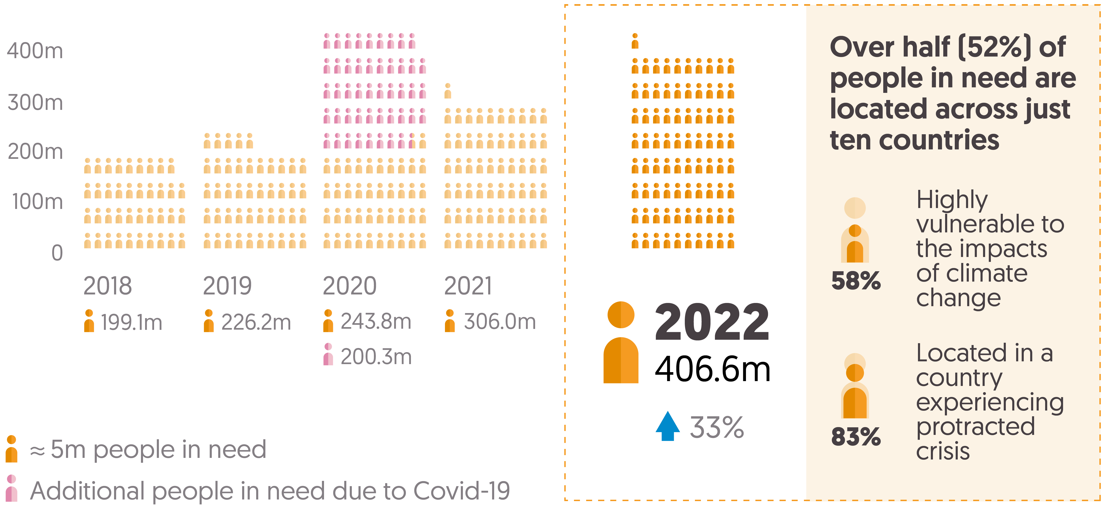

In Chapter 1, we explore how the number of men, women and children in need of humanitarian assistance has more than doubled over the last five years. In 2022 alone, this number grew by a third to an estimated 406.6 million people. Data on gender and age is available for just a third of UN-coordinated appeals. But where this data exists it shows that half of people in need are children under the age of 18 (49%, or 90 million). Several large-scale protracted crises account for the bulk of humanitarian needs, with more than half of all people in need over the past five years living in just 10 countries.

**Insight:** Read more in Chapter 1, where Jan Egeland, Secretary General of the Norwegian Refugee Council and outgoing Eminent Person of the Grand Bargain, proposes the need to change the narrative around humanitarian need to address the growing humanitarian funding gap.

## What has driven need?

### A growing number of people in need face intersecting threats from conflict, climate change and socioeconomic vulnerability

As new shocks follow and compound existing crises, affected people are increasingly vulnerable as their resilience and ability to cope is eroded. In 2022, three-quarters of all people in need of humanitarian assistance faced at least two risk dimensions: conflict, climate and/or socioeconomic vulnerability. This means that most crises are now long-term; a growing majority of people in need (83%) live in a country that has had a UN-coordinated appeal for five or more consecutive years.

* **Insight:** Read more about the implications of recurrent crises in Chapter 1, where Albashir Ibrahim, Executive Director of NEXUS Consortium in Somalia, reinforces the importance of taking an integrated approach to humanitarian, development and peace programming to build the self-reliance of communities and reduce dependence on humanitarian assistance.

### The numbers of people experiencing food insecurity have more than doubled in the past three years

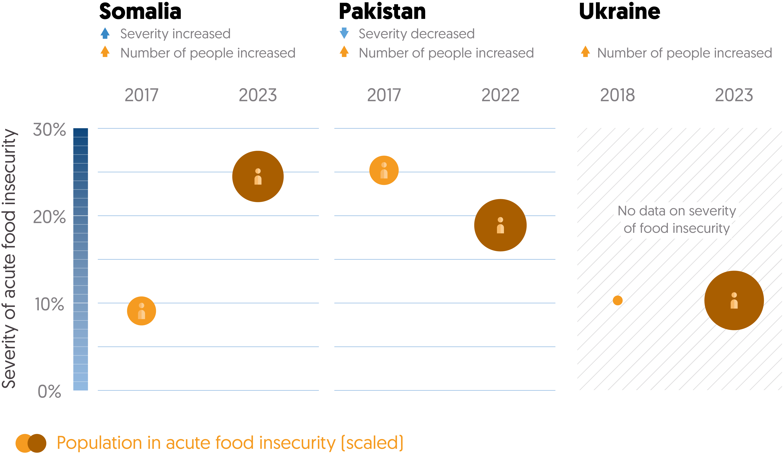

One of the primary drivers of need in 2022 was food insecurity; the number of people experiencing severe food insecurity continued to grow, driven by the war in Ukraine and a food crisis in the Horn of Africa. An estimated 265.7 million people were facing crisis-level acute food insecurityin 2022/23. This is more than double the number of people (115.2 million people) facing this level of food insecurity in 2019, before the Covid-19 pandemic. In Chapter 2, we demonstrate why the severity of food insecurity – as well as the number of people experiencing it – should inform how responses are targeted. These two factors do not always correlate. In Somalia, the number of people affected rose from 2.6 to 8.3 million, and the severity of food insecurity increased more than in any other country. However, in Pakistan, where a similar rise in the number of people experiencing food insecurity (from 2.7 to 8.6 million) occurred, there was a significant decrease in the severity of food insecurity.

* **Insight:** Read more in Chapter 2 where N4D highlights the importance of local ownership and long-term financing in multi-sector nutrition programming, drawing on their experiences in Yemen.

Forced displacement also continued to drive rising levels of humanitarian need. An additional 16.5 million people were displaced internally or across borders in 2022; over 10 million of these were people affected by the war in Ukraine.

## Humanitarian funding trends

### How much international humanitarian assistance was there in 2022?

International humanitarian assistance grew by more than a quarter in 2022

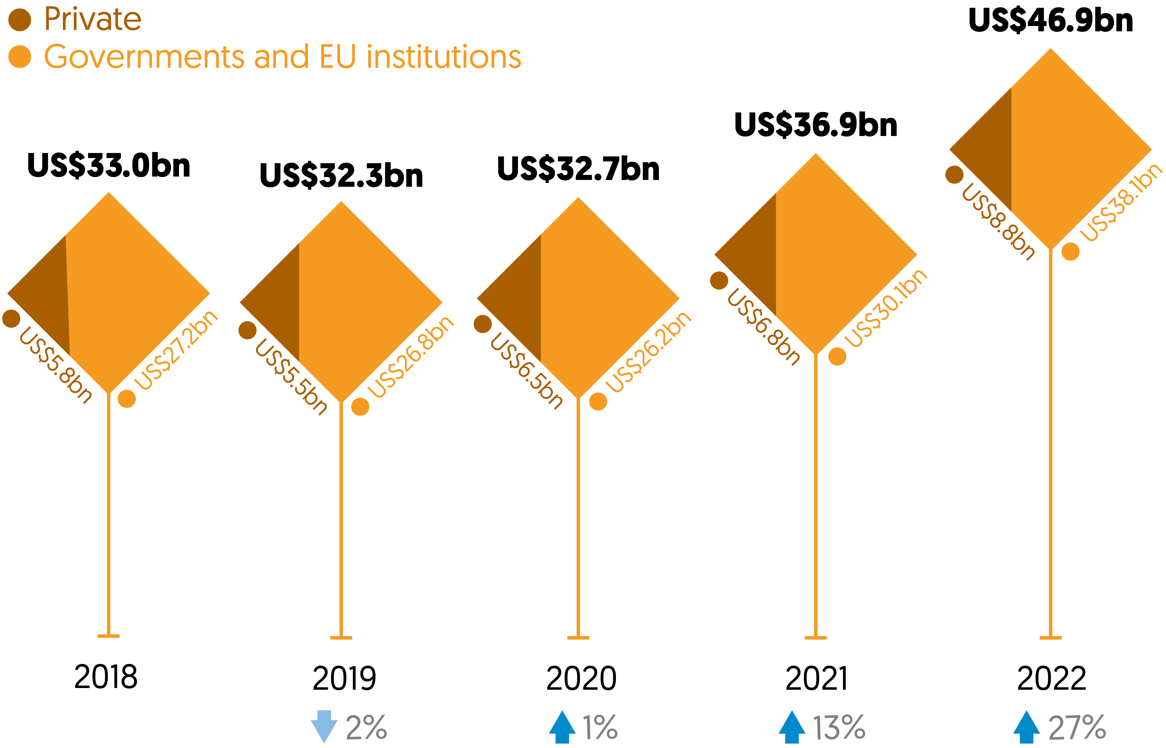

Both public and private donors gave substantially more humanitarian funding in 2022. Total international humanitarian assistance (from public and private donors) increased by US$10.0 billion (27%) to US$46.9 billion. This pace of growth marks a significant departure from much slower growth trends in recent years.

The increase in funding was in response to appeal requirements in 2022 that stood at a record US$52.4 billion, an increase of 37% from 2021. This was driven in part by the significant jump in funding requested through the Ukraine, Afghanistan, Ethiopia and Somalia appeals. At the time of writing, requirements for 2023 have already eclipsed this, with a total US$54.9 billion requested to meet new and worsening crises. Despite the unprecedented response, driven partly by strong donor solidarity with Ukraine, the appeals funding shortfall grew to a record US$22.1 billion in 2022.

### Who provided international humanitarian assistance?

#### Public donors gave more than ever in 2022, with most making large increases in the volume of funding

#### Stylised column chart showing largest donors of international humanitarian assistance, with US (US$15 billion), Germany (US$5.3 billion), EU institutions (US$4.1 billion), Japan (US$2.1 billion) and UK (US$1.7 billion).

Nearly all the top 20 public donors increased their contributions in 2022, with over half increasing assistance by more than 20%. However, the humanitarian funding system remains reliant on a small number of donors. The three largest – the US, Germany and EU institutions[1] – together accounted for 64% of total international humanitarian assistance from public donors, with the US alone providing 39%.

* **Insight:** Read more in Chapter 2, whereMichael Köhler, Deputy Director of the Department of Humanitarian Aid and Civil Protection (ECHO), proposes to establish national funding targets as a way of building peer pressure, making donor contributions more comparable and widening the donor base.

Donors are faced with a complex set of choices in how and where to allocate their funding. In 2022 there was significant variation between the largest donors in the share of their total assistance allocated at the country and the global or regional levels. The US, EU institutions and UK allocated almost all assistance to specific country contexts with 6% or less provided at the global or regional level. This compares with Japan, which allocated 55% of assistance to the global or regional level, and Germany, which allocated 17%. There is also notable variation in how donors choose to allocate funding to individual crises.

As a result of this increased humanitarian funding, the proportion of official development assistance (ODA) from the Organisation for Economic Co-operation and Development (OECD) Development Assistance Committee (DAC) members provided as international humanitarian assistance grew to 17% (US$36.4 billion) from 15% (US$27.9 billion) in 2021. Donors also spent more ODA on hosting refugees within their own countries – this expenditure more than doubled in 2022 to US$30.1 billion.

### Where did international humanitarian assistance go?

#### 10 countries received almost two-thirds of all funding, with Ukraine receiving the largest ever volume in one year

The largest recipient of humanitarian funding in 2022 was Ukraine – receiving the highest volume of contributions ever recorded in one year (US$4.4 billion). As in previous years, a small number of large long-term crises absorbed the majority of funding – in 2022, the 10 largest recipients of humanitarian assistance received 63% of total country-allocable funding. In addition to Ukraine, four countries (Afghanistan, Yemen, Syria and Ethiopia) received more than US$2 billion each in humanitarian funding.

## Improving the delivery of humanitarian assistance

### How was humanitarian assistance channelled?

#### The volume and share of funding provided to UN agencies increased in 2022

In the context of rapidly growing requirements and limited resources, the need to ensure that humanitarian assistance is delivered as effectively and efficiently as possible is more urgent than ever. UN agencies continued to receive the majority of funding from public donors. In 2022, the share of funding they received grew from 52% in 2021 to 61% (US$22.8 billion). Despite calls for better reporting, generally there is inadequate data on how this funding is passed on.

* Insight: Read more in Chapter 3 where Hibak Kalfan, Executive Director of the NEAR network, reinforces the need to recentre the current humanitarian model around local communities.
* Insight: In Chapter 3, the Feminist Humanitarian Network set out the unique challenges faced by women’s rights civil society organisations in accessing international funding and urges donors to provide more multi-year, flexible funding.

### What progress has been made towards more locally led humanitarian action?

Local and national actors continue to receive minimal funding directly from donors

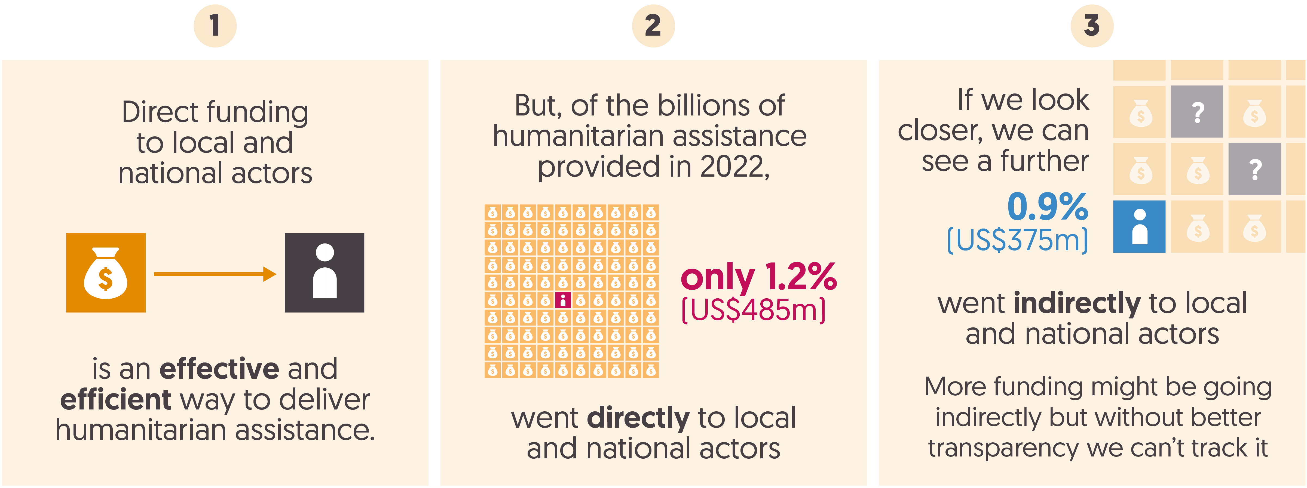

As we show in Chapter 3, progress against commitments to support greater local humanitarian leadership through increasing funding to local and national actors has been disappointing. There was no increase in the proportion of total international humanitarian assistance provided directly to local and national actors in 2022, which stood at just 1.2% (US$485 million). It remains difficult to know how much funding reaches local and national actors indirectly – through one or more intermediary organisation – due to incomplete reporting.

However, funding allocated to local and national actors through the UN’s Office for the Coordination of Humanitarian Affairs (OCHA) pooled funds did increase – 28% of direct allocations of the country based pooled funds in 2022 and a preliminary 18% of the Central Emergency Response Fund allocations were sub-granted in 2021.

More positively, shifts in practice are occurring. Some momentum for change is building to provide more equitable access to unrestricted funding for non-project costs (i.e. overheads) for local and national partners.

* **Insight:** Read more in Chapter 2 whereThe Organisation for Children Harmony (TOCH) from South Sudan share their experiences of accessing the UN South Sudan Humanitarian Fund and call for more multi-year funding.
* **Insight**: In Chapter 3,Virginie Lefèvre of Amel Association International also advocates for overhead funding for local and national actors.

### How was humanitarian assistance delivered?

Cash and voucher transfers increased by a record volume in 2022

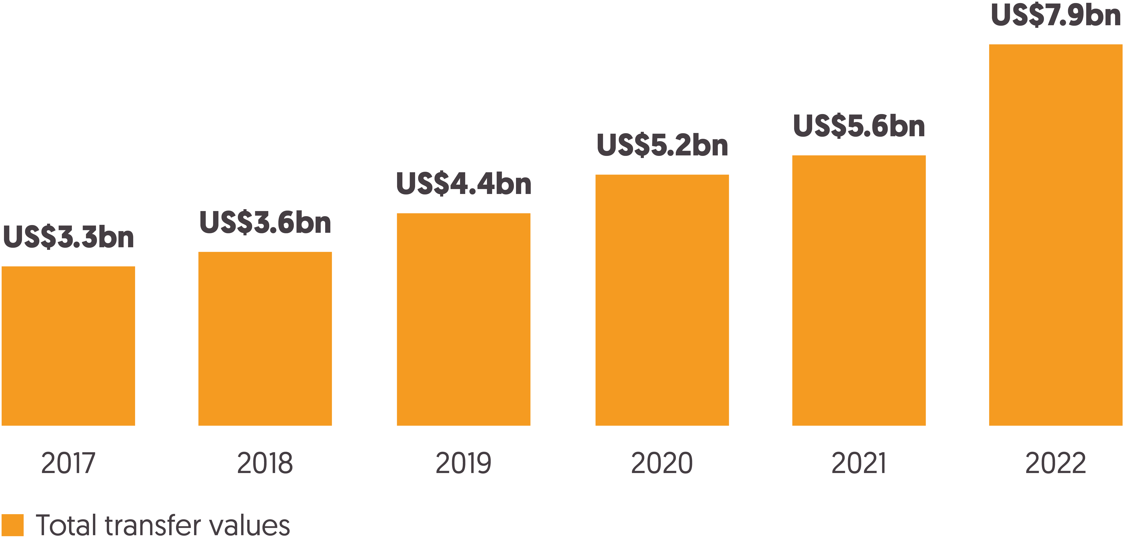

The steady growth seen since 2017 in the provision of humanitarian assistance as cash and vouchers continued in 2022. The use of cash and vouchers rose in response to the Ukraine conflict and rising levels of food insecurity, increasing by a record 40% to US$7.9 billion in 2022. Cash and vouchers accounted for an estimated 20% of total humanitarian assistance in 2022.

## Wider crisis funding

### What resources beyond humanitarian assistance are reaching countries in crises?

Countries facing long-term crisis receive a growing share of their aid as humanitarian assistance over funding for development and peace

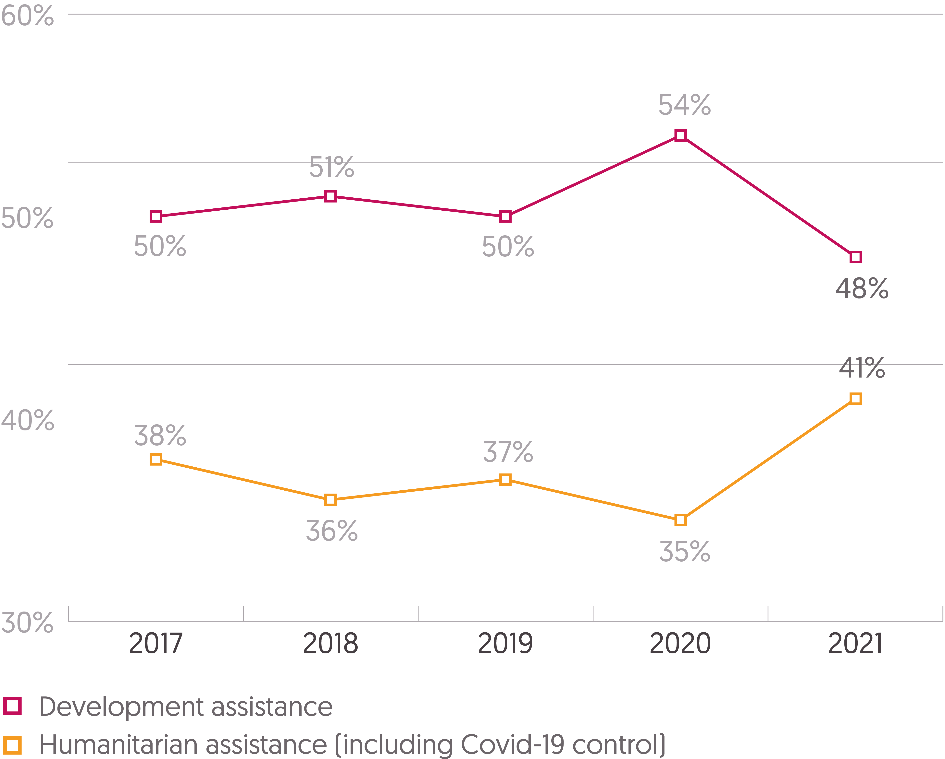

Countries facing humanitarian crisis are also recipients of development, peace and climate financing. In Chapter 4, we explore how balancing these funding flows correctly is critical to ensuring that urgent needs are met, while also addressing the root causes of crisis and building resilience to shocks. Countries facing long-term crisis have not seen a notable transition from humanitarian to longer-term development assistance. Between 2017 and 2021, the volume and proportion of development assistance received by countries facing long-term crisis reduced (by US$0.6 billion and from 50% to 48%), while the volume and proportion of total ODA received as humanitarian assistance increased – reaching 41% in 2021, compared to an average of 37% over the past five years.

### What climate finance is reaching countries in crisis?

Of the countries most vulnerable to climate change, those that also face long-term humanitarian crises receive less climate funding

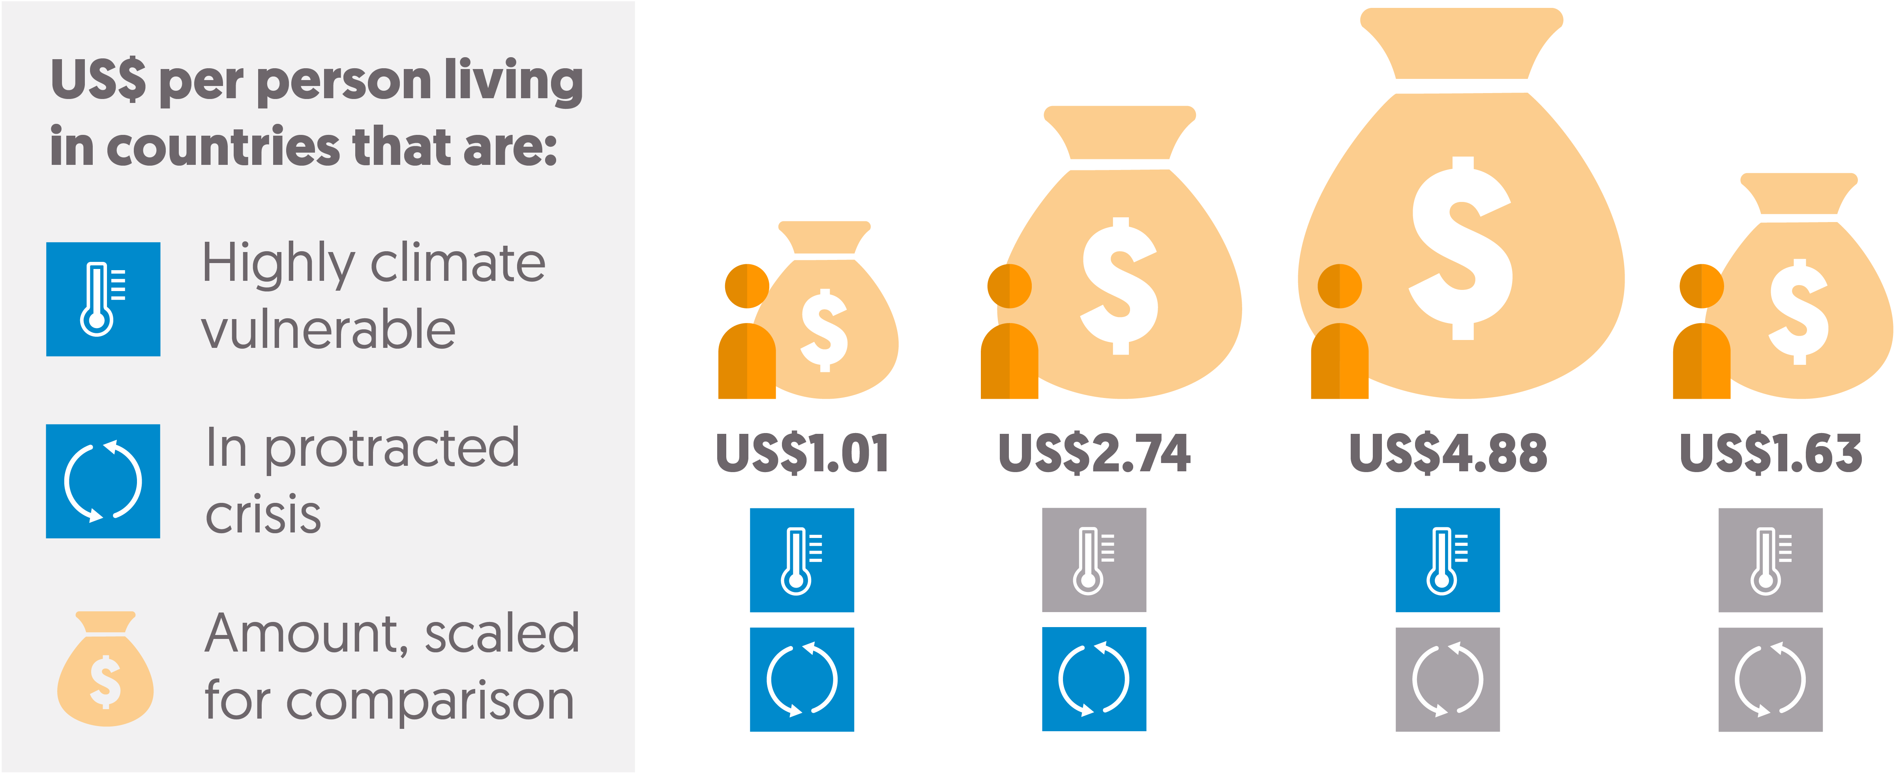

The accelerating impacts of climate change are driving new crises and compounding existing risks. Despite this, countries that are most vulnerable to climate-related shocks are not receiving the necessary funding to prepare for and alleviate these shocks. People in countries experiencing protracted crisis and a high level of climate vulnerability receive a lower proportion of their total ODA as climate finance than other climate-vulnerable countries. They also receive less finance from multilateral climate funding mechanisms and less per capita multilateral climate finance: US$1 per person, compared to US$4.88 per person in the most climate-vulnerable countries not experiencing long-term crisis.

* **Insight:** Read more in Chapter 4, where Harjeet Singh from the Climate Action Network call for new and additional loss and damage finance to address the impacts of climate disasters.

Funding can also be made available ahead of time for predictable hazards to reduce humanitarian impacts. This type of anticipatory action, such as disaster risk reduction (DRR), is essential alongside climate and humanitarian funding to support response, recovery and resilience building. Despite this, 2022 saw the volume of ODA provided for DRR fall for the first time in four years to US$3.0 billion, driven by large reductions from key donors including the UK and the World Bank.

**Insight**: Read more in Chapter 4, where Christina Bennett from Start Network comments on the importance of anticipatory action evidenced by the impact of the heatwave risk finance system of Start Network’s Pakistan Hub.

Read the full report for more in-depth analysis on key trends in humanitarian and wider crisis funding and use our interactive tool to explore the data in more detail.

[Sign up to our mailing list](https://us11.list-manage.com/subscribe?u=a829237ca0cf1470615c7f059&id=ce30e2af0f) to receive updates of our work and visit [Development Initiatives’ website](https://devinit.org/) for more resources related to humanitarian assistance.

# Chapter 1 – Key trends in humanitarian need and funding: 2022

## Summary

The scale of global humanitarian crisis significantly worsened in 2022. The number of people assessed to be in need of humanitarian assistance grew by a third, to an estimated 406.6 million people. Humanitarian action had to adapt to new and worsening crises, including conflict in Ukraine, climactic shocks in Pakistan and East Africa, and the ongoing socioeconomic impact of the Covid-19 pandemic. Complex, protracted crises[2] are increasingly the norm with three-quarters of people in need facing at least two risk dimensions of conflict, climate and socioeconomic vulnerability, an increase from 61% in 2021. As a result, a growing majority of people in need (83%) now live in a country experiencing protracted crisis. In his Insight piece, Albashir Ibrahim, Executive Director of NEXUS Consortium in Somalia, comments on the urgent need to build the self-reliance of communities that face these recurrent crises through more joined up humanitarian, development and peace programming.

There was an unprecedented response from both public and private humanitarian donors in 2022, largely driven by support for Ukraine. Total international humanitarian assistance increased by US$10.0 billion (27%) to US$46.9 billion in 2022, a sharp increase in the pace of growth from the previous year. Nearly all of the top 20 public donors increased their contributions in 2022, with over half increasing assistance by more than 20%. Despite this, the humanitarian funding gap grew larger than ever – in 2022 a record US$52.4 billion was requested through UN-coordinated appeals, with the volume of unmet requirements growing to US$22.1 billion. This is only getting worse: to date, requirements for 2023 (US$54.9 billion) have already eclipsed last year and are around 80% higher than requirements before the Covid-19 pandemic in 2019. In his Insight piece, Jan Egeland proposes some potential solutions to the growing funding gap. These go beyond traditional humanitarian actors, including a need to change the narrative around humanitarian assistance as a solely philanthropic venture towards the idea that it is an investment in stability for a common global good.

Rising humanitarian needs, particularly in the fallout of the Russian invasion of Ukraine, mean governments face increasing pressures on their wider aid budgets. There is a real risk that longer-term development funding is both reduced and diverted away from other crises and the poorest countries. In 2022, official development assistance (ODA) spent on hosting refugees in donor countries more than doubled to US$30.1 billion. The proportion of total ODA from Organisation for Economic Co-operation and Development (OECD) Development Assistance Committee (DAC) donors and EU institutions[3] provided as international humanitarian assistance also grew to 17% (US$36.4 billion) from 15% (US$27.9 billion) in 2021.

## What is the scale of crisis and need? Risk, vulnerability and protracted crisis

Figure 1.1: Four out of five people in need of humanitarian assistance live in countries experiencing protracted crisis   
Map of countries in crisis, 2022

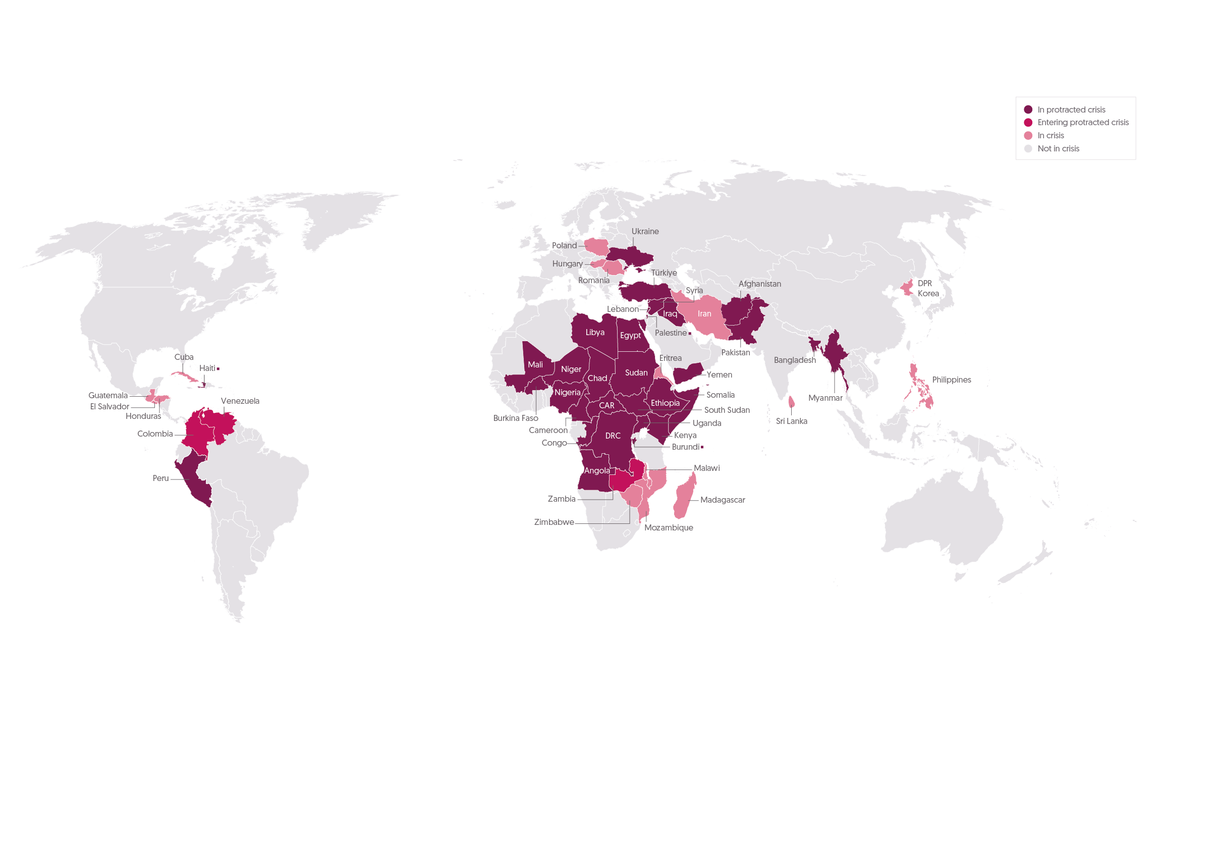

Source: Development Initiatives based on UN Office for the Coordination of Humanitarian Affairs (OCHA) Humanitarian Programme Cycle (HPC), INFORM Index for Risk Management, ACAPS, and UN High Commissioner for Refugees (UNHCR).

Notes: CAR = Central African Republic; DPR, Democratic People’s Republic (of Korea); DRC = Democratic Republic of the Congo. Shown only are countries with a UN-coordinated appeal, or more than one million people in need.

Figure 1.2: The number of people affected by humanitarian crisis increased by a third in 2022

|  |  |
| --- | --- |
| **Country** | **People in need, dimensions of risk and funding requirements** |
| Afghanistan | In 2022, there were 24.4 million people in need, and that number was expected to increase in 2023. The country has been in protracted crisis for 15 consecutive years. It has high conflict risk and high socioeconomic fragility and high climate vulnerability. The IPC acute food insecurity classification is P3. The CRP is 76% funded (of US$4,442.2 m total). There is no data for RRP. |
| Angola | In 2022, there were 1.6 million people in need, and that number was expected to be stable in 2023. The country has been in protracted crisis for 6 years. It has high socioeconomic fragility. The IPC acute food insecurity classification is P3. The RRP is 45% funded (of US$25.1 m total). There is no CRP data. |
| Bangladesh | In 2022, there were 4.9 million people in need, and that number was expected to decrease in 2023. The country has been in protracted crisis for 7 consecutive years. It has high conflict risk and high socioeconomic fragility and high climate vulnerability. The IPC acute food insecurity classification is P3+. The RRP is 63% funded (of US$881m total). There is no data for CRP. |
| Burkina Faso | In 2022, there were 4.9 million people in need, and that number was expected to be stable in 2023. The country has been in protracted crisis for 19 years. It has high conflict risk and high socioeconomic fragility and high climate vulnerability. The IPC acute food insecurity classification is P2. The CRP is 42% funded (of US$805.1 m total). There is no RRP data. |
| Burundi | In 2022, there were 2.4 million people in need, and that number was expected to decrease in 2023. The country has been in protracted crisis for 7 years. It has high conflict risk, high socioeconomic fragility and high climate vulnerability. The IPC acute food insecurity classification is P2. The CRP is 52% funded (of US$182.4 m total). The RRP is 29% funded (of US$54.3m total) |
| Cameroon | In 2022, there were 11.7 million people in need, and that number was expected to be decrease in 2023. The country has been in protracted crisis for 9 consecutive years. It has high socioeconomic fragility and high conflict risk. The IPC acute food insecurity classification is P2. The CRP is 55% funded (of US$376.0 m total). There is no RRP data |
| Central African Republic | In 2022, there were 3.1 million people in need, and that number was expected to increase in 2023. The country has been in protracted crisis for 20 years. It has high conflict risk, high socioeconomic fragility and high climate vulnerability. The IPC acute food insecurity classification is P3. The CRP is 94% funded (of US$461.3 m total). There is no RRP data. |
| Chad | In 2022, there were 6.4 million people in need, and that number was expected to be stable in 2023. The country has been in protracted crisis for 19 consecutive years. It has high conflict risk and high socioeconomic fragility and high climate vulnerability. The IPC acute food insecurity classification is P2. The CRP is 60% funded (of US$510.9 m total). There is no RRP data. |
| Colombia | In 2022, there were 7.7 million people in need, and that number was expected to be stable in 2023. The country has been in protracted crisis for 5 consecutive years. It has high conflict risk. The IPC acute food insecurity classification is P3+. The CRP is 38% funded (of US$797.1 m total). The RRP is 46% funded (of US$802.9 m total). |
| Congo | In 2022, there were 1.2 million people in need, and that number was expected to be decrease in 2023. The country has been in protracted crisis for 9 years. It has high conflict risk and high socioeconomic fragility. The country has no IPC acute food insecurity classification. The RRP is 93% funded (of US$15.5m total). There is no CRP data. |
| Cuba | In 2022, there were 1.1 million people in need, and that number was expected to decrease in 2023. The country has been in crisis for 1 year. The IPC acute food insecurity classification is P3+. The CRP is 18% funded (of a US$41.8m total) There is no data for the RRP. |
| DPR Korea | In 2022, there were 10.4 million people in need, and that number was expected to be stable in 2023. The country has not been in crisis yet. It has high socioeconomic fragility. The IPC acute food insecurity classification is P3+. There is no data for CPR and RRP. |
| Egypt | In 2022, there were 2.7 million people in need, and that number was expected to decrease in 2023. The country has been in protracted crisis for 10 consecutive years. It has high socioeconomic fragility. The country has no IPC acute food insecurity classification. The RRP is 53% funded (of US$130.2 m total). There is no data for CRP. |
| El Salvador | In 2022, there were 1.7 million people in need, and that number was expected to be stable in 2023. The country has been in crisis for 2 consecutive years. It has high conflict risk. The IPC acute food insecurity classification is P2. The CRP is 27% funded (of a US$114.3 m total). There is no data for the RRP. |
| Eritrea | In 2022, there were 2.6 million people in need, and that number was expected to decrease in 2023. The country has not been in crisis yet. It has high conflict risk, high socioeconomic fragility and high climate vulnerability. The country is not in IPC acute food insecurity classification. There is no CRP or RRP data. |
| Ethiopia | In 2022, there were 28.5 million people in need, and that number was expected to increase in 2023. The country has been in protracted crisis for 9 consecutive years. It has high conflict risk and high socioeconomic fragility and high climate vulnerability. The IPC acute food insecurity classification is P3+. The RRP is 74% funded (of US$287.8m total). The CRP is 50% funded (of US$3,335.0 m total). |
| Guatemala | In 2022, there were 3.8 million people in need, and that number was expected to increase in 2023. The country has been in crisis for 2 consecutive years. It has high conflict risk, high socioeconomic fragility. The IPC acute food insecurity classification is P3. The CRP is 37% funded (of a US$153.5 m total). There is no data for the RRP. |
| Haiti | In 2022, there were 5.1 million people in need, and that number was expected to be stable in 2023. The country has been in protracted crisis for 13 consecutive years. It has high conflict risk, high socioeconomic fragility, and high climate vulnerability. The IPC acute food insecurity classification is P3. The CRP is 39% funded (of US$518.8 m total). There is no data for the RRP. |
| Honduras | In 2022, there were 3.3 million people in need, and that number was expected to be stable in 2023. The country has been in crisis for 2 consecutive years. It has high conflict risk, high socioeconomic fragility. The IPC acute food insecurity classification is P3. The CRP is 44% funded (of a US$155.3 m total). There is no data for the RRP. |
| Hungary | In 2022, there were 1.6 million people in need, and that number was expected to decrease in 2023. The country has been in crisis for 1 year. It has high conflict risk. The country has no IPC acute food insecurity classification. The RRP is 57% funded (of a US$75.3m total). There is no data for CPR. |
| Iran | In 2022, there were 4.5 million people in need, and that number was expected to incease in 2023. The country has been in crisis for 1 year. It has high socioeconomic fragility. The country has no IPC acute food insecurity classification. The RRP is 47% funded (of a US$258.7m total). There is no data for CRP. |
| Iraq | In 2022, there were 2.8 million people in need, and that number was expected to be stable in 2023. The country has been in protracted crisis for 11 consecutive years. It has high conflict risk and high socioeconomic fragility. The IPC acute food insecurity classification is P3+. The RRP is 28% funded (of a US$251.1m total). The CRP is 84% funded (of US$400.0m total). |
| Kenya | In 2022, there were 4.9 million people in need, and that number was expected to be increase in 2023. The country has been in protracted crisis for 15 years. It has high conflict risk. The IPC acute food insecurity classification is P3. The CRP is 57% funded (of US$289.6 m total). The RRP is 219% funded (of US$115.2 m total) |
| Lebanon | In 2022, there were 2.5 million people in need, and that number was expected to be stable in 2023. The country has been in protracted crisis for 11 consecutive years. It has high conflict risk and high socioeconomic fragility. The IPC acute food insecurity classification is P3. The RRP is 26% funded (of a US$3,196.0 m total). The CRP is 74% funded (of US$378.2 m total). |
| Libya | In 2022, there were 1.3 million people in need, and that number was expected to decrease in 2023. The country has been in protracted crisis for 8 consecutive years. It has high conflict risk and high socioeconomic fragility. The IPC acute food insecurity classification is P3+. The CRP is 83% funded (of US$113.8 m total). There is no data for RRP. |
| Madagascar | In 2022, there were 3.3 million people in need, and that number was expected to increase in 2023. The country has been in crisis for 2 years. It has high socioeconomic fragility and high climate vulnerability. The IPC acute food insecurity classification is P3. The CRP is 81% funded (of US$219.3 m total). There is no RRP data. |
| Malawi | In 2022, there were 4.5 million people in need, and that number was expected to be stable in 2023. The country has been in crisis for 1 year. It has high socioeconomic fragility and high climate vulnerability. The IPC acute food insecurity classification is P2. The CRP is 64% funded (of US$29.5 m total). There is no RRP data. |
| Mali | In 2022, there were 7.5 million people in need, and that number was expected to increase in 2023. The country has been in protracted crisis for 19 consecutive years. It has high conflict risk and high socioeconomic fragility and high climate vulnerability. The IPC acute food insecurity classification is P2. The CRP is 40% funded (of US$685.7 m total). There is no RRP data. |
| Mozambique | In 2022, there were 2.5 million people in need, and that number was expected to be stable in 2023. The country has been in crisis for 4 years. It has high socioeconomic fragility and high conflict risk. The IPC acute food insecurity classification is P2. The CRP is 67% funded (of US$436.6 m total). There is no RRP data. |
| Myanmar | In 2022, there were 14.4 million people in need, and that number was expected to increase in 2023. The country has been in protracted crisis for 10 consecutive years. It has high conflict risk and high socioeconomic fragility and high climate vulnerability. The IPC acute food insecurity classification is P3+. The CRP is 41% funded (of US$825.7m total). There is no data for RRP. |
| Niger | In 2022, there were 3.8 million people in need, and that number was expected to increase in 2023. The country has been in protracted crisis for 18 years. It has high conflict risk, high socioeconomic fragility and high climate vulnerability. The IPC acute food insecurity classification is P2. The CRP is 70% funded (of US$552.6 m total). There is no RRP data. |
| Nigeria | In 2022, there were 19.2 million people in need, and that number was expected to be stable in 2023. The country has been in protracted crisis for 9 consecutive years. It has high socioeconomic fragility and high conflict risk. The IPC acute food insecurity classification is P2. The CRP is 65% funded (of US$1,127.2 m total). There is no RRP data. |
| Pakistan | In 2022, there were 23.6 million people in need, and that number was expected to decrease in 2023. The country has been in protracted crisis for 7 consecutive years. It has high conflict risk and high socioeconomic fragility and high climate vulnerability. The IPC acute food insecurity classification is P3. The CRP is 69% funded (of US$472.3 m total). The RRP is 62% funded (of a US$310.4 m total). |
| Palestine | In 2022, there were 2.4 million people in need, and that number was expected to decrease in 2023. The country has been in protracted crisis for 20 consecutive years. It has high conflict risk and high socioeconomic fragility. The IPC acute food insecurity classification is P3+. The CRP is 77% funded (of US$509.9 m total). There is no data for RRP. |
| Peru | In 2022, there were 1.7 million people in need, and that number was expected to be stable in 2023. The country has been in protracted crisis for 6 consecutive years. The country has no IPC acute food insecurity classification. The RRP is 33% funded (of US$304.0m total). There is no data for CRP. |
| Philippines | In 2022, there were 2.7 million people in need, and that number was expected to be decrease in 2023. The country has been in crisis for 1 year. It has high conflict risk. The IPC acute food insecurity classification is P3+. The CRP is 55% funded (of a US$168.9 m total). There is no data for RRP. |
| Poland | In 2022, there were 7.6 million people in need, and that number was expected to decrease in 2023. The country has been in crisis for 1 year. It has high conflict risk. The country has no IPC acute food insecurity classification. The CRP is 50% funded (of a US$3,335.0m total) and the RRP is 55% funded (of a US$777.8 total). There is no data for CPR. |
| Romania | In 2022, there were 1.6 million people in need, and that number was expected to decrease in 2023. The country has been in crisis for 1 year. It has high conflict risk. The country has no IPC acute food insecurity classification. The RRP is 88% funded (of a US$226.6 m total). There is no data for CPR. |
| Somalia | In 2022, there were 7.8 million people in need, and that number was expected to be stable in 2023. The country has been in protracted crisis for 23 consecutive years. It has high conflict risk and high socioeconomic fragility and high climate vulnerability. The IPC acute food insecurity classification is P3. The CRP is 70% funded (of US$2,267.4 m total). The RRP is 4% funded (of US$11.3 m total) |
| South Sudan | In 2022, there were 12.5 million people in need, and that number was expected to be stable in 2023. The country has been in protracted crisis for 12 consecutive years. It has high conflict risk and high socioeconomic fragility and high climate vulnerability. The IPC acute food insecurity classification is P4. The CRP is 72% funded (of US$1,699.6 m total). There is no RRP data |
| Sri Lanka | In 2022, there were 7 million people in need, and that number was expected to be stable in 2023. The country has been in crisis for 1 year. The IPC acute food insecurity classification is P3+. The CRP is 67% funded (of US$149.7 m total). There is no data for RRP. |
| Sudan | In 2022, there were 15.8 million people in need, and that number was expected to be stable in 2023. The country has been in protracted crisis for 23 consecutive years. It has high conflict risk and high socioeconomic fragility and high climate vulnerability. The IPC acute food insecurity classification is P2. The CRP is 47% funded (of US$1,936.7 m total). There is no RRP data. |
| Syria | In 2022, there were 14.6 million people in need, and that number was expected to be stable in 2023. The country has been in protracted crisis for 11 consecutive years. It has high conflict risk and high socioeconomic fragility. The IPC acute food insecurity classification is P3+. The CRP is 49% funded (of a US$4,443.7m total). There is no data for RRP. |
| The Democratic Republic of the Congo | In 2022, there were 27 million people in need, and that number was expected be stable in 2023. The country has been in protracted crisis for 23 consecutive years. It has high conflict risk and high socioeconomic fragility and high climate vulnerability. The IPC acute food insecurity classification is P3. The CRP is 51% funded (of US$1,881.7 m total). There is no RRP data. |
| Türkiye | In 2022, there were 2.4 million people in need, and that number was expected to increase in 2023. The country has been in protracted crisis for 11 consecutive years. It has high conflict risk, high socioeconomic fragility. The country has no IPC acute food insecurity classification. The RRP is 35% funded (of a US$1,163.7m total). There is no data for CPR. |
| Uganda | In 2022, there were 2.3 million people in need, and that number was expected to be stable in 2023. The country has been in protracted crisis for 9 years. It has high conflict risk, high socioeconomic fragility and high climate vulnerability. The IPC acute food insecurity classification is P3. The RRP is 36% funded (of US$816.5 m total). There is no CRP data. |
| Ukraine | In 2022, there were 17.7 million people in need, and that number was expected to remain stable in 2023. The country has been in protracted crisis for 9 consecutive years. It has high conflict risk. The IPC acute food insecurity classification is P3+. The CRP is 84% funded (of a US$4,292.5m total). There is no data for the RRP. |
| Venezuela | In 2022, there were 18.5 million people in need, and that number was expected to be stable in 2023. The country has been in protracted crisis for 5 consecutive years. It has high socioeconomic fragility and high climate vulnerability. The IPC acute food insecurity classification is P3+. The CRP is 34% funded (of US$797.1 m total). There is no data for RRP. |
| Yemen | In 2022, there were 23.5 million people in need, and that number was expected to be stable in 2023. The country has been in protracted crisis for 15 consecutive years. It has high conflict risk, high socioeconomic fragility, and high climate vulnerability. The IPC acute food insecurity classification is P4. The CRP is 54% funded (of a US$4,271.9 m total). There is no data for RRP. |
| Zambia | In 2022, there were 2.0 million people in need, and that number was expected to be stable in 2023. The country has been in protracted crisis for 5 years. It has high socioeconomic fragility. The IPC acute food insecurity classification is P2. The RRP is 18% funded (of US$65.2 m total). There is no CRP data. |
| Zimbabwe | In 2022, there were 7 million people in need, and that number was expected to be stable in 2023. The country has not been in crisis yet. It has high socioeconomic fragility. The IPC acute food insecurity classification is P3. There is no RRP and CRP data. |

Source: Development Initiatives based on UN Office for the Coordination of Humanitarian Affairs (OCHA) Humanitarian Programme Cycle (HPC), ACAPS, UN High Commissioner for Refugees (UNHCR), INFORM Index for Risk Management, Integrated Food Security Phase Classification (IPC), Heidelberg Institute for International Conflict Research, Notre Dame Global Adaptation Initiative (ND-GAIN), Organisation for Economic Cooperation and Development (OECD) States of Fragility 2022, and UN OCHA Financial Tracking Service (FTS) data.  
Notes: CAR = Central African Republic; CRP, country response plan; DPR, Democratic People’s Republic (of Korea); DRC = Democratic Republic of the Congo; RRP, regional response plan. Countries with fewer than an estimated one million people in need are not shown. For further information on coding crisis types, see our ‘Methodology and definitions’, Chapter 5.

In 2022, long-term, complex crises continued to be the norm, and the number of people requiring humanitarian assistance was greater than ever. New and ongoing conflicts (such as in Ukraine, Myanmar and Ethiopia), climate change-related disasters (such as in Pakistan and the Horn of Africa), and the ongoing socioeconomic fallout from the Covid-19 pandemic (such as in Sri Lanka) drove an increase in the number of countries in crisis. As existing crises within countries continued to deepen, the number of countries experiencing protracted crisis and the number of countries with high levels of humanitarian need also grew in 2022.

* In 2022, an estimated 406.6 million people living in 82 countries were assessed to be in need of humanitarian assistance – continuing a trend of consistent annual growth. This represents an increase of one-third, from 306.0 million people living in 73 countries in 2021, and growth of more than two-thirds (67%), from 243.8 million people in 2020 (excluding needs related to Covid-19).
* More countries than ever are experiencing a protracted crisis. In 2022, 44 of the 82 countries with people in need of humanitarian assistance were experiencing protracted crisis, an increase of eight since 2021. Three of these newly protracted crises have more than one million people in need – Colombia, Venezuela and Zambia.
* As a result, a growing majority of people in need of humanitarian assistance live in countries experiencing protracted crisis. In 2022, the 44 countries experiencing protracted crisis accounted for 83% (339.3 million people) of total people in need – an increase from 2021 when 74% (227.3 million people) of people in need lived in a country facing protracted crisis.
* These crises are not abating – 78 out of the 82 countries in crisis in 2022 had populations assessed to be in need of humanitarian assistance in 2023 (as of April), with 14 countries already recording significant increases of 10% or more.
* The number of countries with high levels of humanitarian need (identified as having more than one million people in need) increased to 51 in 2022, from 49 in 2021.
* To meet these needs, there were 46 UN-coordinated appeals in 2022, similar to 2021 (48 appeals) but still notably higher than in 2019 (36 appeals) before the Covid-19 pandemic.

The widespread increase in the number of people in need was driven both by existing crises worsening and major new crises, particularly in Ukraine, Pakistan and Myanmar, as well as smaller increases in most other countries in need.

* Of the 82 countries with people in need of humanitarian assistance in 2022, more than half (47 countries, 57%) saw an increase in the number of people in need from 2021.
* In total, eight countries saw an increase of more than five million people in need in 2022 and over a quarter (29%, 24 countries) had increases of more than one million people. The largest increases in the numbers of people in need of humanitarian assistance were in Ukraine (increase of 14.3 million people to 17.7 million), Pakistan (increase of 12.6 million to 23.6 million) and Myanmar (increase of 10.7 million to 14.4 million).
* Overall, nine countries newly had people in need of humanitarian assistance in 2022 compared to 2021. Most notable was Poland (7.6 million people) and Sri Lanka (7.0 million people). Only eight countries had a smaller number of people in need of humanitarian assistance compared to 2021, and just one country no longer had any people assessed to need humanitarian assistance.
* High numbers of people in need continue to be concentrated in a small number of countries. More than half (212.8 million) of the people in need in 2022 lived in 10 countries – each with more than 10 million people in need.
* Since 2019, 6 countries have consistently had more than 10 million people in need: Yemen, Syria, Democratic Republic of the Congo, Afghanistan, Venezuela and Democratic People’s Republic of Korea.

Many countries continue to experience complex crises in 2022. Climate-related shocks, for instance the flooding in Pakistan in June 2022 and recurrent droughts in the Horn of Africa, are driving and compounding other risk factors such as conflict and socioeconomic fragility. These shocks erode people’s resilience and ability to recover and increase their need for longer-term humanitarian assistance, undermining efforts to address the root causes of vulnerability. Increasingly the main drivers of humanitarian crisis – conflict, climate and socioeconomic fragility – intersect and overlay one another, with most people in need of humanitarian assistance living in countries experiencing at least two of these risks.

* Three-quarters (75%, 306.9 million) of all people in need of humanitarian assistance in 2022 lived in countries facing at least two of these risk dimensions. This represents a significant rise in both volumes and proportions since 2021 (61%, 187.4 million people).
* More than half (54%, 220.8 million) of all people in need were living in countries facing a combination of all three vulnerabilities.
* The most prevalent dimension was conflict – 87% (354.3 million) of all people in need were living in countries experiencing high-intensity conflict. Also, 85% (343.6 million) were living in socioeconomically fragile countries and 58% (236.7 million) were living in countries with high levels of vulnerability to the impacts of climate change.

A growing number of countries in crisis also have populations facing acute levels of food insecurity, especially those in protracted crisis.

* Of the 82 countries with people in need in 2022, 34 (41%) had populations that were facing at least crisis-level acute food insecurity (Integrated Food Security Phase Classification, IPC, Phase 3+ or equivalent). This is an increase from 27 (37%) of 73 countries in 2021.
* In 2022, two countries – South Sudan and Yemen – had populations that were experiencing emergency-level acute food insecurity (IPC Phase 4), an increase from one country (Afghanistan) in 2021.

Insight: Albashir Ibrahim

*Albashir Adan Ibrahim is an international development professional with over 12 years’ experience in humanitarian development. He is the Executive Director for Nexus Consortium Somalia – a platform that brings together eight local organisations from all over Somalia in a bid to transform the humanitarian, development and peace ecosystem through locally led action. He has been extensively involved in a number of areas which include but not limited to, fundraising, institutional development, anticipatory emergency response, research, and peacebuilding in both Somalia and Kenya. He is also the focal person for Somali Humanitarian Hub (SHH).*

The need for humanitarian assistance globally has skyrocketed over the last four years or so as more appeals continue to stream in, while funding from donors has not increased. This funding gap will continue to exacerbate the already worsening situation if it is not addressed.

Most of the crises the world is experiencing are caused by armed conflict and climate change and the countries that are experiencing these protracted crises are Somalia, Ukraine, Sudan, Congo, Syria, Bangladesh and Afghanistan, among others. For instance, the long-protracted drought – five failed rainy seasons – in eastern Africa, caused untold suffering on the lives of the communities whose economic mainstay is livestock keeping. The drought was then replaced by a flood crisis, which has already claimed the lives of over twenty people in Somalia. As a result of these unending crises, global needs are rising much faster than donor funding is coming in.

If not addressed, this underfunding will worsen the situation – more people will die of starvation, malnutrition rate will go through the roof, basic infrastructures will be destroyed and domestic and global markets will be on their knees as the situation will take its economic toll on the world. Prices of basic food commodities will exponentially increase. Underfunding could have devastating impacts for millions of people globally – particularly putting children and women at risk, and disrupting essential services such as health, shelter, water and sanitation, and many other programmes.

As Nexus Consortium and focal person for Somali Humanitarian Hub, I believe that for us to find a lasting solution in responding to these protracted crises, we need a humanitarian system that puts the agency and self-reliance of local communities at the centre of its responses and decision-making. The protracted and recurrent crises the world faces need to be addressed by humanitarian responses that look beyond providing immediate humanitarian assistance and instead contribute to building self-reliance of the affected communities. I envision a humanitarian system where locally led humanitarian responses are primary. We should move away from short-term, project-based funding and stop-gap solutions towards a model that integrates humanitarian, development, and peace programming – the triple nexus.

Preparedness and flexibility in dealing with recurrent and sudden-onset crises through the anticipatory and emergency response is a cardinal strategy to avert crises. Humanitarian assistance should aim to decrease the devastating impact of recurring shocks and explicitly focus on building self-reliance and communities’ capacities to withstand or mitigate the impacts of recurrent crises. In doing so, we aim to reduce dependence on humanitarian responses in the future.

Flexible and multi-year funding is another key solution as it gives organisations time to plan and respond to humanitarian needs of the affected populations and make tangible interventions.

Most funding goes to humanitarian response; a paltry sum goes to development. We need to focus on long-term development strategies where we invest heavily in building the resilience of the affected populations instead of always thinking of emergency humanitarian response.

## Was humanitarian funding sufficient? Appeals, donors and total assistance

Figure 1.3: International humanitarian assistance from public and private donors grew by over a quarter in 2022   
Total international humanitarian assistance, 2018–2022

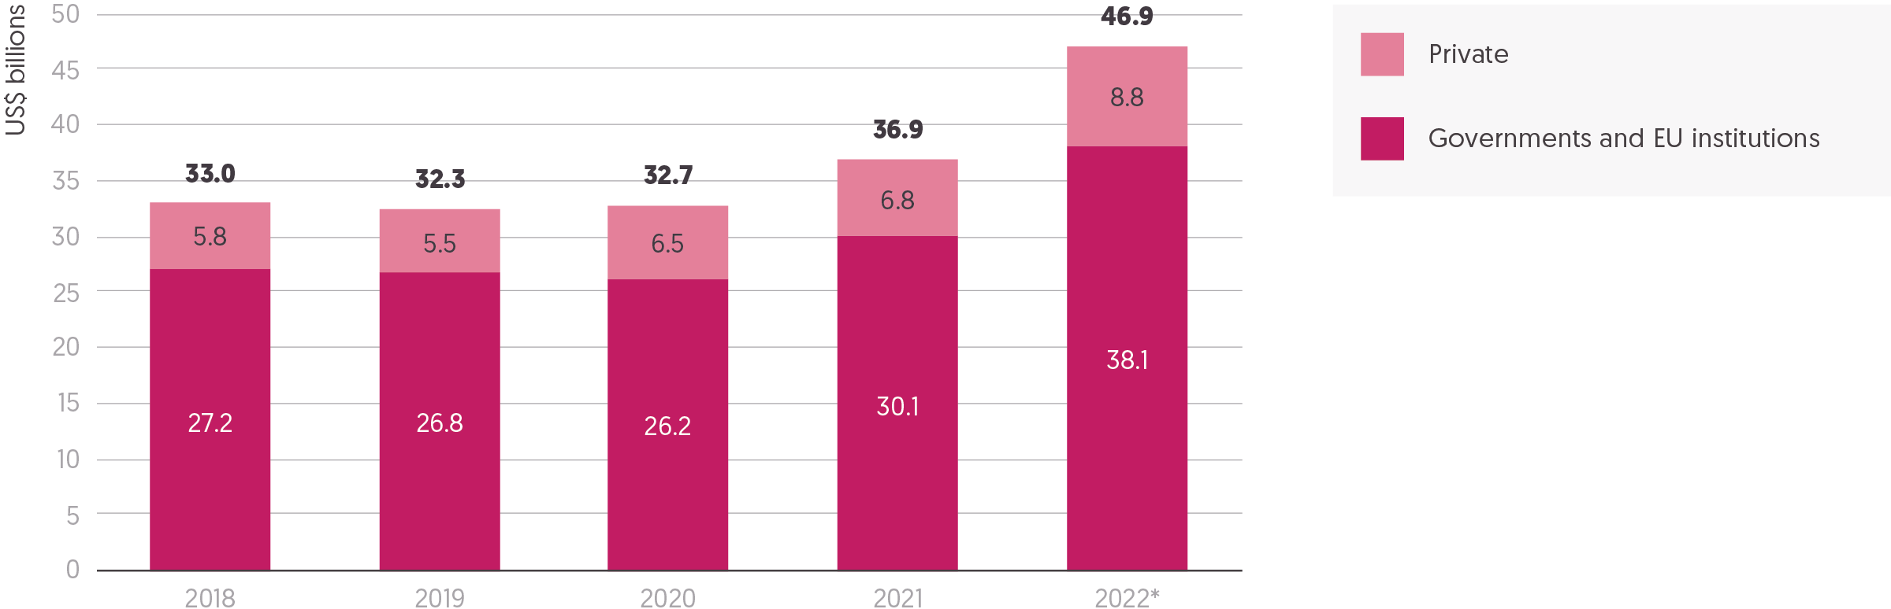  
Source: Development Initiatives based on Organisation for Economic Co-operation and Development (OECD) Development Assistance Committee (DAC), UN Office for the Coordination of Humanitarian Affairs (OCHA) Financial Tracking Service (FTS), UN Central Emergency Response Fund (CERF) and our unique dataset for private contributions.

Notes: Figures for 2022 are preliminary. Totals for previous years differ from those reported in previous Global Humanitarian Assistance reports due to deflation and updated data. Data is in constant 2021 prices.

Public and private donors both responded exceptionally to the growth in humanitarian needs in 2022 with a sharp increase in the volumes of funding provided. After three years of stagnating funding levels, assistance grew for a second year with the pace of growth rapidly accelerating in 2022.

* In 2022, the estimated total international humanitarian assistance from governments, EU institutions and private donors increased to US$46.9 billion.
* The rate of growth in funding in 2022 significantly increased. Total funding rose by US$10.0 billion from 2021, a 27% increase, compared to the 13% (US$4.2 billion) increase from 2020 to 2021.

This growth was driven by increased contributions from both public and private donors, largely for the response to the conflict in Ukraine.

* Funding from public donors – governments and EU institutions – grew by US$8.0 billion (27%) in 2022, from US$30.1 billion in 2021 to US$38.1 billion.
* Similarly, private donors appear to have responded very strongly to the Ukraine crisis, with estimated contributions increasing by at least US$2.0 billion (29%), from US$6.8 billion to US$8.8 billion. This increase will likely be even greater once more 2022 data becomes available (see our ‘Methodology and definitions’, Chapter 5). This compares to the 17% increase (US$1.0 billion) from private donors in 2020, in response to the Covid-19 pandemic.

The sharp increase in humanitarian needs in 2022 (see Figure 1.4), driven by new and worsening crises in Ukraine, Afghanistan and the Horn of Africa, has led to growing pressure on the ODA budgets of countries that give assistance. While total ODA increased in 2022, strong donor solidarity with Ukraine in particular risks development funding being diverted away from other countries in crisis and the poorest countries to support both the humanitarian response in Ukraine and donors’ domestic expenditure on hosting Ukrainian refugees (see Figure 1.5 in this chapter and 2.6 in Chapter 2). This, in addition to a reduction in development aid, undermines efforts to effectively address the root causes of crisis and build long-term resilience (See ‘The triple nexus. What is the mix of humanitarian, development and peace funding reaching countries in crisis?’, Chapter 4).

* Preliminary figures show that the total net ODA from OECD DAC members grew by 15% (US$28.4 billion) between 2021 and 2022, from US$185 billion to US$213 billion.
* As a result, both the volume and proportion of ODA provided as international humanitarian assistance grew, with 17% (US$36.4 billion) of total ODA provided as international humanitarian assistance in 2022 compared with 15% (US$27.9 billion) in 2021.[4]
* Significantly more ODA was also spent on the in-country hosting of refugees. The average proportion of total ODA spent on in-country refugee hosting by DAC donors increased from 4.7% in 2021 to 18% in 2022. (See Figure 1.5).

Figure 1.4: Despite funding to appeals rising by 40% in 2022 and coverage increasing, the rapid growth in requirements meant the funding shortfall by volume was larger than ever  
Funding and unmet requirements, UN-coordinated appeals, 2013–2023

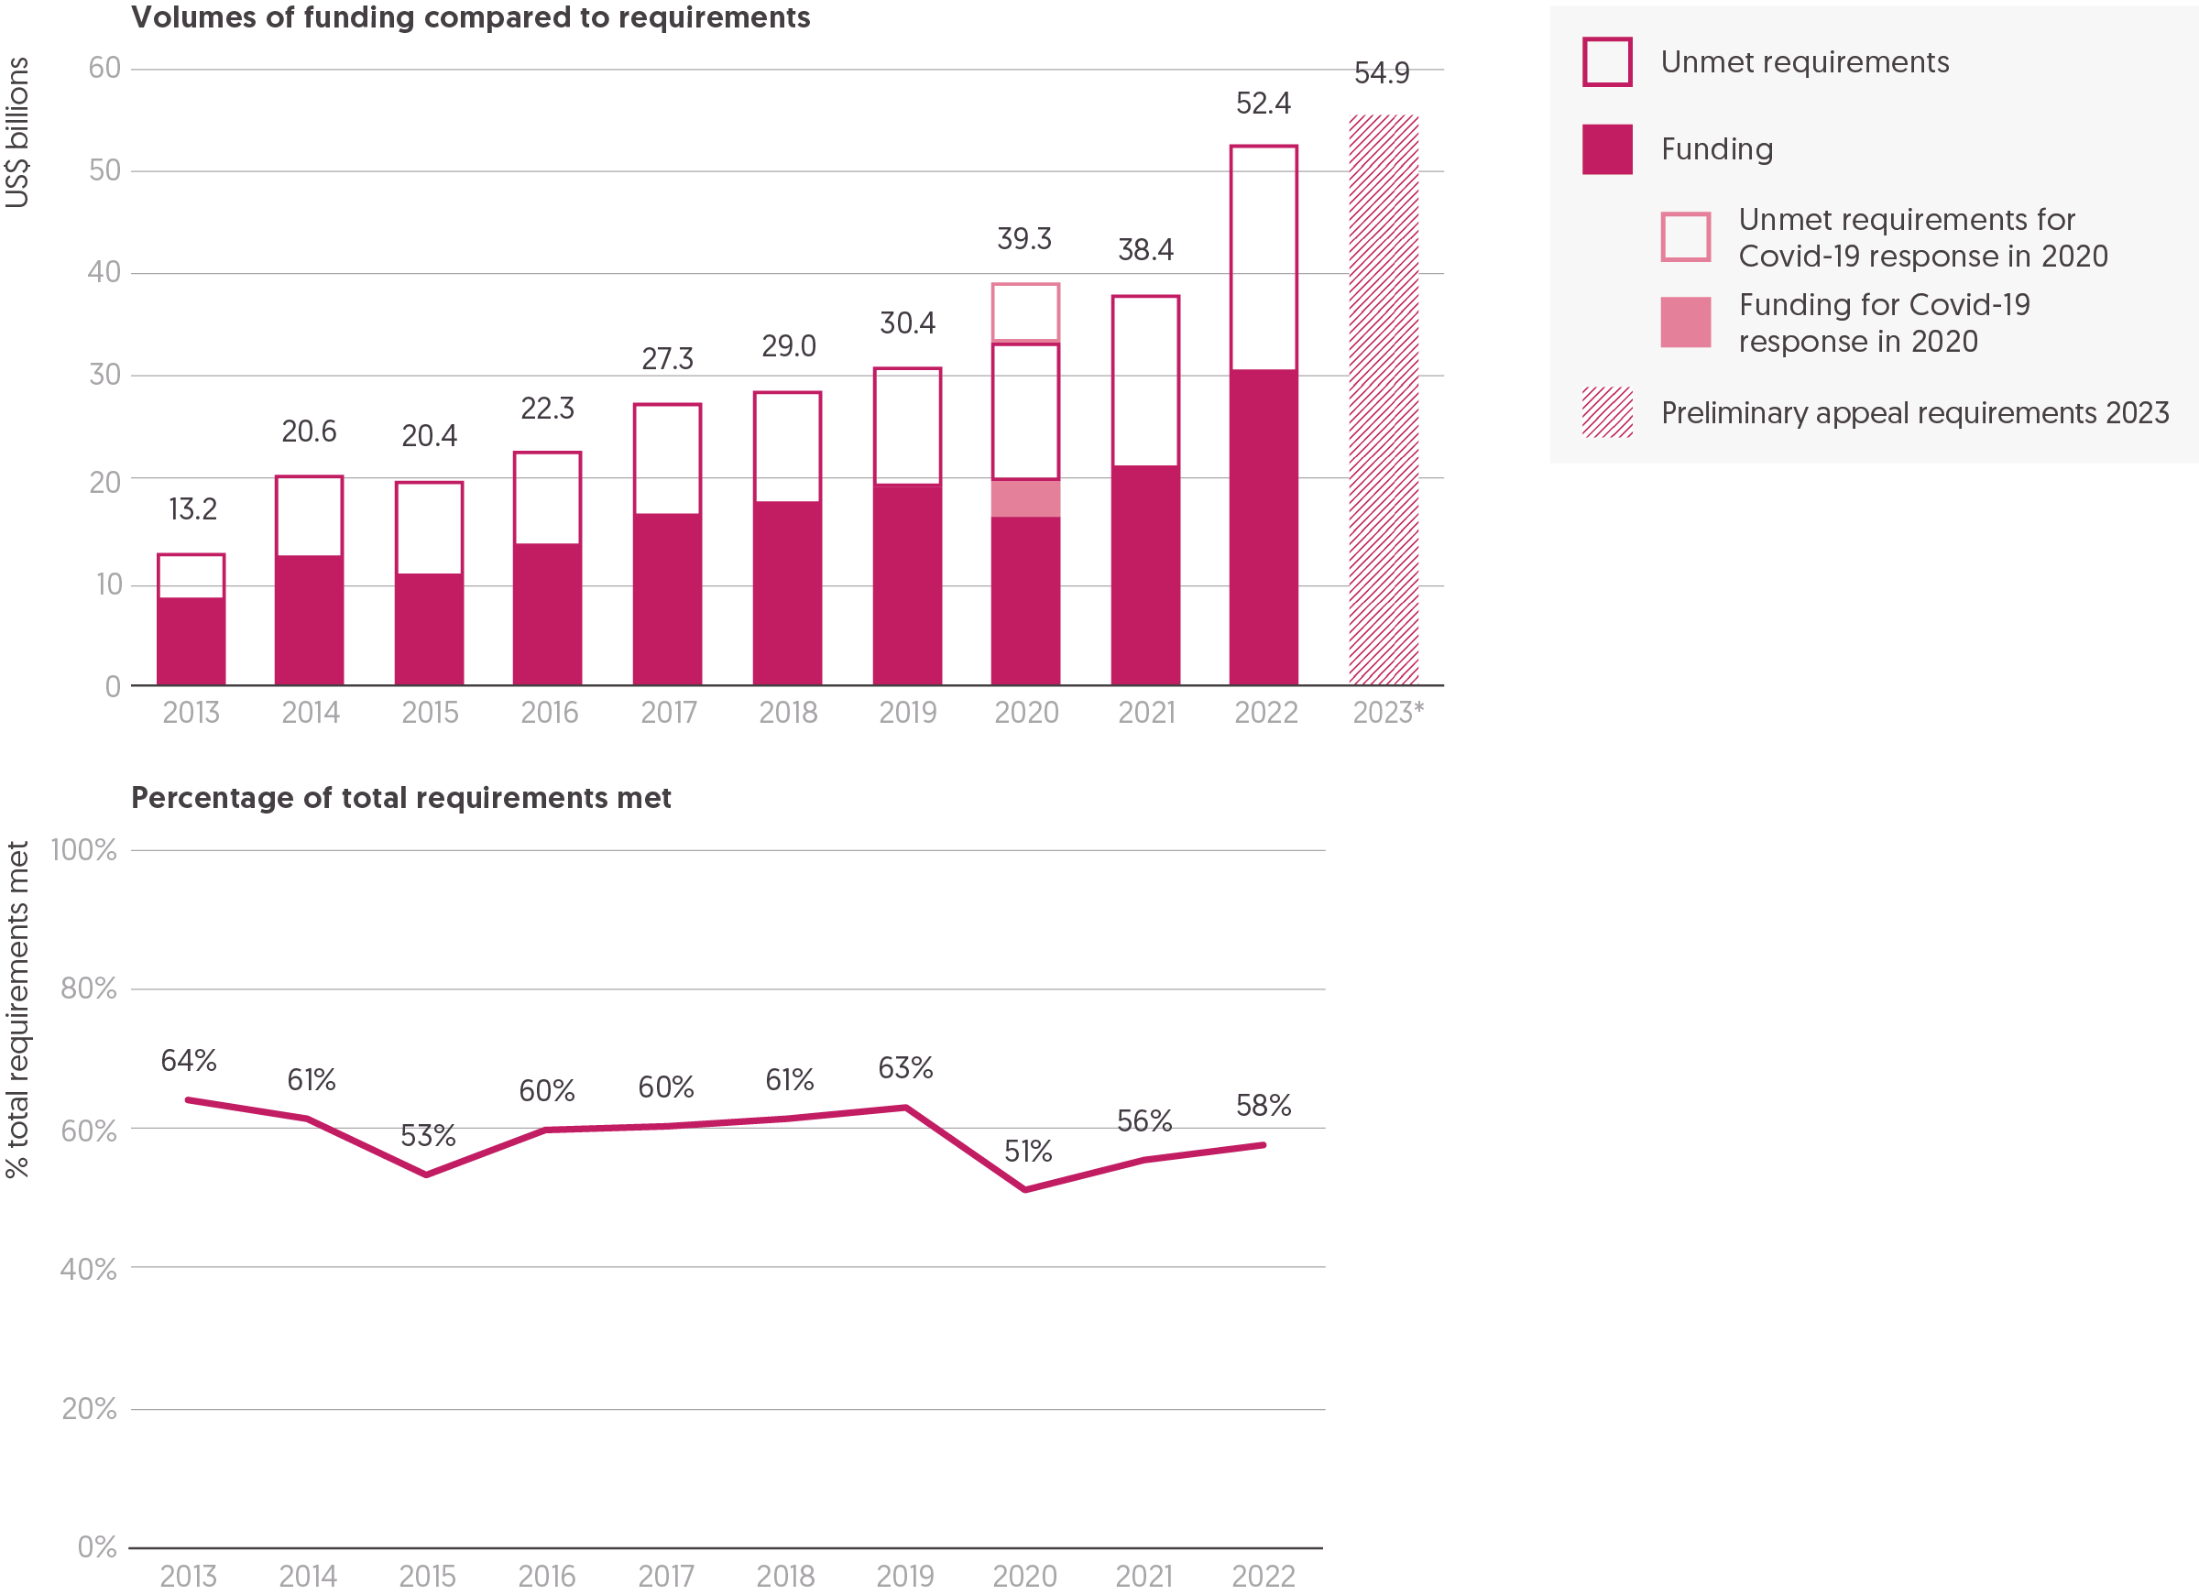

Source: Development Initiatives based on UN Office for the Coordination of Humanitarian Affairs (OCHA) Financial Tracking Service (FTS), UN High Commissioner for Refugees (UNHCR) and Syria 3RP financial dashboard data.  
Notes: Data is in current prices. 2023 data is preliminary in terms of total requirements as of April 2023. Figures for the breakdown of funding and requirements in 2023 to date are not visualised because the funding data is partial and continuously changing at the time of writing.[5] The percentage of requirements met in 2020 includes all funding, for Covid-19 and other responses, against all requirements that year.

The UN-coordinated appeals process is designed to provide a strategic approach to financing humanitarian action by collating together the funding required by UN agencies and NGOs to meet humanitarian needs in major crises.

In 2022, the scale of the funding required to meet humanitarian needs globally jumped to a record high, which looks to be surpassed in 2023 according to preliminary data. The systemic shock of the Covid-19 pandemic had already driven an unprecedented rise in funding requirements within humanitarian appeals in 2020 and 2021, however new and worsening crises in Ukraine, Afghanistan and the Horn of Africa led to a significant increase in the volumes of humanitarian assistance required in 2022. While funding to appeals grew significantly as a result, the scale of needs meant that the proportion of requirements met in 2022 only slightly increased compared to 2021, and the overall funding shortfall grew in absolute terms to US$22.1 billion – the highest volume recorded.

* A record total of US$52.4 billion was requested through UN-coordinated appeals in 2022. Funding requirements for UN-coordinated appeals in 2023 have already overtaken this, which to date stand at US$54.9 billion – around 40% more than requirements in 2020 and 80% more than requirements in 2019 before the Covid-19 pandemic.
* Funding in 2022 was required to meet the needs identified through 46 UN-coordinated appeals, compared to 48 appeals in 2021 and 55 in 2020. However, the number of appeals remains notably higher than 2019 (36).
* The Russian invasion of Ukraine led to the creation of a new flash appeal and a new regional response plan. Other new response plans in 2022 included for the Pakistan floods, the Super Typhoon Rai (Odette) in the Philippines, and for the multidimensional socioeconomic crisis in Sri Lanka.
* Two longstanding humanitarian appeals, in Libya and Iraq, were discontinued after 2022 following eight and nine years, respectively. These transitioned into development-focused assistance frameworks.
* The number of countries with UN appeals that are experiencing protracted or recurrent crisis is growing. In 2022, 44 countries had UN-coordinated appeals for five years or more compared to 36 countries in 2021. This continues to increase with 52 countries to date in 2023 experiencing protracted crisis, partly due to the Venezuela Regional Refugee and Migrant Response Plan entering its fifth year and also due to increasingly protracted UN-coordinated responses in Zambia and Mozambique. This represents an almost four-fold increase in the number of countries (14) in protracted crisis since 2014.

### Appeal requirements

The sharp increase in financial requirements for UN-coordinated appeals in 2022 and 2023 was primarily driven by additional crisis shocks in countries that were facing pre-existing humanitarian needs.

* Funding requested through UN appeals in 2022 increased by 37% from 2021 (an increase of US$14.0 billion). Funding requirements have increased nearly fourfold since 2013, from US$13.2 billion to US$52.4 billion.
* In total, 14 appeals in 2022 had requirements of over US$1.0 billion, compared to 4 appeals in 2013.
* Looking forwards, appeal requirements for 2023 have already surpassed those for 2022 with at least, to date, a 4.8% (US$2.5 billion) growth in funding requirements recorded.
* Funding requirements to respond to the regional Syria crisis remain the highest. In 2022, the Syrian Refugee Regional Response Plan (3RP) had an appeal of US$6.1 billion (9.0% increase from 2021) and the Syria Humanitarian Response Plan (HRP) had an appeal of US$4.4 billion (5.2% increase from 2021).
* The overall growth in funding requirements was driven by the combined appeal requirements for the Ukraine response in 2022, which stood at US$5.9 billion of additional funding. While a HRP already existed in Ukraine prior to that for people affected by conflict in Donetska and Luhanska, the requirements of the response within Ukraine rose sharply from US$168 million in 2021 to US$4.3 billion in 2022. A regional response plan for the Ukraine crisis was newly formed in 2022, requesting an additional US$1.8 billion.
* The humanitarian response requirements for Afghanistan tripled to US$4.4 billion in 2022, from US$1.5 billion in 2021, partly reflecting the severe impact the reduction in international development assistance has had on humanitarian needs.
* The conflict in the north of Ethiopia and droughts in the south led humanitarian response requirements to more than double to US$4.0 billion in 2023, from US$1.5 billion in 2021.
* The longest and most severe drought in Somalia’s recorded history led humanitarian actors to request US$2.6 billion in 2023, more than double the amount in 2021 (US$1.1 billion).

### Funding commitments to appeals

There was a significant response from donors to the growth in appeal requirements, with a large increase in funding committed to appeals in 2022. The proportion of overall requirements met therefore increased, inching closer to pre-Covid-19 levels. Despite this, the large increase in overall requirements meant the overall humanitarian funding gap grew in absolute terms to historic volumes.

* Donors provided a record US$30.3 billion of funding towards UN-coordinated appeals in 2022, an increase of more than 40% (US$8.9 billion).
* Despite this rise in funding, the volume of appeal requirements unmet in 2022 increased to US$22.1 billion, from US$17.0 billion in 2021 (30% increase). This is an alarming increase compared to between 2013 and 2019 – before the Covid-19 pandemic – when the volume of unmet funding requirements stood on average at US$9.2 billion. The funding gap in 2022 nearly doubled since 2019, before the Covid-19 pandemic.
* In 2022, 58% of funding requirements globally were met, increasing for a second year in a row since the 2020 drop to 51%. However, this still remains below the average of 61% between 2013 and 2019.
* This surge in appeal funding in 2022 was mostly driven by the top three donors: the US, Germany and EU institutions, meaning the share of funding to UN-coordinated response plans provided by these donors increased further, from 59% in 2021 to two-thirds (66%) of all funding in 2022.
* The US increased funding to UN-coordinated response plans in 2022 by 72% (US$5.9 billion), while Germany and EU institutions both increased their contributions to those plans by around half. This meant the US alone provided almost half (48%) of all funding to UN-coordinated appeals in 2022.

The proportion of funding requirements met differed between appeals, although with slightly less variation than in 2021.

* In 2022, about a third (18 of 46) of appeals received 50% or less of their requested funding, compared to nearly half of appeals in 2021.
* Of the 46 appeals in 2022, 10 received more than 75% of requirements, the highest of which was the Regional Migrant Response Plan for the Horn of Africa and Yemen (97%). Two appeals were funded at less than 25% (the Haiti Cholera Flash Appeal and the Cuba Hurricane Ian response), fewer than the five funded at this level in 2021.
* The appeals that received the highest volume of funding were the Ukraine Flash Appeal (US$3.7 billion, 85%), the Afghanistan HRP (US$3.2 billion, 73%) and the Syria 3RP (US$2.4 billion, 39%).
* As well as the Ukraine Flash Appeal and the Afghanistan HRP, the best funded appeals that had requirements over US$1.0 billion were the Somalia HRP (US$1.9 billion, 85%) and the Ukraine Regional Refugee Response Plan (US$1.3 billion, 74%). The least well-funded appeal with requirements of over US$1.0 billion was the South Sudan Regional RRP (US$361.6 million, 30%). (See Figure 2.2, Chapter 2)

The funding to appeals in countries with protracted crises also fluctuated significantly, with trends differing between appeals.

* The largest fluctuation in requirements met within appeals that have existed for at least 10 years in 2022 was for the Haiti HRP and the Central African Republic HRP. Haiti funding fluctuated between 12% in 2018 to 80% in 2014 and Central African Republic ranged from 37% coverage in 2016 to 96% in 2022.
* The protracted crisis appeals in 2022 with the largest year-on-year fluctuations since they began were the Pakistan and Libya appeals, which both saw average year-on-year changes in appeal requirements met of 30% or more, both up and down. Funding to the Pakistan appeal ranged from US$58 million (29% coverage) in 2019 to US$344 million (104%) in 2021, while the Libya appeal’s funding ranged from US$78 million (25% coverage) in 2018 to US$137 million (105%) in 2020.
* The largest changes in the coverage of appeals between 2021 and 2022 for countries experiencing protracted crisis were for the Myanmar appeal, which fell from 85% (US$235 million in funding received) of requirements met to 42% (US$343 million), and the Pakistan appeal, which fell from 104% (US$344 million) to 71% (US$333 million), both due to funding not being able to match increases in requirements. The largest increases in coverage were for the Ukraine appeal, which increased from 61% (US$102 million in funding received) of requirements met in 2021 to 85% (US$3.7 billion) in 2022, and the Chad appeal, which increased from 36% (US$221 million) to 61% (US$309 million).

### Red Cross Red Crescent appeals

The International Red Cross and Red Crescent Movement sets out its requirements separately from UN-coordinated appeals. In 2022, the International Federation of Red Cross and Red Crescent Societies (IFRC) appeal requirements increased by almost two-thirds (65%), driven by the large emergency appeal for Ukraine. The appeal from the International Committee of the Red Cross (ICRC) was larger and saw record contributions from donors, with 90% (US$2.4 billion) of its 2022 requirements covered.

IFRC emergency appeals relate mostly to disasters associated with natural hazards.

* In 2022, IFRC appeal requirements increased to US$2.1 billion, a 65% increase from 2021 (US$1.3 billion).[6]
* Funding to the IFRC increased by almost half (49%): from US$738 million in 2021 to US$1.1 billion in 2022.
* The proportion of requirements met fell slightly in 2022 (53%) from 2021 (59%).[7]
* The largest IFRC emergency appeal was for Ukraine, with US$576 million requirements and 71% (US$409 million) coverage. Excluding Ukraine, overall IFRC appeals coverage in 2022 was 46%.

ICRC appeals respond mainly to conflict-related situations.

* ICRC appeal requirements in 2022 increased by 15%, from US$2.3 billion to US$2.7 billion.
* Contributions toward ICRC appeals increased by 22%, from US$2.0 billion in 2021 to US$2.4 billion in 2022 – covering 90% of funding requirements.[8] Since 2014, coverage has averaged 89%. Total ICRC funding is expected to fall in 2023, as cuts of US$450 million were announced by the board in March 2023.[9]

Figure 1.5: Nearly all the top 20 donors increased contributions in 2022  
20 largest public donors of humanitarian assistance in 2022 and change from 2021

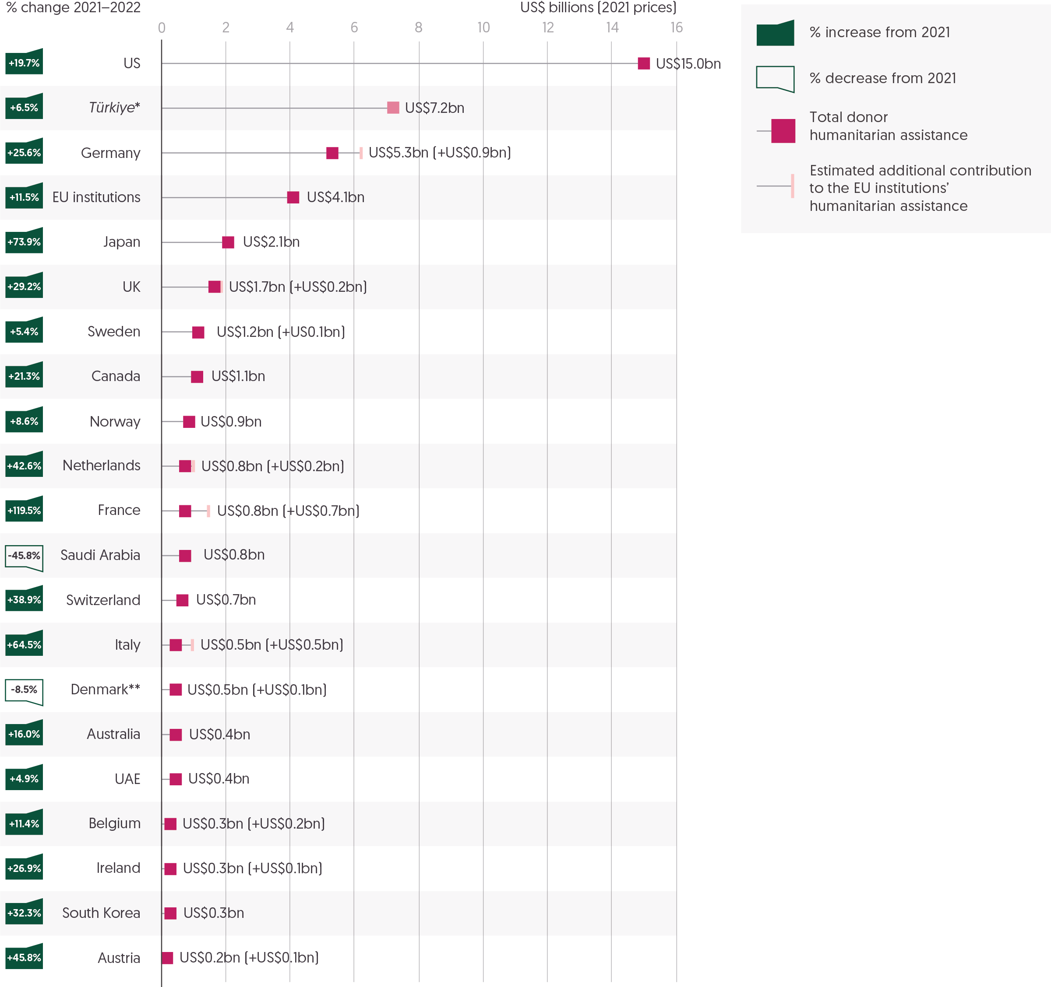

Source: Development Initiatives based on Organisation for Economic Co-operation and Development (OECD) Development Assistance Committee (DAC), UN Office for the Coordination of Humanitarian Affairs (OCHA) Financial Tracking Service (FTS), UN Central Emergency Response Fund (CERF), and Turkish Cooperation and Coordination Agency (TIKA).

Notes: UAE = United Arab Emirates. 2022 data is preliminary. Data is in constant 2021 prices. ‘Public donors’ refers to governments and EU institutions. Contributions of current and former EU member states to EU institutions’ international humanitarian assistance is shown separately (see our ‘Methodology and definitions’, Chapter 5). Percentage change excludes EU contributions and compares for donors with 2022 volumes based on only FTS data with 2021 volumes from the same source and according to the same methodology. *Türkiye is shaded differently because the humanitarian assistance it voluntarily reports to the DAC is largely expenditure on hosting Syrian refugees within Türkiye, and so not strictly comparable with the international humanitarian assistance from other donors in this figure. ** Preliminary 2022 figures for Denmark have only been partially reported and are likely to be revised upwards in final reporting at the end of 2023. 2021 figures differ from the GHA Report 2022 due to final reported international humanitarian assistance data.

The unprecedented growth in the volumes of funding required to meet humanitarian needs in 2022 (see Figure 1.4), and the particularly strong donor response to the humanitarian impacts of the Russian invasion of Ukraine, led to a significant increase in funding from public donors.

* In total, international humanitarian assistance from public donors grew from US$30.1 billion in 2021 to US$38.1 billion in 2022 (see Figure 1.3), an increase of 27%.
* Nearly all (18) of the top 20 public donors of international humanitarian assistance increased their contributions in 2022 from 2021. An unprecedented number made large increases in their contributions, with over half (11) increasing assistance by more than 20%.
* On average, funding from the top 20 donors increased by 27% in 2022. This marks a significant departure from 2021 when funding increased on average by 11%.
* The public donor base has not broadened. The top 20 donors accounted for nearly all public funding, representing 97% (US$37.2 billion) of total public resources, a similar share as in 2021 (98%).

Following a somewhat static funding base over the past decade, 2022 saw notable changes among the top donors as Germany overtook EU institutions to become the second largest public donor and Japan overtook the UK as the fourth largest.[10] Overall, the humanitarian system remains dependent on a small number of key donors, especially the US and Germany, which both significantly increased funding in 2022.

* In 2022, the largest donors provided the largest increases in funding by volume. The largest increases were from the US, which provided US$15.0 billion (an increase of US$2.5 billion, up 20%), Germany, which provided US$5.3 billion (up US$1.1 billion, 26%) and Japan, which provided US$2.1 billion (up US$0.9 billion, 74%). Funding from the third largest public donor, EU institutions, grew by US$0.4 billion, a 12% rise to US$4.1 billion.
* The three largest public donors – US, Germany and EU institutions – together accounted for 64% of total international humanitarian assistance from public donors, with the US alone accounting for 39% of total assistance from public donors.
* Despite an increase in allocations from the UK, up 29% in 2022 to US$1.7 billion, cuts in 2020 and 2021 mean it remains outside the top three largest government donors. In 2022, the UK’s share of contributions accounted for 4.6% of total funding from public donors, compared to 10% in 2019.
* Other notable increases in funding came from France, which more than doubled its contributions from US$358 million in 2021 to US$785 million in 2022 (up 119%), Italy, which increased its humanitarian assistance by 64% to US$493 million and the Netherlands, which increased funding by 43% in 2022 to US$803 million.

The conflict in Ukraine led to a significant increase in the number of refugees hosted by countries which also provide humanitarian assistance. These countries can report some of their spending in the first year of hosting refugees as ODA to the OECD DAC.[11]

In 2022, donor spending on hosting refugees in-country more than doubled to a record high driven by the conflict in Ukraine.

* In 2022, the preliminary reported ODA spent on in-country refugee hosting costs by DAC members grew to a record US$30.1 billion, from US$12.8 billion in 2021 (an increase of 134%). Spending in 2022 on hosting refugees in DAC member countries therefore significantly exceeded the previous annual high in 2016 (US$18.6 billion).
* Six countries increased their expenditure on in-country refugee hosting in 2022 by more than US$1 billion. The largest increase was seen by the UK, which more than tripled spending to US$4.8 billion in 2022 from US$1.4 billion in 2021. Other notable increases were seen in Poland (from US$17 million to US$2.3 billion), Germany (from US$2.7 billion to US$4.8 billion), the US (from US$4.7 billion to US$6.2 billion), Ireland (from US$50 million to US$1.3 billion) and Italy (from US$556 million to US$1.6 billion).
* Several other countries saw significant increases in expenditure on hosting refugees from Ukraine, most of whom had spent minimal amounts on in-country refugee hosting in previous years: Japan (from US$0.27 million to US$61 million), the Czech Republic (from US$6.4 million to US$640 million) and Lithuania (from US$1.9 million to US$48 million).
* In 2022 and according to preliminary data, Poland hosted the highest number of people seeking asylum, including Ukrainian refugees (1.6 million), at an estimated per person cost of US$1,455, followed by Germany (1.2 million people) at an estimated per person cost of US$4,134. In comparison, three European donors were estimated to have spent over US$15,000 per person while hosting significantly fewer people seeking asylum: Switzerland hosted 85,000 people at a per person cost of US$15,099, Ireland hosted 77,000 people at a per person cost of US$17,326 and the UK hosted 188,000 people at a per person cost of US$25,717.[12]
* As a result, the average proportion of total ODA spent on in-country refugee hosting by DAC donors increased from 4.7% in 2021 to 18% in 2022. In total, six donors allocated more than 25% of total ODA to refugee hosting within their own country: Poland (67%), the Czech Republic (65%), Ireland (54%), the UK (31%), Switzerland (29%) and Finland (27%).

Read more from DI on the [impact of the rise in in-donor refugee costs on those most in need of assistance](https://devinit.org/blog/new-dac-data-reveals-impact-of-ukraine-invasion-on-aid/).

Figure 1.6: A growing number of donors provided more than 0.1% of GNI as humanitarian assistance in 2022  
20 largest government donors of international humanitarian assistance by % GNI

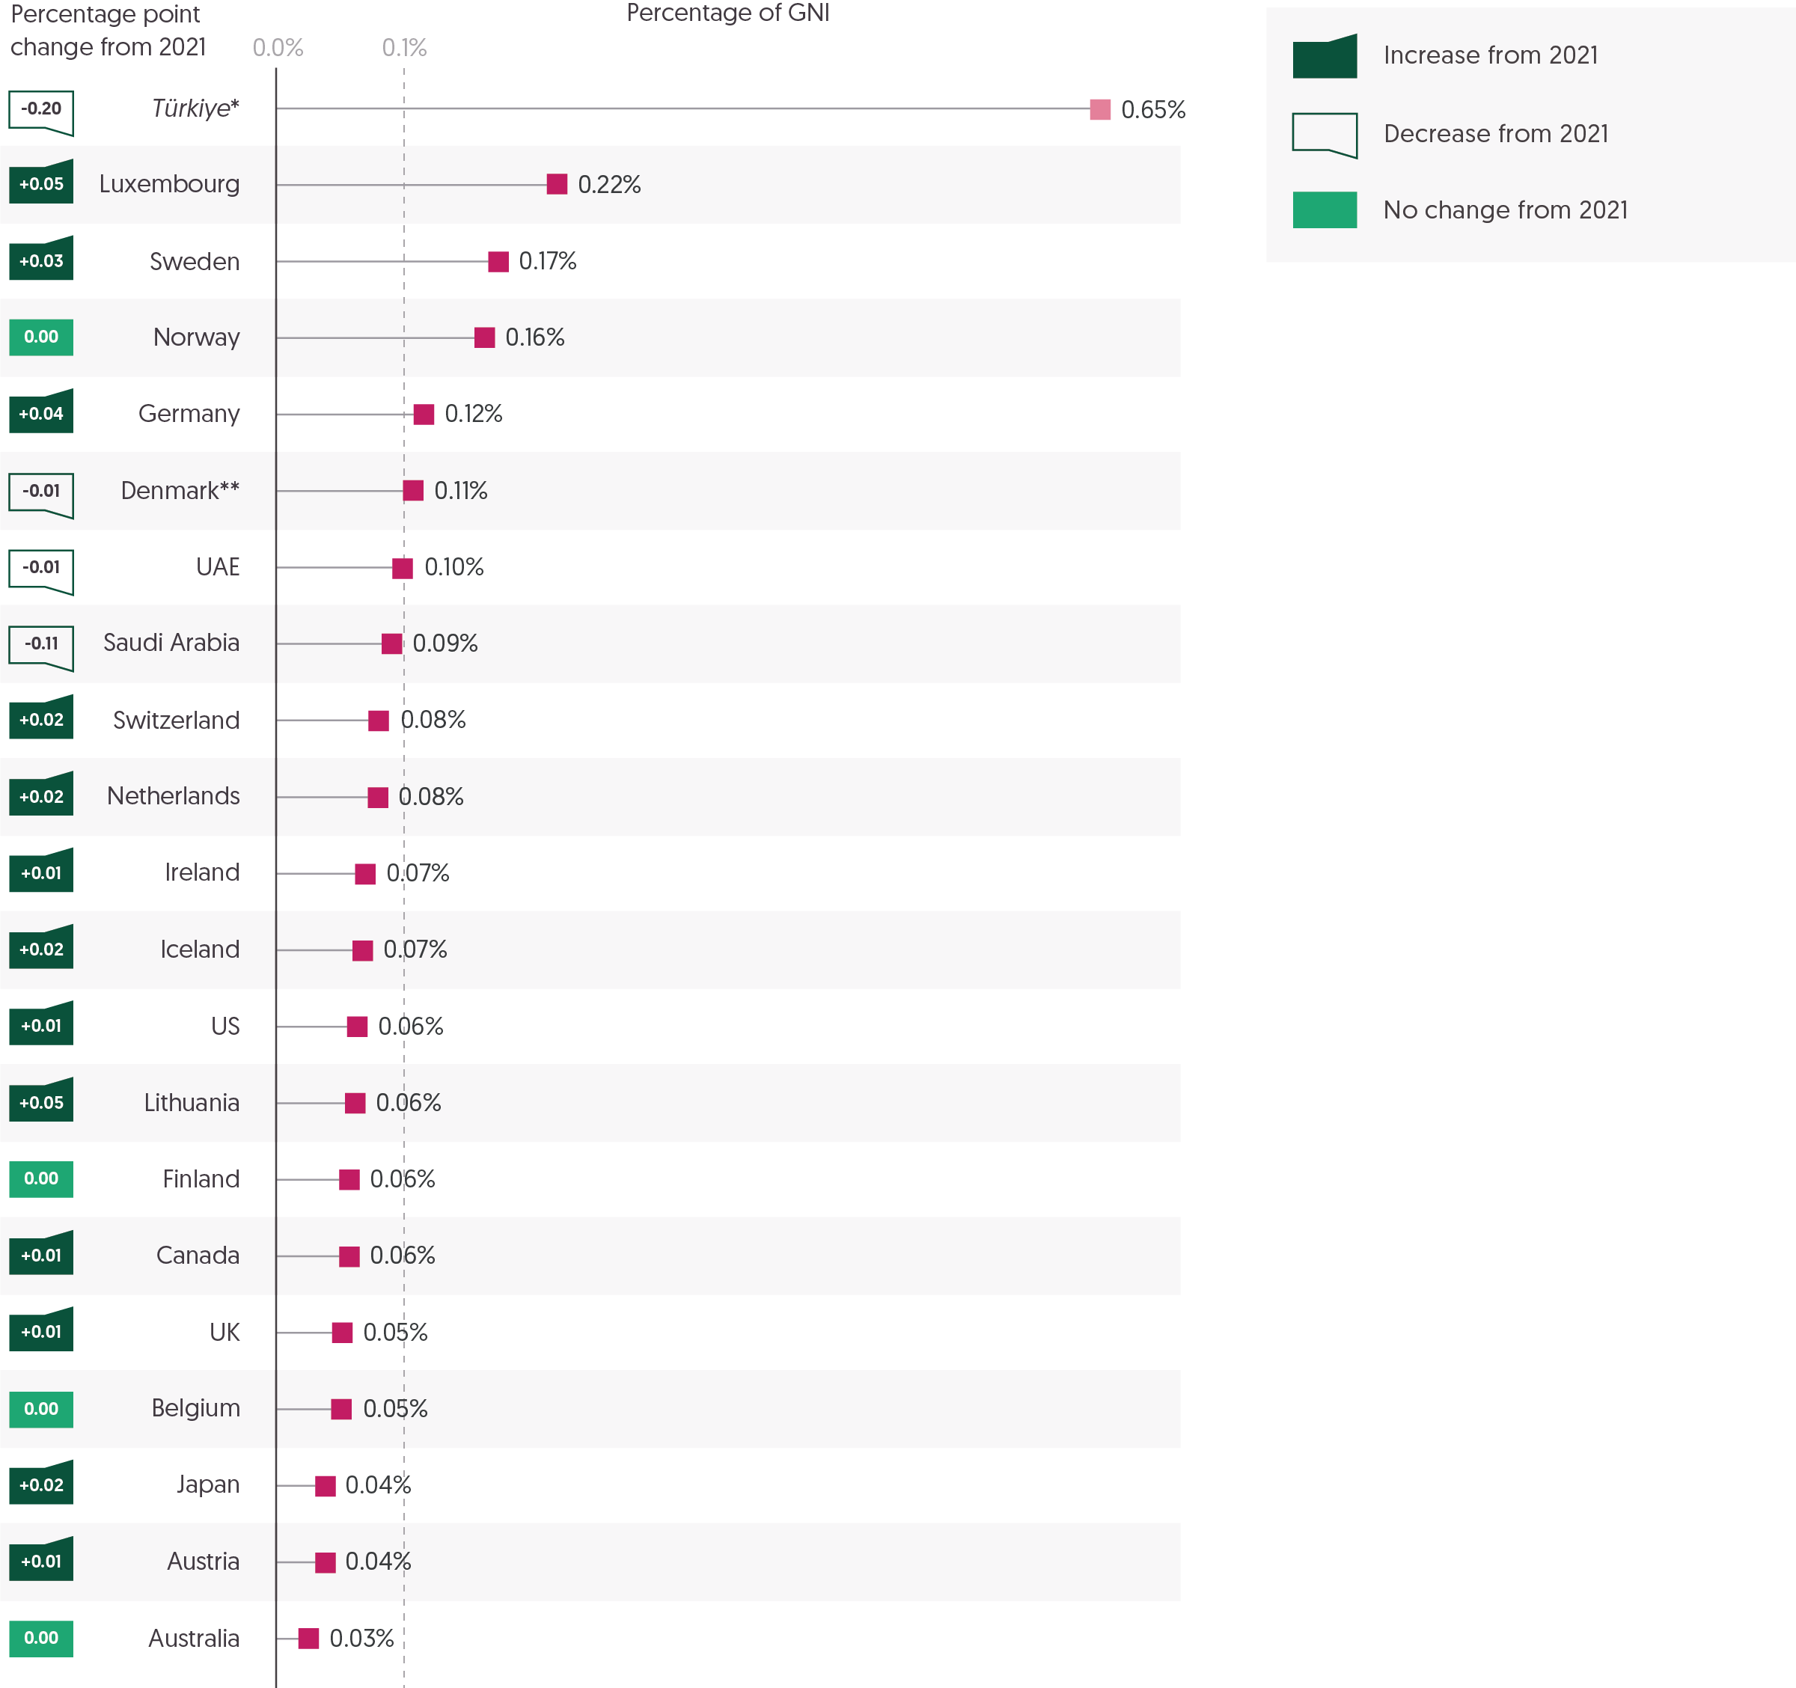

Source: Development Initiatives based on Organisation for Economic Co-operation and Development (OECD) Development Assistance Committee (DAC), and UN Central Emergency Response Fund (CERF).

Notes: 2022 data is preliminary. EU institutions are not shown due to no comparable gross national income (GNI) figure. Government figures exclude EU contributions. *Türkiye is shaded differently because the humanitarian assistance it voluntarily reports to the DAC is largely expenditure on hosting Syrian refugees within Türkiye, and so not strictly comparable with the international humanitarian assistance from other donors in this figure. ** Preliminary 2022 figures for Denmark have only been partially reported and are likely to be revised upwards in final reporting at the end of 2023. Figures for 2021 differ from the GHA Report 2022 due to final reported international humanitarian assistance data and revised GNI figures.

The growing humanitarian funding gap is exacerbated by the narrow donor base the system relies on. There is a need to both diversify the number of funding sources and move towards greater responsibility-sharing. One metric to assess the extent to which public donors prioritise humanitarian responses is the proportion of GNI committed to it. In 2022, most donors increased the proportion of GNI provided as humanitarian assistance in line with overall increases in volume, but the share of GNI continues to vary greatly among donors.

* Of the 20 government donors that provided the largest volume of international humanitarian assistance as a percentage of GNI in 2022, 12 increased this proportion, compared to 7 in 2021.
* Six government donors allocated 0.1% or more of their GNI to humanitarian responses in 2022 (Luxembourg, 0.22%; Sweden, 0.17%; Norway, 0.16%; Germany, 0.12%, Denmark, 0.11% and the United Arab Emirates (UAE), 0.10%). This is one more than in 2021.
* Türkiye also reported an equivalent of 0.65% of its GNI as humanitarian assistance in 2022, down from 0.85% in 2021. Türkiye’s reported contributions are not directly comparable with those of other donors, however, as the assistance voluntarily reported to the OECD DAC largely comprises spending on hosting Syrian refugees within Türkiye.
* The largest increases of humanitarian funding in terms of GNI came from Lithuania and Luxembourg (both +0.05 percentage points) and Germany (+0.04 percentage points).
* The most notable reduction among the top 20 government donors in terms of their humanitarian contributions relative to GNI in 2022 was from Saudi Arabia, which was ranked the highest in 2021 (0.20%) and fell to 0.09% in 2022 (-0.11 percentage points).
* The large increase in funding provided by the US in 2022 is reflected in the share of GNI provided as humanitarian assistance, which has risen to 0.06%. This now places the US ahead of other large donors, the UK (0.05%) and Japan (0.04%), but behind 11 other donors.
* There are also notable high-income countries outside of the top 20 government donors that contribute a relatively small proportion of their GNI to international humanitarian assistance. In 2022, this included: France (fifth highest GNI, providing 0.03%), Italy (sixth highest GNI, providing 0.02%), Korea (eighth highest GNI, providing 0.01%) and Spain (tenth highest GNI, providing 0.01%).

Read more from DI and Oxfam about the [widening gap between humanitarian need and funding in the context of the escalating climate crisis](https://devinit.org/resources/still-too-important-to-fail/).

Insight: Jan Egeland

*Jan Egeland has been Secretary General of the Norwegian Refugee Council since August 2013, leading humanitarian operations with some 16,000 relief workers, serving over 9 million people in need across the world. In June 2021, he was appointed Eminent Person of The Grand Bargain initiative. Within this role he is responsible for promoting and advocating for the advancement of The Grand Bargain’s commitments to better serve people in need. Egeland served as UN Under-Secretary-General for Humanitarian Affairs and Emergency Relief Coordinator 2003*–*2006 where he spearheaded a reform of the global humanitarian system.*

Over the past 10 years, humanitarian needs have grown exponentially. In 2023, the total requirements for UN-coordinated humanitarian responses globally will be more than five times as large as in 2013. Requirements will be 40% larger than during 2020, a year that was marked by a steep increase in needs due to the Covid-19 pandemic.

While donor funding has grown substantially, the system continues to rely on the generosity of a handful of Western donors, with the US, Germany, and the EU contributing two-thirds of all humanitarian assistance. Furthermore, these resources are unequally distributed, with some countries becoming caught in a cycle of neglect.

At the same time, the number of countries facing protracted crises has grown. In the past twelve months, I have visited Afghanistan, Niger, Somalia, Ukraine, Bangladesh and Palestine, and witnessed large communities engulfed in never-ending war, strife and disasters.

The gap between needs and available funding continues to widen and the system is under increasing pressure. We simply cannot keep up. So, how do we fix it?

Over the past two years, I have chaired the work of the Grand Bargain, a unique platform that brings together donors, UN agencies, the Red Cross Red Crescent (RCRC) movement, international NGOs and local actors with the aim of making humanitarian action more effective and efficient. We have pursued this aim through a focus on predictable and flexible funding, through localised humanitarian action, and through better communication with those affected. This emphasis on improving the delivery of aid and finding durable solutions to vulnerability and displacement is one of the tools in our toolbox as we try to keep up with increasing needs and the growing funding gap. But it cannot – and should not – be the only one.

We cannot close the funding gap without shrinking the needs in the first place. We must work on finding political solutions to the many crises and convince our leaders to invest their political capital to solve them. At the same time, we need to find ways to help people to emerge from displacement and re-establish themselves in safe and lasting communities. Humanitarians cannot do this alone – we need development actors and international financial institutions to step up their game.

To be successful, we need new players on board with us. We can get them by gaining broader support for humanitarian action. Humanitarian assistance is not solely philanthropically motivated – we should change our narrative and discuss the benefits of humanitarian assistance as an investment in resilience and stability for a global common good. This could motivate more states to step up their support to humanitarian (and development) funding. If we look back to 2020, the entire humanitarian budget we requested – US$39 billion – represented less than 0.1% of the 57 highest-income countries' gross national income (GNI). In other words, had each of these countries contributed a fraction of a percent of its GNI to humanitarian assistance, all the funding needed to respond to international humanitarian crises would have been available.

# Chapter 2 – Characteristics of crisis: Need and funding

## Summary

While the numbers of people in need of assistance rose significantly in 2022, the increase is part of a longer-term trend of rapidly accelerating humanitarian needs. Estimations show that needs have more than doubled over the past five years. Several large-scale protracted crises account for the bulk of humanitarian needs, with more than half of all people in need over the past five years living in just 10 countries. The humanitarian system’s response capacity has grown to match this rise in needs, with the number of people targeted to receive assistance doubling over the past five years.

Challenges remain on gathering consolidated data on the people reached by humanitarian interventions and despite efforts to improve data disaggregation. Where data is available (for only one-third of UN coordinated appeals), half of all people in humanitarian need are under the age of 18.

As in previous years, a small number of crises received the majority of humanitarian funding, with the 10 largest recipients receiving 63% of the total country-allocable funding in 2022. Ukraine received the highest amount of humanitarian funding of any country in a given year ever recorded, at US$4.4 billion.

Donors are faced with a complex set of choices on how and where to allocate their funding. In 2022 there was significant variation between the largest donors in the share of their total assistance allocated to country, regional or global levels, and to individual countries. The US, EU institutions[13] and UK allocated just 6% or less at the global or regional level, while Japan provided 55% and Germany 17%. In his Insight piece, Deputy Director General of European Civil Protection and Humanitarian Aid Operations (ECHO), Michael Köhler, proposes solutions for more balanced humanitarian financing and suggests establishing national humanitarian funding targets to secure a more sustainable and equal sharing of financing.

Forced displacement was, as in previous years, a key driver of the rise in humanitarian needs in 2022, with an additional 16.5 million people displaced internally and across borders. Over 10 million of those people forcibly displaced were Ukrainians. The impacts of the Ukraine crisis also contributed to rising levels of global food insecurity with an estimated 265.7 million people facing crisis-level acute food insecurity across 60 countries in 2022/23. Among the countries affected, South Sudan, Yemen and Somalia experience some of the most severe food insecurity in the world. In their Insight piece, the Organisation for Children Harmony (TOCH, a South Sudanese NGO) recount their experience accessing the UN South Sudan Humanitarian Fund, calling for more predictable multi-year funding for actors working with affected communities.

Humanitarian funding to those sectors that directly address food needs (food security, nutrition and agriculture) rose by 53% in 2022. However, humanitarian food sector funding in crisis-level food insecurity remains at less than US$100 per person in four out of the five most severe food insecurity contexts. N4D reflect in their Insight piece on their work in Yemen to promote better multisectoral nutritional programming, highlighting the importance of local ownership and increased longer-term financing to build resilience.

## Who is receiving humanitarian assistance? Gender and age

Figure 2.1: The number of people in need of humanitarian assistance has more than doubled in the last five years  
Trends in people in need over the last decade, 2013–2022 and 2023 (preliminary)

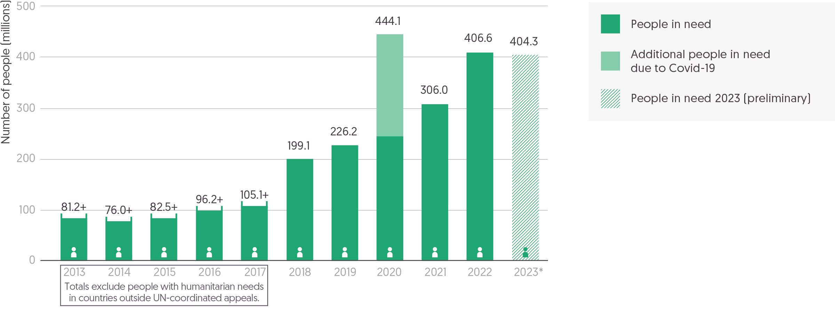

Source: Development Initiatives based on UN Office for the Coordination of Humanitarian Affairs (OCHA) Humanitarian Programme Cycle (HPC), ACAPS and historic people-in-need figures extracted from GHA and Global Humanitarian Overview (GHO) reports.

Notes: 2023 data is preliminary as of April 2023. People-in-need figures for 2019–2023 are based on the maximum number as of UN OCHA HPC year-final per-country estimates, where available for humanitarian response plans and ACAPS year-maximum per-country estimates. 2017 and earlier figures reflect the total number of people receiving humanitarian assistance under interagency coordinated response plans.

There has been a stark increase in needs when examined over the past decade. A multitude of factors have contributed to this increase, but primary drivers include the outbreak of new large-scale crises coupled with an increase in and ongoing prolongment of protracted crises.[14]

Improvements in needs assessments mean there is now a more comprehensive identification of the range of humanitarian needs. Data for years previous to 2018 is based on humanitarian population figures targeted by UN-coordinated appeals, meaning that people with humanitarian needs in countries without UN coordination structures were not included. As of 2018, annual figures have been based on independent assessments across all countries with humanitarian needs, providing a more comprehensive overview of the global panorama. This difference accounts for a 19% average increase in people in need from 2018 onwards, due to needs in countries outside of UN-coordinated appeals. However, this difference fluctuates across the years, making the data before and after 2018 not directly comparable. Taking these fluctuations into account, estimations show that needs have increased by at least three times, and potentially four, over the past decade.

* Between 2018 and 2022, the number of people in need of humanitarian assistance has doubled from 199.1 million to 406.6 million.
* While figures before and after 2018 are not directly comparable due to different data sources, estimations show that over the past decade the number of people in need of humanitarian assistance may have increased by four times. In 2013 at least 81.2 million people were identified by UN-coordinated appeals to be in need of humanitarian assistance, while in 2022 406.6 million people were identified by both UN-coordinated appeals and independent assessments.
* As of April 2023, an estimated 404.3 million people in 83 countries are in need of humanitarian assistance. However, this figure is subject to change throughout the year and is likely to increase.

The response capacity of the humanitarian system has been significantly stretched by several large-scale crises that account for the bulk of needs. In most cases, these countries with very high numbers of people in need are experiencing protracted crisis, lasting five or more years. Across a range of contexts, the general trend is of increasing needs, with few crises abating or transitioning into longer-term recovery and development. Multiple layers of complexity, such as economic crises, accelerating climate impacts and shocks, and an absence of political solutions, are increasingly creating situations in which humanitarian actors must deliver throughout recurrent and overlapping crises.

* Since 2018, more than half of all people in need lived in just 10 countries. In 2022, each of these countries had more than 10 million people in need.
* Between 2018 and 2022, Ethiopia, Democratic Republic of the Congo (DRC) and Yemen were consistently in this top 10 list of countries. 16 other countries have featured among the top 10, with Afghanistan, Nigeria, Sudan, Syria and Venezuela present in 4 out of 5 years.
* The largest yearly increase on record (excluding the additional responses in 2020 for the Covid-19 pandemic) was measured between 2021 and 2022 when humanitarian needs grew by 100.6 million people from an estimated 306.0 million people living in 73 countries in 2021 to 406.6 million in 82 countries in 2022. Contributing to this were large increases of over 10 million people in need in three countries (Ukraine, Pakistan and Myanmar).
* Between 2018 and 2022, the number of people in need increased by at least 10% in 64 of the 102 countries with available data. It decreased in 14 countries. Increases in needs over this time period were particularly pronounced in protracted crisis countries.
* Needs have more than tripled over this period in Ethiopia, from 7.9 million in 2018 to 28.5 million in 2022. The Tigray conflict in the north of the country, combined with drought in the south, has driven this increase, with a particularly sharp rise between 2019 and 2020 of an additional 10.3 million people in need (116% increase). The 2023 preliminary picture shows a further rise to 38.2 million people in need.
* The increase in needs in Myanmar was even starker over this time period, rising sixteenfold from 0.9 million in 2018 to 14.4 million to 2022 (the largest percentage increase at 1570%). The rise in needs was particularly striking between 2021 and 2022, almost tripling in just one year (an increase of 10.7 million, or 289%).
* In the past 5 years, needs also increased by 20.4 million people in Pakistan (a rise of 638%) to 23.6 million in 2022, by 13.9 million people in DRC (doubling to 27.0 million, and by 13.8 million in Afghanistan (130%) to 24.4 million. Yemen has also recorded consistently high levels of people in need, but this has remained stable between 22 and 24 million people in need during this period.

The rise in humanitarian needs over the past decade also points to the expanding responsibilities and remit of the humanitarian sector, as programming attends to a wider range of needs and over a longer timeframe.[15] In addition, system-wide shocks, like the Covid-19 pandemic in 2020, have significantly increased the pressure on response capacity, and several large-scale crises have driven notable spikes in need simultaneously across multiple regions.

* In 2020, an estimated 200.3 million additional people were considered to be in need of humanitarian assistance due to the Covid-19 pandemic.
* Between 2015 and 2016, four emergencies drove a significant increase in people in need: Syria and the neighbouring region, Iraq, Yemen and South Sudan. The interagency appeals for these countries surpassed the billion dollar mark in 2016.[16]

Figure 2.2: People targeted to receive UN-coordinated assistance have doubled in the past five years  
People targeted in countries with UN-coordinated response plans, 2019–2022 and 2023 (preliminary)

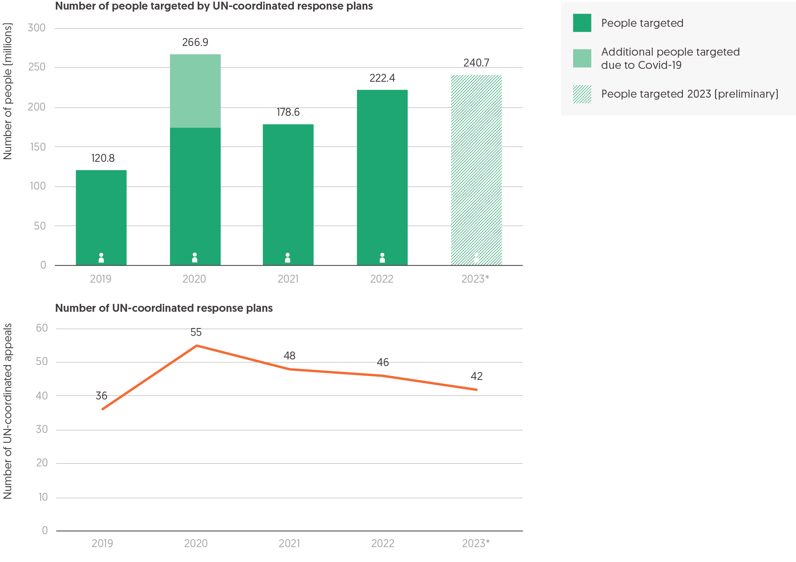

Source: Development Initiatives based on UN Office for the Coordination of Humanitarian Affairs (OCHA)’s Humanitarian Action data portal, United Nations High Commissioner for Refugees (UNHCR) and data from UN response plan documents.

Notes: 2023 data is preliminary as of April 2023. The number of people targeted under Covid-19 response plans in 2020 only includes data for the 17 Covid-19-specific response plans with available data on the number targeted to receive assistance; more people affected by Covid-19 were targeted for assistance under response plans that responded to other humanitarian crises alongside the Covid-19 pandemic.

A key indicator to understand how the humanitarian system is responding is the number of people targeted by UN-coordinated humanitarian responses and the number of people actually reached by these responses.[17] The UN Office for the Coordination of Humanitarian Affairs (OCHA) collates information on people in need and targeted with humanitarian UN-coordinated response plans, including humanitarian response plans, regional refugee response plans and other types of emergency response plans.[18]

UN-coordinated humanitarian response plans capture identified needs across various sectors such as health and food security that are identified through a collaborative needs assessment process. They then set out how to meet those needs alongside the financial requirements to carry out this plan. However, UN-coordinated plans only target a proportion of those identified as in need of humanitarian assistance. In part, the number targeted may be impacted by the assistance provided by others and the need to ensure response coherence with other actors (including the national government, the International Red Cross and Red Crescent Movement, and development actors). Other considerations that may determine the number of people targeted include prioritisation of needs, operational capacity restrictions and humanitarian access impediments.[19] The numbers of people targeted therefore give an indication of the reach of the UN-coordinated humanitarian response. Given that not all people identified as in need of humanitarian assistance will be targeted and thus reached, the extent to which UN-coordinated appeal requirements are fulfilled therefore provides only part of the picture of global humanitarian need and, as such, the extent of unmet need is larger than underfunding levels suggest (see the section titled ‘Was humanitarian funding sufficient? Appeals, donors and total assistance’ in Chapter 1).

The numbers of people targeted have steadily increased over the past five years, with the exception of a large spike in 2020, which saw a large number of people targeted by the UN-coordinated response plans for the Covid-19 pandemic. This rise far outstrips the growth in the number of plans, showing how increases in the number of people targeted have primarily been driven by the escalating needs in countries facing protracted humanitarian crises.

* Since 2019, the number of people targeted in countries with UN response plans has doubled (from 120.8 to a preliminary 240.7 million people targeted in 2023).
* In 2021, 67% of people identified to be in need under appeals were targeted with assistance. In 2022 and 2023,[20] targeting remained stable at around 66% of people identified as in need. However, given the significant rise in people in need, this stability in targeting reflects a growth in the ambition of UN-coordinated responses to meet rising challenges.
* In 2020, only 60% of people identified under UN-coordinated response plans were targeted to received assistance (266.9 million people), as the humanitarian system was put under increased pressure due to additional Covid-19-related needs. Most of the ad-hoc Covid-19 plans for countries that did not already have UN-coordinated appeals were discontinued in 2021.
* UN-coordinated response plans rose from 36 in 2019 to 42 in 2023, a 17% increase. The scale of this increase is much lower than the numbers of people targeted, the latter having doubled over the same time period.
* Over two-thirds of the total increase in people targeted by UN-coordinated responses between 2019 and 2023 were in 22 out of 24 countries experiencing protracted crises, an additional 82.7 million people.

Increases in people targeted for humanitarian assistance occurred in the same countries that saw the largest spikes in people in need, with some of the largest increases in Ukraine, Myanmar and Afghanistan. Country-specific differences in the share of people in need that response plans targeted with assistance point to the restrictive and challenging operational conditions in which humanitarian actors are currently operating in some contexts. These challenges speak to the increasing complexity of crises (see Chapter 1).

* The number of people targeted with humanitarian assistance in Afghanistan increased more than fivefold from 4.5 million in 2019 to 23.7 million people in 2023. Despite the challenging political and operational context, humanitarian actors increased the proportion of people targeted out of people identified in need of assistance from 71% in 2019 to 84% in 2023.
* The scope of the humanitarian response plan for Ukraine has also expanded significantly, targeting almost fivefold the number of people in 2023 (11.1 million) than in 2019 (2.3 million) and managing to target a similar share of people in need despite a significantly larger response (63% in 2023 compared to 66% in 2019).
* The number of people targeted also increased almost fivefold in Myanmar between 2019 and 2023, from 0.9 million to 4.5 million. However, in 2023, the interagency response is focusing its efforts on the most vulnerable people in rural areas given sharply rising needs, targeting only 25% of people in need compared with 100% in 2019. This is because of a shrinking operational space in Myanmar due to ongoing conflict, bureaucratic access constraints and violence against aid workers.[21]
* Similarly, the interagency response in DRC now focuses its efforts on 10.0 million people targeted in the most vulnerable areas, which amounts to 38% of the identified population in need in 2023. This is a decrease from 70% in 2019 due to the identified needs more than doubling since then. Humanitarian access is also limited because of security incidents affecting aid operations, poor road infrastructure and administrative constraints.[22]

Box 2.1: Challenges with ‘people reached’ data

Significant progress has been made on needs assessments (ensuring greater clarity on the numbers of people in need), the response requirements for different clusters[23] and prioritising the targeting of people in need, however monitoring and understanding the impact of interagency humanitarian response has been less consistent. One of the ways UN OCHA has tried to present a rough overview of the scope of assistance provided is through the number of people reached, although this metric has its challenges as outlined below. Since 2019, UN OCHA has provided increasingly consolidated data on the estimated number of people reached by at least one form of assistance (a term used by OCHA to describe assistance from programmes under at least one cluster’s remit) under interagency humanitarian responses, either through response plans or flash appeals. In 2022, consolidated data on people reached was available for 35 out of the 46 UN-coordinated response plans. However, the quality of these reported figures has repeatedly been put in question. At face value, the estimated reach of the humanitarian interagency response seems impressive relative to the levels of received funding. Yet certain inconsistencies point to an incomplete picture.

* Across the 35 appeals with available 2022 data, 157.0 million people were estimated to have been reached with at least one form of assistance – this amounts to 85% of the number of people targeted under the same plans despite only 62% of these plans’ funding requirements being met.
* This pattern is particularly notable for eight plans in 2022, where the estimated reach differs significantly from the coverage of funding requirements, signalling underlying challenges of consolidated data on people reached.
* Some examples of these in 2022 include the flash appeal for Haiti, which only received 10% of requested funding yet reported to have reached 140% of people targeted, and the Mozambique Gombe Emergency Flash Appeal, which also only covered 37% of required funding yet reported to meet 123% of people targeted.

While a global aggregate estimate is produced annually as part of UN OCHA’s Global Humanitarian Overview, the consolidation or collection of figures at country-level is unclear. Research points to the different methods and incentives for agencies to calculate the number of people reached by their programmes, potentially leading to overestimates in some cases.[24] The Inter-Agency Humanitarian Evaluation of the Yemen crisis goes even further, stating that “the formulation of numbers reached [is] imprecise to the point of being almost meaningless”.[25] One big challenge is that this data is collected separately by each cluster, often with little standardisation across them, and therefore is difficult to consolidate.

Even in cases where estimations might be more accurate, the current data still does not reveal how well humanitarian needs have been met, meaning that the number of people reached should not be seen as a measure of the quality or impact of assistance. This was already recognised in 2016 by the Inter-Agency Standing Committee in its own guidance on humanitarian population figures.[26] It is also reflected in the findings of the Inter-Agency Humanitarian Evaluation of the interagency humanitarian Covid-19 response that “it was difficult to determine whether those who did receive assistance were in need, or most in need” in the context of “a humanitarian algorithm that prioritizes the overall numbers of people reached over addressing those in greatest need”, alongside a spiralling caseload and resource limitations.[27] This poses an important challenge for the humanitarian system as to how to meaningfully monitor the reach of the interagency response, and whether capturing people reached is a useful measure of the system’s performance.

Figure 2.3: Needs data on sex and age breakdown is incomplete, but it suggests a high proportion of children in humanitarian crises   
Breakdown of people in need by sex and age, 2022

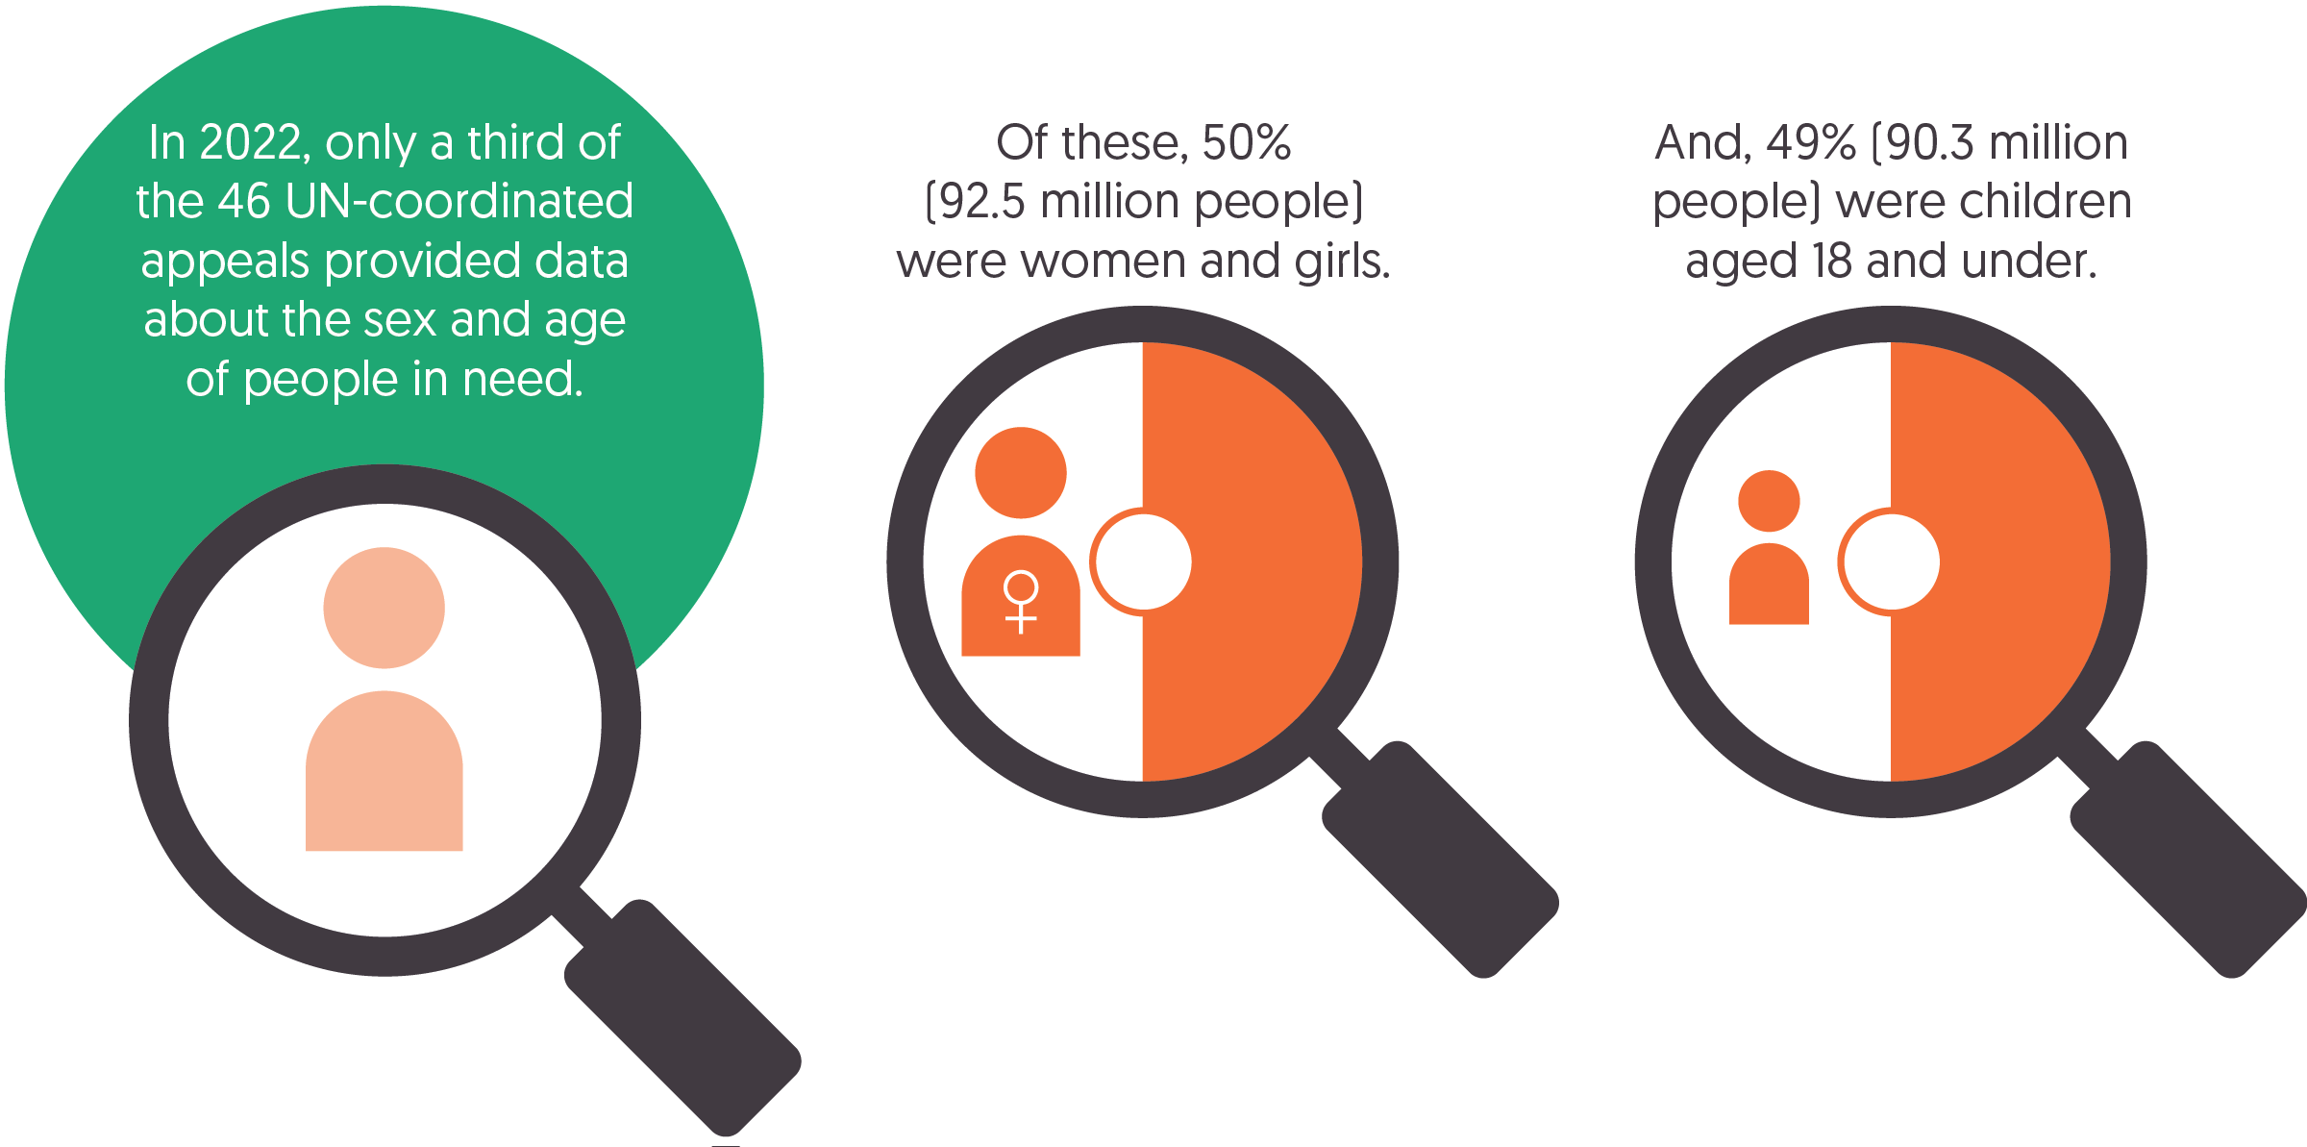

Source: Development Initiatives based on Office for the Coordination of Humanitarian Affairs (OCHA)’s Humanitarian Action data portal.  
Notes: Figures are for the 18 humanitarian response plans and other appeals in 2022 with people-in-need data disaggregated by sex and age. This represents 55% out of all people in need covered by UN-coordinated appeals in 2022. The female/male split by age categories is an estimate based on the overall figure of people in need for the humanitarian response plans in Afghanistan, Sudan, Syria and Ukraine. Figures for Ukraine are before the Russian invasion in February 2022. For the humanitarian response plans in Ethiopia, Democratic Republic of the Congo and South Sudan, and for the Lebanon Emergency Response Plan 2022 and Pakistan Floods Response Plan 2022, figures are estimated based on the food security cluster people in need.

Despite increasing efforts over the past decade[28] to disaggregate data on people with humanitarian needs and provide greater clarity on the demographic profiles of populations in crisis settings, in 2022 only a third of UN-coordinated appeals provided information on the proportions of women and children per crisis context. A recent review of sex- and age-disaggregated data in the humanitarian sector found that these gaps were due to a lack of accountability for existing standards, a lack of gender-specific expertise and capacity in crisis contexts, and increasing data collection at the project level that is not being communicated to the cluster or wider system level.[29]

* Only 18 out of 46 UN-coordinated appeals[30] contained disaggregated data on people in need by sex (female/ male split), whereas 17 appeals contained data disaggregated by age (children under 18; adults from 18–59; elderly over 60).
* In 2022, data was available for over half of all people in need under UN-coordinated appeals, close to 186.6 million people.

According to data available from these appeals, there is a relatively even split between men and women in their exposure to humanitarian crisis (though with differences between countries). In general, children under the age of 18 are particularly affected by humanitarian crises compared to adults and the elderly.

* Females (women and girls) and males (men and boys) are equally affected by humanitarian crises, each accounting for 50% of people in need. This split is marginally different when just considering adults, with a slightly higher proportion of women affected by crisis (53%) than men (47%).
* Half of all people in humanitarian need are children under the age of 18 (49%, or 90.3 million). In contrast, 30% of the global population is estimated under the age of 18 in 2022.[31]
* Women and children make up 76% of people in humanitarian need.

Country-specific breakdowns provide a compelling case for improving the sex and age data disaggregation of people in need, as they enable insights into demographic profiles, specific needs and priorities for in-country responses.

* Among the largest appeals with more than 10 million people in need, the proportions of the total population affected by humanitarian crisis are relatively consistent, with Afghanistan differing from the general trend with just 29% of those affected being children. This is notable as the proportion of people under 18 in Afghanistan was estimated at half the country population (50%) in 2022.[32]
* Among other appeals, the Kenya Drought Flash Appeal 2022 had the highest share of female (61%) and children (69%) people in need covered by any appeal. This was due to a greater share of girls and women assessed to be in need in the drought-affected areas of the appeal, with a very low share of adult men (7.6%). This is higher than the trends across the general population in 2022, where half (51%) of people are estimated female and 45% under 18.[33]
* In contrast, the Pakistan Floods Response Plan 2022 had the lowest share of female people in need (46%) due to higher levels of boys under the age of 18 assessed to be in need.
* The Lebanon Emergency Response Plan 2022 had the lowest share of children (24%), lower than the country share of around a third (33%) of people estimated to be under the age of 18, but also due to the plan covering Lebanese and migrant adults facing increased levels of extreme poverty, food insecurity and the absence of social safety nets.

The demographic profile of Ukrainians in need has shifted following the Russian invasion in 2022.

* Prior to the invasion, 2022 data from between January and March for 2.9 million people in need pointed to a higher proportion of women being affected (54%) than men and 13% of all people in need being under the age of 18. Furthermore, 30% of people in need in Ukraine at the beginning of 2022 were over the age of 60.
* Sex- and age-disaggregated data was not available in 2022 following the invasion. However, the humanitarian response plan for 2023 in Ukraine, targeting 11.1 million people in need, showed a shift to 56% female, 27% children and 22% elderly.
* The figures under the refugee response plan for displaced Ukrainians in 2023 vary to those in-country, with a higher proportion of children (38% of people in need) and a lower proportion of elderly persons (9.0%). Close to two-thirds of those in need are female. These proportions are higher in comparison to general demographic trends estimated for 2022, with 59% of Ukrainians being female and 18% under the age of 18.[34]

Read more on the [quality and quantity of funding to women’s rights and women-led organisations](https://devinit.org/resources/how-humanitarian-system-can-better-fund-women-led-womens-rights-organisations/) in this report by IRC with support from DI.

## Where is humanitarian assistance targeted? Recipients and donor priorities

Figure 2.4: Ukraine was the largest recipient of humanitarian assistance in 2022  
10 largest recipient countries of international humanitarian assistance

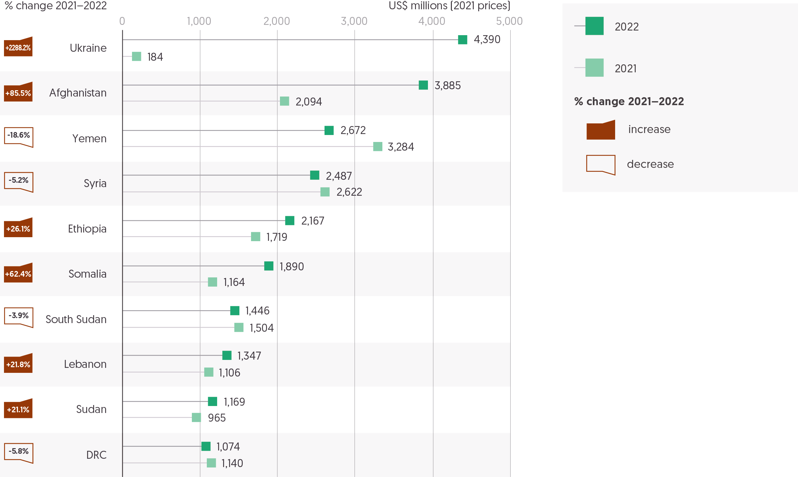

Source: Development Initiatives based on UN Office for the Coordination of Humanitarian Affairs (OCHA) Financial Tracking Service (FTS).

Notes: DRC = Democratic Republic of Congo. Data is in constant 2021 prices. Totals for previous years differ from those reported in previous GHA reports due to deflation and updated data.

Despite there being 46 UN-coordinated humanitarian responses in 2022, 10 crises received nearly two-thirds of all international humanitarian assistance. The share of total funding (funding channelled inside and outside of UN appeals) (see Figure 1.4 in Chapter 1) received by the 10 largest recipients in each year has varied little over the past decade. Over this period, however, the number of humanitarian crises has increased, suggesting a greater concentration of total funding among the largest recipients. A large majority of funding goes to countries experiencing protracted crisis.

* In 2022, the top 10 recipients of humanitarian assistance received 63% of the total country-allocable funding, an increase from 2021 (60%). Over the past 10 years the average has been 64%, with the proportion accounted for by the 10 largest recipients varying relatively little each year, from a high of 70% in 2018 to a low of 58% in 2020.
* Out of a total US$140.2 billion country-allocable international humanitarian assistance received across 2018–2022, 10 countries received 63%, while five accounted for 43%.
* 13 countries have featured in the top 10 recipients of international humanitarian assistance between 2018–2022. Seven countries – South Sudan, Somalia, Syria, Lebanon, Ethiopia, Yemen, and DRC – have consistently appeared during this timeframe.
* In total, 158 countries received international humanitarian assistance in 2022, with 134 receiving over US$1 million and 102 receiving more than US$5 million. This is a slight increase from 2021, when 155 countries received international humanitarian assistance, 112 over US$1 million and 91 over US$5 million.
* Protracted crisis countries received 92% of all funding (US$32.8 billion) in 2022, an increase on 2021 when protracted crisis countries received 88% (US$24.8 billion).

International solidarity for humanitarian needs in Ukraine following the Russian invasion significantly altered the profile of the top 10 countries receiving the most international humanitarian assistance. Ukraine moved from the position of 31st largest recipient in 2021 to the largest recipient in 2022.

* Ukraine received US$4.4 billion of international humanitarian assistance in 2022. This far exceeds amounts that previous largest recipients have received; for example, in 2021 Yemen received US$3.3 billion.
* Afghanistan was the second largest recipient in 2022, receiving US$3.9 billion, an increase of 85.5% from 2021 (US$2.1 billion), and almost five times the funding received in 2020 (US$780 million).
* Funding dropped for both Yemen and Syria, the two largest recipients in 2021. Yemen received US$2.7 billion in 2022, down 19% from 2021 (US$3.3 billion). Syria received US$2.5 billion in 2022, a reduction of 5.2% from 2021 (US$2.6 billion), following a 15% reduction from 2020.

Figure 2.5: The share of funding provided by donors often varies between crises  
Share of funding provided by the top five donors to the largest three crises (by US$), 2022

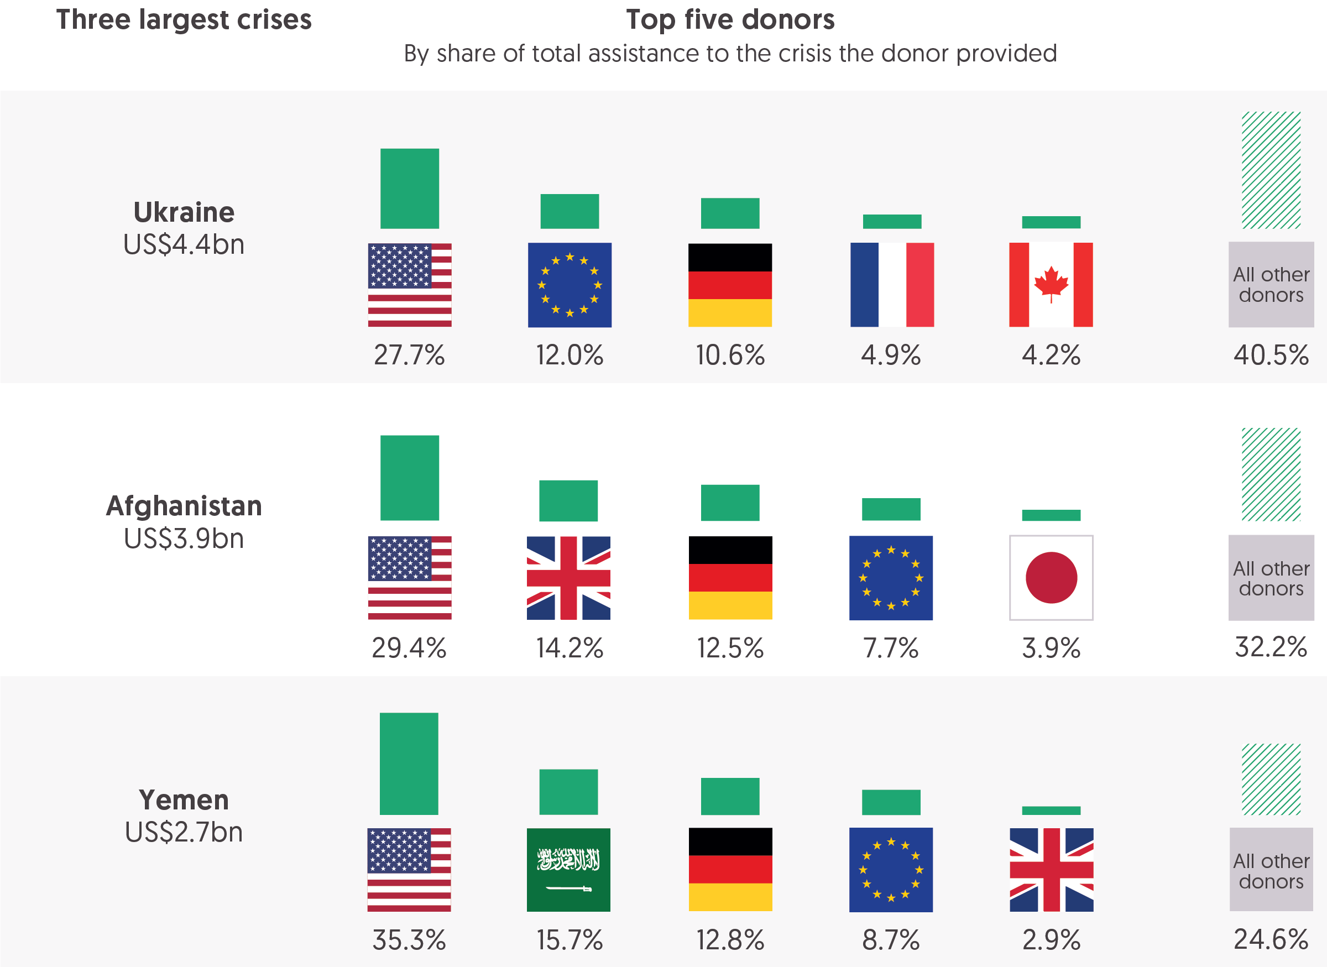

Source: Development Initiatives based on UN Office for the Coordination of Humanitarian Affairs (OCHA) Financial Tracking Service (FTS) data.

Notes: Figure shows country-allocable international humanitarian assistance from top donor governments and EU institutions only (it excludes funding to global, blank and to multi-destination countries). Data is in constant 2021 prices.

Donors are faced with a complex set of choices in how and where to allocate budgets across an ever-growing set of needs (see Figures 1.2 and 1.4 in Chapter 1 and Figure 2.1 in this chapter). This is in addition to the question of how much humanitarian assistance each can afford to provide (see Figure 1.6 in Chapter 1). Part of this decision-making relates to initial choices about targeting funding to specific countries experiencing crisis directly or whether to provide flexible funding at the global or regional level. In this regard, in 2022 there was significant variation between the largest donors in the share of their total assistance allocated at the country and the global or regional levels.

* The US, EU institutions and UK allocated almost all assistance to specific country contexts with 6% or less provided at the global or regional level (4.4%, 1.4% and 6.3%, respectively).
* This is in marked contrast to other donors: Japan allocated more than half its assistance to the global or regional level (55%), Sweden more than a third (37%) and Norway more than a fifth (23%). Slightly lower – but still comparatively large – shares were provided by Germany (17%) and Canada (11%).

Ongoing discussions around the need for more quality funding, including within the Grand Bargain, focus on the importance of a significant share of funding being provided softly-earmarked or unearmarked.[35] Analysis in previous [Global Humanitarian Assistance reports](https://devinit.org/resources/global-humanitarian-assistance-report-2022/recipients-and-delivery-of-humanitarian-funding/#section-4-6) indicates that this flexible funding, to UN agencies at least, has been reducing in recent years. Between 2016 and 2021, UN agencies have reported that the proportion of the total funding they received unearmarked reduced from 19% to 13%. Limited transparency of how softly earmarked or unearmarked funding is spent means it is difficult to identify where and how this funding supports responses to particular crises or needs.

### What are the patterns of funding by volume of the largest donors?

Looking more closely at humanitarian assistance that is allocated to specific countries can provide some indication of how donors are prioritising this earmarked funding and how choices between donors vary. Using publicly available information it is unfortunately not possible to determine how well these funding decisions were coordinated between donors. However, analysis of the published data that is available on donor funding to individual countries can help to contribute to a better understanding of where donors decide to allocate limited resources in the context of a system that is globally underfunded. By volume of funding to these countries, the US, Germany and EU institutions consistently provide the most international humanitarian assistance, as they do globally, though there are a few cases where other donors provide notably large volumes to individual crises.

* In 2022, the US provided the largest volume of assistance to all of the 10 largest humanitarian crises.
* The second and third largest donors of country-allocable international humanitarian assistance, Germany and EU institutions, were also consistently among the five largest donors by volume to these ten crises in 2022.
* There are however a few notable examples of individual donors giving significantly more to individual crises than might be expected given the overall volume of country-allocable assistance they provide globally. The UK was the second largest donor of international humanitarian assistance to Afghanistan in 2022, but the fourth largest globally. Saudi Arabia was the second largest donor to Yemen, while being the eighth largest globally. The United Arab Emirates (UAE) made the third largest contribution to Ethiopia but in 2022 was the eleventh largest donor globally.

### What share of donors’ total country-allocable funding do they give to individual crises?

The findings below reflect donor funding behaviour to the six countries that received the most humanitarian assistance in 2022: Ukraine, Afghanistan, Somalia, Yemen, Syria and Ethiopia. Analysing the share of their total country-allocable assistance[36] donors provided to individual crises gives an indication of the extent to which those contexts were prioritised. This funding behaviour should be considered in the context of how well needs were met in a given context. Response plans in the Ukraine, Afghanistan and Somalia were comparatively well funded (74% or more of requirements), while response plans in Yemen, Syria and Ethiopia only had around half of their requirements met in 2022. There is significant variation between donors in the proportion of their total country-allocable assistance that they provide to these individual crises.

* The US stands out as being particularly consistent in the proportion of its global total of country-allocable assistance that it provided to the largest crises in 2022, providing around 8% to Ukraine (8.3%), Afghanistan (7.8%), Ethiopia (8.2%) and Somalia (7.6%), and 6.4% to Yemen and 6.7% to Syria.
* Greater variance is evident in the proportion of the total country-allocable assistance provided by Germany and EU institutions, the next largest donors in 2022. Germany provided 15% to Syria and just 3.4% to Somalia. EU institutions provided 13% to Ukraine and below 4% to both Ethiopia (3.7%) and Somalia (3.8%).
* There are even more stark differences in 2022 allocations by other countries. The UK provided 42% of all its country-allocable assistance to Afghanistan; France allocated 31% and Canada allocated 20% to Ukraine. Saudi Arabia provided 68% of its country-allocable assistance to Yemen and the UAE allocated 36% to Ethiopia.

### How do donor contributions to a crisis compare to their overall share of global funding?

* Some sense of the prioritisation of funding to individual crises by donors, in comparison to other leading donors, is given by the variance between the proportion of total assistance that donors provide globally and the share they make up of the total to individual crises. The more prominent examples noted above in relation to the share of donor totals provided to particular crises continue to stand out from this perspective. It also shows where donors may, relative to one another, be carrying a greater or lesser financial burden. While the data on country-allocable assistance includes funding channelled inside and outside of UN-coordinated appeals, with the majority of funding allocated against UN appeal requirements, the scale of appeal requirements and the extent of coverage provides some context for the allocation decisions made by donors.
* In 2022, the Ukraine Flash Appeal had requirements of US$4.3 billion, with funding covering 88% of those needs. Looking at the largest donors to Ukraine in 2022 demonstrates the relative prioritisation between donors. 28% of total funding to Ukraine was from the US – considerably below the 41% of global funding accounted for by the US. Relatively, other donors are contributing more. 4.9% of total assistance to Ukraine was from France; this is more than double the 2.0% France accounts for globally. Excluding the five with the largest contributions, all other donors made up 41% of funding to Ukraine – this is compared with an average of 25% that donors outside of top five for each crisis made up globally in 2022. This demonstrates that the financial responsibility for donors of the Ukraine crisis is shared more widely than for other crises.
* UN appeal requirements for Afghanistan were US$4.4 billion, with coverage of 74% of those needs in 2022. As in Ukraine, the US accounted for a smaller share of total funding, 29% compared to its global share of 41%. Conversely the UK made up 14% of all funding to Afghanistan, more than three times its 3.7% share of global assistance. It’s notable that as the fourth largest donor globally, the UK does not appear among the top five donors to Ukraine, Syria or Ethiopia.
* Yemen had similarly high UN appeal requirements to Ukraine and Afghanistan for 2022, at US$4.3 billion, though the level of coverage was notably lower at 54%. While, at 35%, funding from the US was below its global average, the very high share of contributions from Saudi Arabia to Yemen at 16% stands out relative to its share of global country-allocable assistance at 1.7%.
* In Syria, with UN appeal requirements of US$4.4 billion and coverage of just 49%, Germany’s contributions were high relative to its share of global assistance, accounting for 27% of total assistance to Syria in 2022 compared to its global share of 13%. Norway also provided a higher share, 2.7%, compared to its 1.2% global contribution.
* In Ethiopia, with UN appeal requirements of US$3.3 billion and 50% coverage, and Somalia with requirements of US$2.3 billion but higher coverage of 86%, the high share of funding accounted for by the US, above its average to all countries, is most obvious. In Ethiopia, US funding made up 55% of all contributions, while in Somalia the share was even greater at 59%. Also of note is the high share accounted for by the UAE to Ethiopia, 6.9% of the country-allocation compared to a global share of just 1.2%.

Insight: Michael Köhler

*Since August 2019, Dr Köhler has been Deputy Director-General for European Civil Protection and Humanitarian Aid Operations in the European Commission’s DG ECHO where he coordinates the worldwide EU humanitarian aid activities. From April 2022 to February 2023 (inclusive), he also served as Acting Director-General at DG ECHO.*

Humanitarian needs are at an all-time high and continue rising. Meanwhile, the gap between humanitarian needs and available resources globally continues to expand. We must step up efforts to decrease the needs and increase the efficiency and effectiveness of humanitarian action. In parallel, however, we will also have to increase the resources available to meet the surging humanitarian needs.

One key challenge is the patterns of funding: a very small number of major donors account for the bulk of global humanitarian funding, and the increase in volume of funding provided remains too timid from one year to the other, despite a significant increase of needs since 2020 (largely due to the Covid-19 pandemic) and in 2022 due to the Russian war against Ukraine. As a consequence, global humanitarian funding continues to rely heavily on a very limited number of donors: the 10 largest humanitarian donors provide more than 80% of all funding, far more than their collective share in global wealth. 66% of recorded humanitarian funding stems from the US, the EU (Directorate-General for European Civil Protection and Humanitarian Aid Operations) and Germany alone.

Increasing humanitarian funding in times of economic instability, caused not least by the knock-on effects of Russia’s war against Ukraine, is not easy – even for those who so far have not contributed to a degree commensurate with their economic stature. But failing to help people in desperate need is not really a viable option. Humanitarian aid is first and foremost a moral imperative. This is why we provide it and will continue to do so. But humanitarian aid is more than just an emergency-based paradigm.

There is a need to think “outside the box” of considering humanitarian aid as solely philanthropically motivated and move towards discussing the benefit of humanitarian aid as an investment in resilience and stability for a global common good. When we talk about humanitarian assistance, we should not shy away from enriching the discourse with elements such as anticipatory action, resilience, migration, stability, peace and security as well as climate aspects. At the same time, we need to continue supporting every effort to further improve transparency and auditing of how humanitarian aid is spent, upholding accountability to both beneficiaries and taxpayers and illustrating efficiency gains made by humanitarian actors in exchange for increased funding.

If we want to reach beyond the “usual suspects”, we need to adapt our narrative accordingly. And we should be open to be inspired and to learn from each other. Take the example of Spain: earlier this year, Spain passed a law that foresees that by 2030 Spanish cooperation actors as a whole will collectively allocate at least 10% of Spanish official development assistance (ODA) resources to humanitarian action. The law has been the result of broad public participation, political consensus, willingness to reform and an understanding of humanitarian action as an intrinsic part of foreign policy. Establishing a concrete funding target is not only a clear political statement, but it also helps to build peer pressure and make contributions more comparable. Likewise, it can help to depoliticise humanitarian action, while giving humanitarian aid levels more visibility, creating incentives and allowing to pay tribute to performing donors.

The EU and its Member States remain committed to secure additional humanitarian funding in order to ensure a more sustainable and balanced sharing of humanitarian financing, both within the EU and beyond. It is necessary and beneficial to broaden the donor base and, in particular, to bring more emerging and new donor states on board.

## How did displacement and food security relate to crisis in 2022?

### How many people were forcibly displaced in 2022?

Figure 2.6: The numbers of forcibly displaced people across the globe increased by almost 20% between 2021 and 2022, to more than 100 million people  
20 countries with the largest forcibly displaced populations, 2021–2022

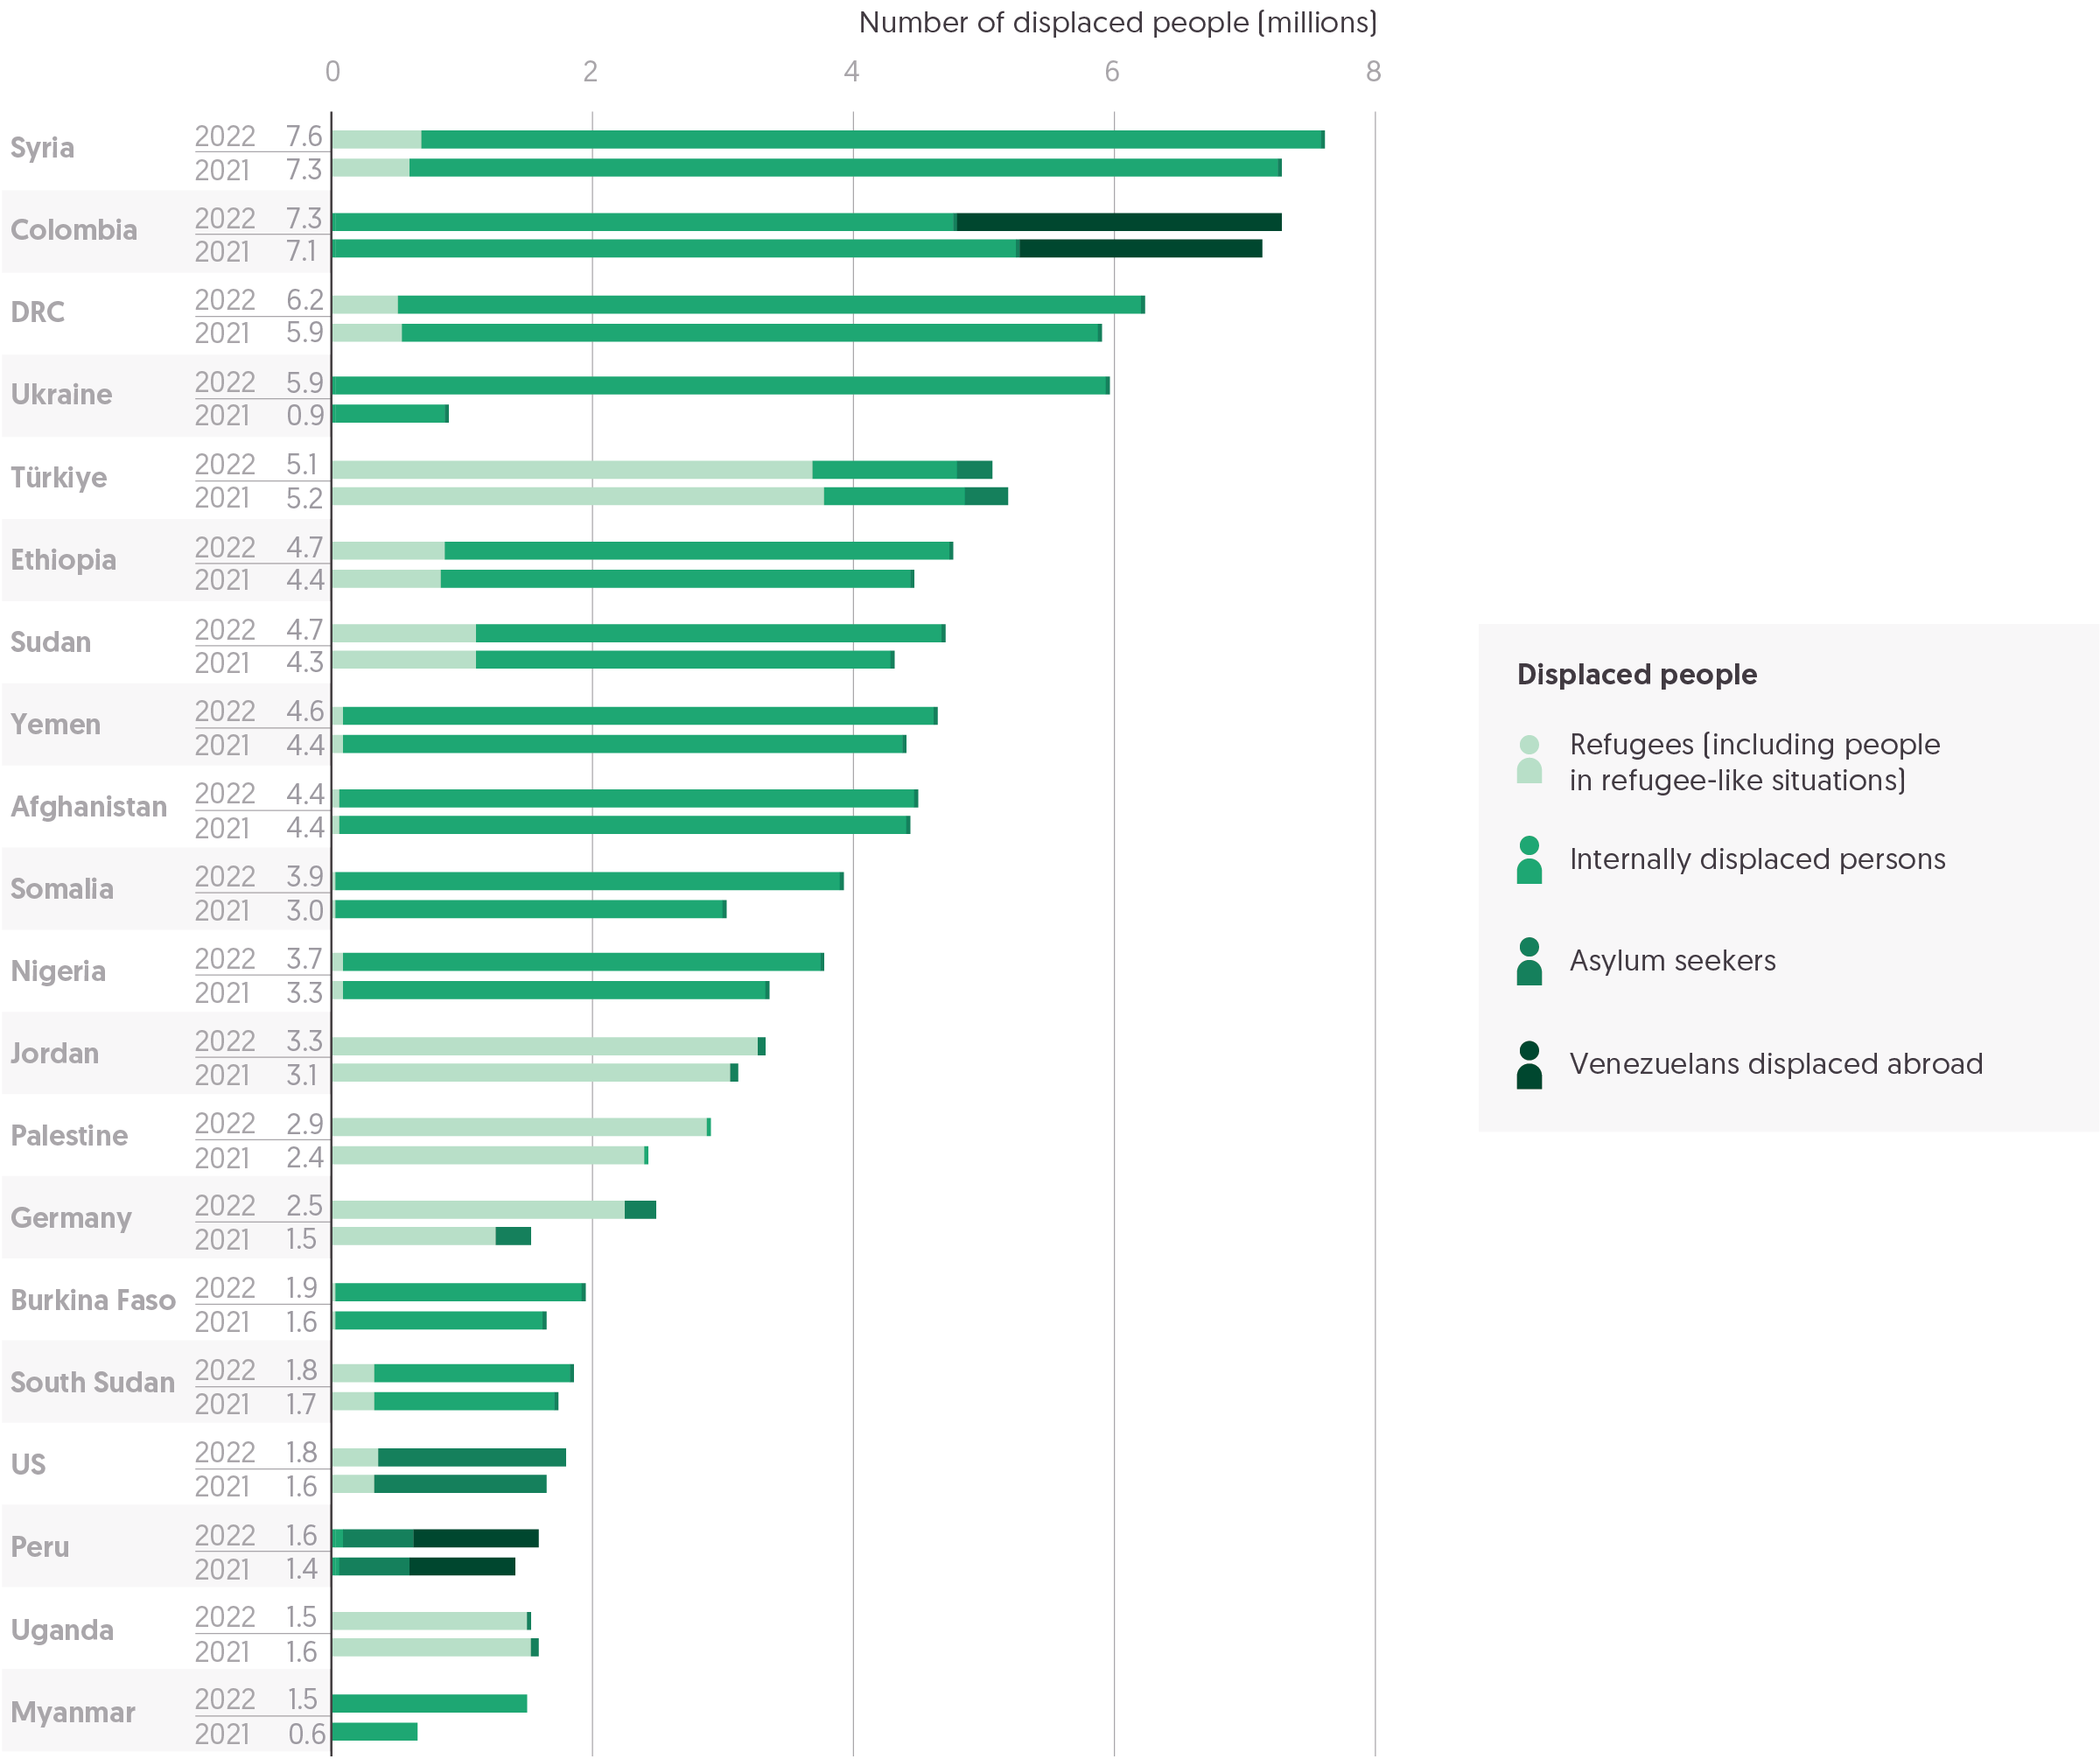

Source: Development Initiatives based on United Nations High Commissioner for Refugees (UNHCR), UN Relief Works Agency for Palestine Refugees in the Near East (UNRWA), Index For Risk Management (INFORM) and Internal Displacement Monitoring Centre (IDMC) data.

Notes: DRC = Democratic Republic of the Congo. The 20 countries are selected based on the size of displaced populations that were hosted in 2022. 'Displaced population' includes refugees and people in refugee-like situations, internally displaced persons (IDPs), asylum seekers and other displaced populations of concern to UNHCR. Other displaced populations of concern to UNHCR includes Venezuelans displaced abroad. IDP figures refer to those forcibly displaced by conflict and exclude those internally displaced due to climate or natural disaster. Data is organised according to UNHCR's definitions of country/territory of asylum. According to data provided by UNRWA, registered Palestine refugees are included as refugees for Jordan, Lebanon, Syria and Palestine. UNHCR data represents 2022 mid-year figures, and UNRWA data for 2022 is based on internal estimates.

The total numbers of people forcibly displaced internally and across borders have been consistently on the rise over the past decade.[37] However, 2022 marked an even sharper rise in global displacement numbers, doubling the annual increases observed between 2019 and 2021. This rise comes in conjunction with the increased demand for funding in countries experiencing crises, with 100 million more people in need of humanitarian assistance in 2022 (see Figure 1.1, in Chapter 1), and with increased in-country spending for refugee hosting (see ‘Was humanitarian funding sufficient? Appeals, donors and total assistance’, Chapter 1). The overall rise in the number of displaced persons was primarily driven by the invasion of Ukraine, as well as increases in internal displacement in Somalia and Myanmar.

* In 2022, the total number of displaced people increased to 107.5 million, an increase of 18.5% (16.5 million people) compared to 2021. Annual increases between 2019–2020 and 2020–2021 were significantly lower, at 3.7% and 8.4%, respectively.
* 59% of this total were people forcibly displaced within their countries of residence (internally displaced persons, or IDPs) due to conflict and violence: a total of 62.5 million people. The total number of IDPs increased by 9.2 million in 2022, a 17.3% rise – significantly higher than the 10.7% annual increase from 2020–2021.
* Refugees accounted for 31% (33.1 million people) of the displaced population in 2022, an increase of 22.2%, following a 1.8% decrease in 2020–2021.
* Asylum seekers represented 4.7% of all displaced people in 2022, an increase of 7.8% (following a significant decrease of 21% in 2020–2021).
* Venezuelans displaced abroad accounted for 5.0% of global displacement numbers, a sharp rise of 21% (0.9 million people) in comparison to the previous year (2.1%).

This significant rise in forcibly displaced people was driven directly by the invasion of Ukraine, and by its indirect knock-on effect on global food insecurity. According to the Internal Displacement Monitoring Centre (IDMC), three-quarters of the countries experiencing food security crises had internally displaced populations (see previous section).[38] Needs were further compounded by the ongoing economic and social consequences of the global Covid-19 pandemic. Displacement increased across a range of ongoing protracted conflict settings and also due to record levels of flooding and drought.[39] Large increases in four countries drove the overall rise.

* The largest increase in forced displacement occurred in and from Ukraine – 5.1 million people were internally displaced in 2022, a near sevenfold (589%) increase from 2021. A further 5.4 million people were displaced across borders from Ukraine in 2022.
* Germany became host to 1.0 million displaced people in 2022, an increase of 39% on the previous year. Of this increase, 875,000 people came from Ukraine, 42,000 from Syria and 24,000 from Afghanistan.
* Internal displacement increased significantly within Myanmar (by 57%, or 0.8 million people) and in Somalia (by 11%, or 0.9 million people).
* Increases across the remaining 20 countries with the highest numbers of displaced people ranged from 0.1 to 0.5 million, with the exception of Uganda and Türkiye, which saw decreases of 38,016 and 96,901 people, respectively.

Accelerating climate impacts, including shocks and slow-onset pressures are increasingly recognised as driving and contributing to humanitarian needs, including internal and cross-border displacement (see Figure 1.2 in Chapter 1 and Chapter 4).

* At least 8.7 million people were estimated to be internally displaced due to disasters at the end of 2022, a 45% increase on the previous year, with 32.6 million people temporarily displaced by disasters over the course of the year.[40]

Unsurprisingly, the countries with the highest levels of humanitarian needs (see Figure 1.2 in Chapter 1 and Figure 2.1 in this chapter) are also prominent countries of origin of displaced people. In parallel, a handful of countries continue to host the majority of forcibly displaced people, and these same countries face the highest amounts of humanitarian needs and financial requirements. Forcibly displaced people continue to face protracted displacement with limited access to durable solutions, while multiple waves of crises compound existing challenges and needs.

* Almost half (44%) of all displaced people lived in just 10 countries, 7 of which are low-income countries.
* Five countries each hosted more than five million forcibly displaced people (both refugees and IDPs) in 2022. In four of these five countries (Ukraine, Syria, Colombia and DRC), the majority of the displaced population constituted people displaced internally. The exception was Türkiye, where the refugee population (3.7 million) was more than triple the IDP population (1.1 million).
* With limited return and long-term crises in many countries, trends in the numbers of refugees originating from individual countries vary little year-on-year. This pattern is evident in 2022, with Syria, Afghanistan, South Sudan and Myanmar all among the largest five countries of origin for refugees – as they were in 2021 – but joined by Ukraine, following the Russian invasion. Beyond Ukraine, the largest increases in refugees by country of origin came from Palestine (an additional 400,000 people), Afghanistan (+100,000), Myanmar (+32,000) and Somalia (+22,000).
* Trends among the largest populations of IDPs follow a similar pattern in 2022, again with Ukraine joining Syria, DRC and Colombia, which had the largest numbers of IDPs in 2021. Yemen overtook Afghanistan in fifth place, with an increase from 4.3 to 4.5 million IDPs. The largest increases in internal displacement occurred in Somalia (+0.9 million), Myanmar (+0.8 million), Nigeria (+0.4 million) and Sudan (+0.4 million).

Regions more affected by humanitarian crises continued to take on a larger share of the hosting responsibility, with the trend in numbers hosted by region similar in 2022 to 2021. The notable exception was in Europe and Central Asia where numbers almost doubled. Despite this rise, sub-Saharan Africa remained the region hosting the largest numbers of displaced persons, hosting 11.5 million more than Europe and North America combined.

* Sub-Saharan Africa hosted the largest number of displaced persons in 2022, with 35.7 million people (34% of the global total), an 8.8% increase on 2021. The region hosts 45% of the global total number of IDPs and 22% of the world’s refugees.
* The number of displaced people in the Middle East and North Africa grew by 1.3 million, to account for 22% of the global figure. This is the second largest regional displaced population, of which 9.9 million were refugees and 12.7 million were IDPs.
* With the invasion of Ukraine, the numbers of refugees and IDPs in Europe and Central Asia nearly doubled in 2022, from 11.4 to 22.2 million people. This amounted to 21% of global displaced persons, with 12.5 million refugees hosted across Europe. Germany was the only country in Europe and Central Asia to feature in the top 20 hosting countries, with 2.2 million refugees in 2022.
* North America hosted only 1.8% of the global displaced population in 2022, at 1.9 million people. This number is largely made up of asylum seekers (1.5 million people), with only 0.4 million refugees in the region who have actually been granted asylum.
* East Asia and the Pacific hosts 2.2% of the global displaced population. The total numbers of displaced people in the region rose by one-third due to the ongoing crisis in Myanmar.
* In other regions, the numbers of displaced populations remained largely static between 2021 and 2022.

### What were the trends in the severity of and funding for food insecurity in 2022/23?

Rising levels of global food insecurity, which is an increasing driver of humanitarian crises, are contributing to and exacerbated by intersecting dimensions of risk, such as high-intensity conflict, socioeconomic fragility and vulnerability to climate change impacts. Almost half (48%, 197.2 million) of all people in need in 2022 were living in countries facing this combination (see Chapter 1). These intersecting dimensions are contributing to, and exacerbated by, rising levels of global food insecurity, which is an increasing driver of humanitarian crises. In certain contexts, like South Sudan, a severely constrained humanitarian response further enables consistently severe food security.

Figure 2.7: Countries with the largest populations facing food insecurity may not be experiencing the most severe food security  
Top 15 countries experiencing food insecurity by population size and food insecurity gap, 2022/23

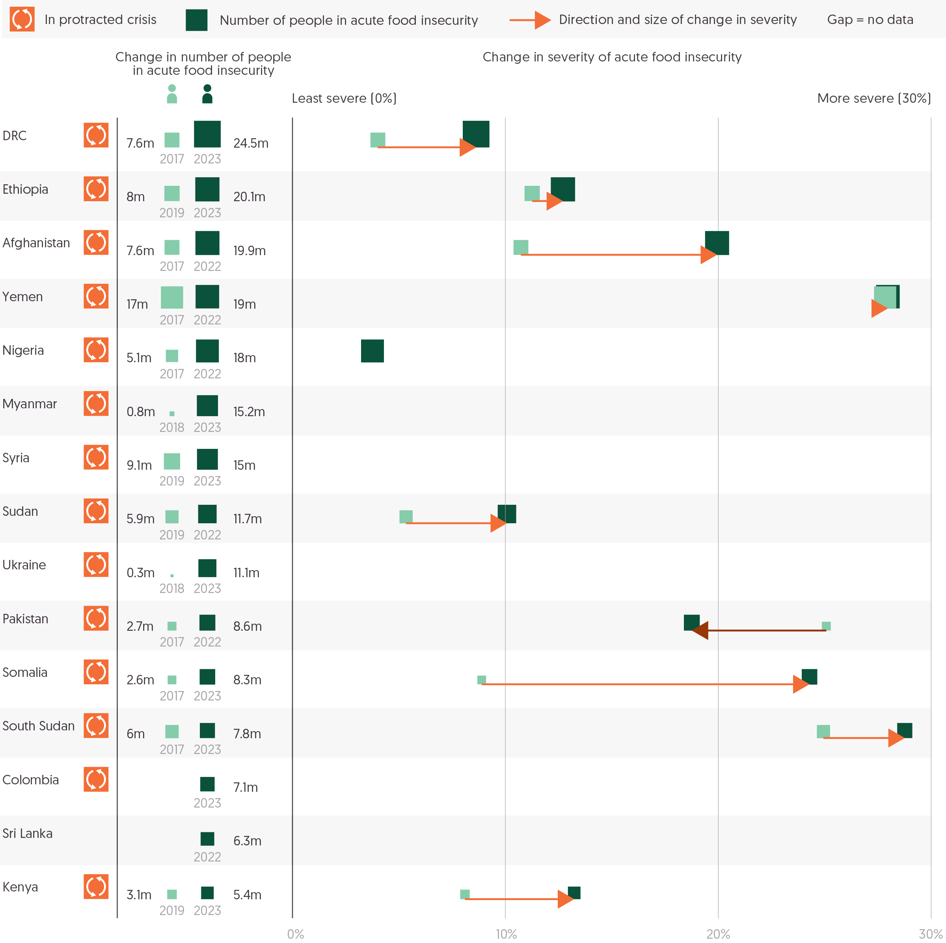

Source: Development Initiatives based on Integrated Food Security Phase Classification (IPC)/Cadre Harmonisé (CH), and UN Office for the Coordination of Humanitarian Affairs (OCHA) Humanitarian Programming Cycle (HPC).

Notes: Acute food insecurity numbers and phases as reported/projected by the year's closest IPC survey. People living in 'crisis' (i.e. Phase 3) or higher food insecurity are shown. The food insecurity gap change is calculated based on an adapted Foster-Greer-Thorbecke (FGT; α=1) index, which weights higher phases of food insecurity.

In 2022, the number of people experiencing severe food insecurity continued to grow, driven by a food crisis in the Horn of Africa and the Ukraine crisis.

* In 2022/23,[41] an estimated 265.7 million people were facing crisis-level acute food insecurity[42] across 60 countries. This is an 8.0% increase (from 246.1 million people) from 2021/22 and over double the number of people facing severe food insecurity (115.2 million people) before the Covid-19 pandemic.
* Large numbers of people experiencing food insecurity were concentrated in just a few countries. The countries with the five largest populations facing food insecurity (DRC, Ethiopia, Afghanistan, Yemen and Nigeria), represented almost two-fifths (38%, 101.5 million people) of the people facing food insecurity in 2022/23.
* DRC (24.5 million people) and Ethiopia (20.1 million people) had the largest populations facing food insecurity.
* The biggest growth in the populations facing food insecurity happened in DRC (+16.9 million people) and Myanmar (+14.4 million people) between the years before the Covid-19 pandemic and 2022/23. In the years before the Covid-19 pandemic, Ukraine had only 300,000 people facing food insecurity. In 2022/23, Ukraine had 11.1 million people facing food insecurity.

Read about the [role of local and national actors in the response to the current hunger crisis in South Sudan](https://devinit.org/resources/food-insecurity-south-sudan-funding-local-actors/) in this report commissioned by the Catholic Agency for Overseas Development (CAFOD).

Insight: The Organisation for Children Harmony (TOCH)

*TOCH is a South Sudanese national NGO, established in 2008. TOCH implements a diverse portfolio of programmes covering emergency responses to social development issues with a particular focus on internally displaced persons (IDPs) and returnees, child protection, women’s empowerment and addressing underlying causes of poverty across their programmes.*

In 2022, South Sudan faced its fourth consecutive year of unprecedented flooding and, going into 2023, an estimated 7.7 million people are likely to face severe acute food insecurity – IPC Phase 3 or above – during the April-July lean season. Climate change continues to worsen agricultural productivity and even community infrastructures like schools and health centres are frequently submerged in water. The current crisis in Sudan has already started to see an influx of refugees and returnees to various states in South Sudan, which can only exacerbate the food crisis. Additionally, South Sudan is heavily dependent on imported food supplies, and crises in Ukraine and now Sudan continue to inflate the market and threaten whatever coping strategies families already have.

TOCH, in partnership with the Catholic Agency for Overseas Development (CAFOD) and Trocaire, has been responding to the food crisis in Gogrial West and East in Warrap State with funding from Caritas Norway and Secours Catholique. Through this support, TOCH was able to tackle food insecurity through distribution of ox ploughs, local seeds and vegetable seeds. 18 agricultural extension workers provided technical skills to local farmers to increase productivity and adapt to climatic changes in the environment. Through this project, they have seen an increase in productivity among local farmers. Cash assistance also accompanied the programme, supporting families through the lean season.

Local and national organisations like TOCH are on the frontlines of responding to the food crisis in South Sudan. Having worked with these communities for years, they understand the context, the needs and have good relationships to be able to deliver high quality response, including in locations where international NGOs are unable or unwilling to access. Yet, the funding landscape for local and national NGOs (L/NNGOs) in South Sudan is challenging. Funding towards food insecurity has seen little change in the last three years, while needs continue to grow, leading to a reduction in available resources from donors. Preference still goes to funding larger international organisations perceived to have less ‘risk’, and when L/NNGOs are funded, there is reluctance to cover overhead costs, capacity strengthening and security costs, which are essential in contexts like South Sudan.

In partnership with CAFOD and Trocaire, TOCH was able to access the UN South Sudan Humanitarian Fund in 2021 for a multi-sectoral response including food security and livelihoods. The pooled fund is hugely beneficial, but many L/NNGOs still feel unable to access it directly, and last year the total percentage directed to L/NNGOs had decreased substantially. Additionally, the fund dictates which locations and sectors can be responded to, meaning the support is not dependable year-on-year even for those able to access it. More predictable multi-year and multi-sectoral funding is essential. Competing needs and requirements of various donors – including different capacity assessments, due diligence and adhering to different policies, reporting structures and timelines – adds extra pressure to L/NNGOs. These processes must be simplified, and funding for the food crisis must be increased and made more accessible for those organisations working on the ground with these communities every day.

14 of the 15 largest populations facing food insecurity are in countries experiencing protracted crisis. Food insecurity can be both a measure of population size and the severity at which a population is facing food insecurity.

The intensity of food insecurity can vary between populations, and measuring these ‘gaps’ in food security can both help to create a more complete picture of vulnerability and foster a more complete understanding of the required interventions to help the population.[43] Greater ‘[food insecurity gaps](https://devinit.org/resources/food-insecurity-gap-protracted-humanitarian-crisis/)’,[44] represented as a percentage, signify more severe food insecurity. Most countries with populations assessed as experiencing food insecurity have national food insecurity gaps of between 5% and 20%, though the most severely affected subnational areas can register gaps as high as 50%. On average, countries experiencing protracted crisis have higher food insecurity gaps than others.

* The average food insecurity gap for countries experiencing protracted crisis is 10%, compared to an average food insecurity gap for others of 6.0%.
* The countries with the most severe food insecurity in 2022/23, as measured by the food insecurity gap, were South Sudan (food insecurity gap of 29%), Yemen (28%) and Somalia (24%). These three countries have consistently experienced some of the most severe food insecurity in the world. The populations facing food insecurity in these countries are 7.7 million people for South Sudan, 19.0 million people for Yemen and 8.2 million people for Somalia.
* In comparison, the largest populations facing food insecurity in DRC (24.5 million people) and Ethiopia (20.1 million people) had respective food insecurity gaps of 8.8% and 13%.
* Between the years before Covid-19 and 2022/23 the severity of food insecurity worsened most significantly in Somalia (from 9.1% to 25%) and Afghanistan (from 11% to 20%).

Read more from DI on the [relationship between concurrent humanitarian crises and acute food insecurity](https://devinit.org/resources/food-insecurity-gap-protracted-humanitarian-crisis/).

Figure 2.8: The US represents half of all food sector funding in the last five years, and substantially increased their funding in 2022  
Top five donors for food insecurity, 2018–2022

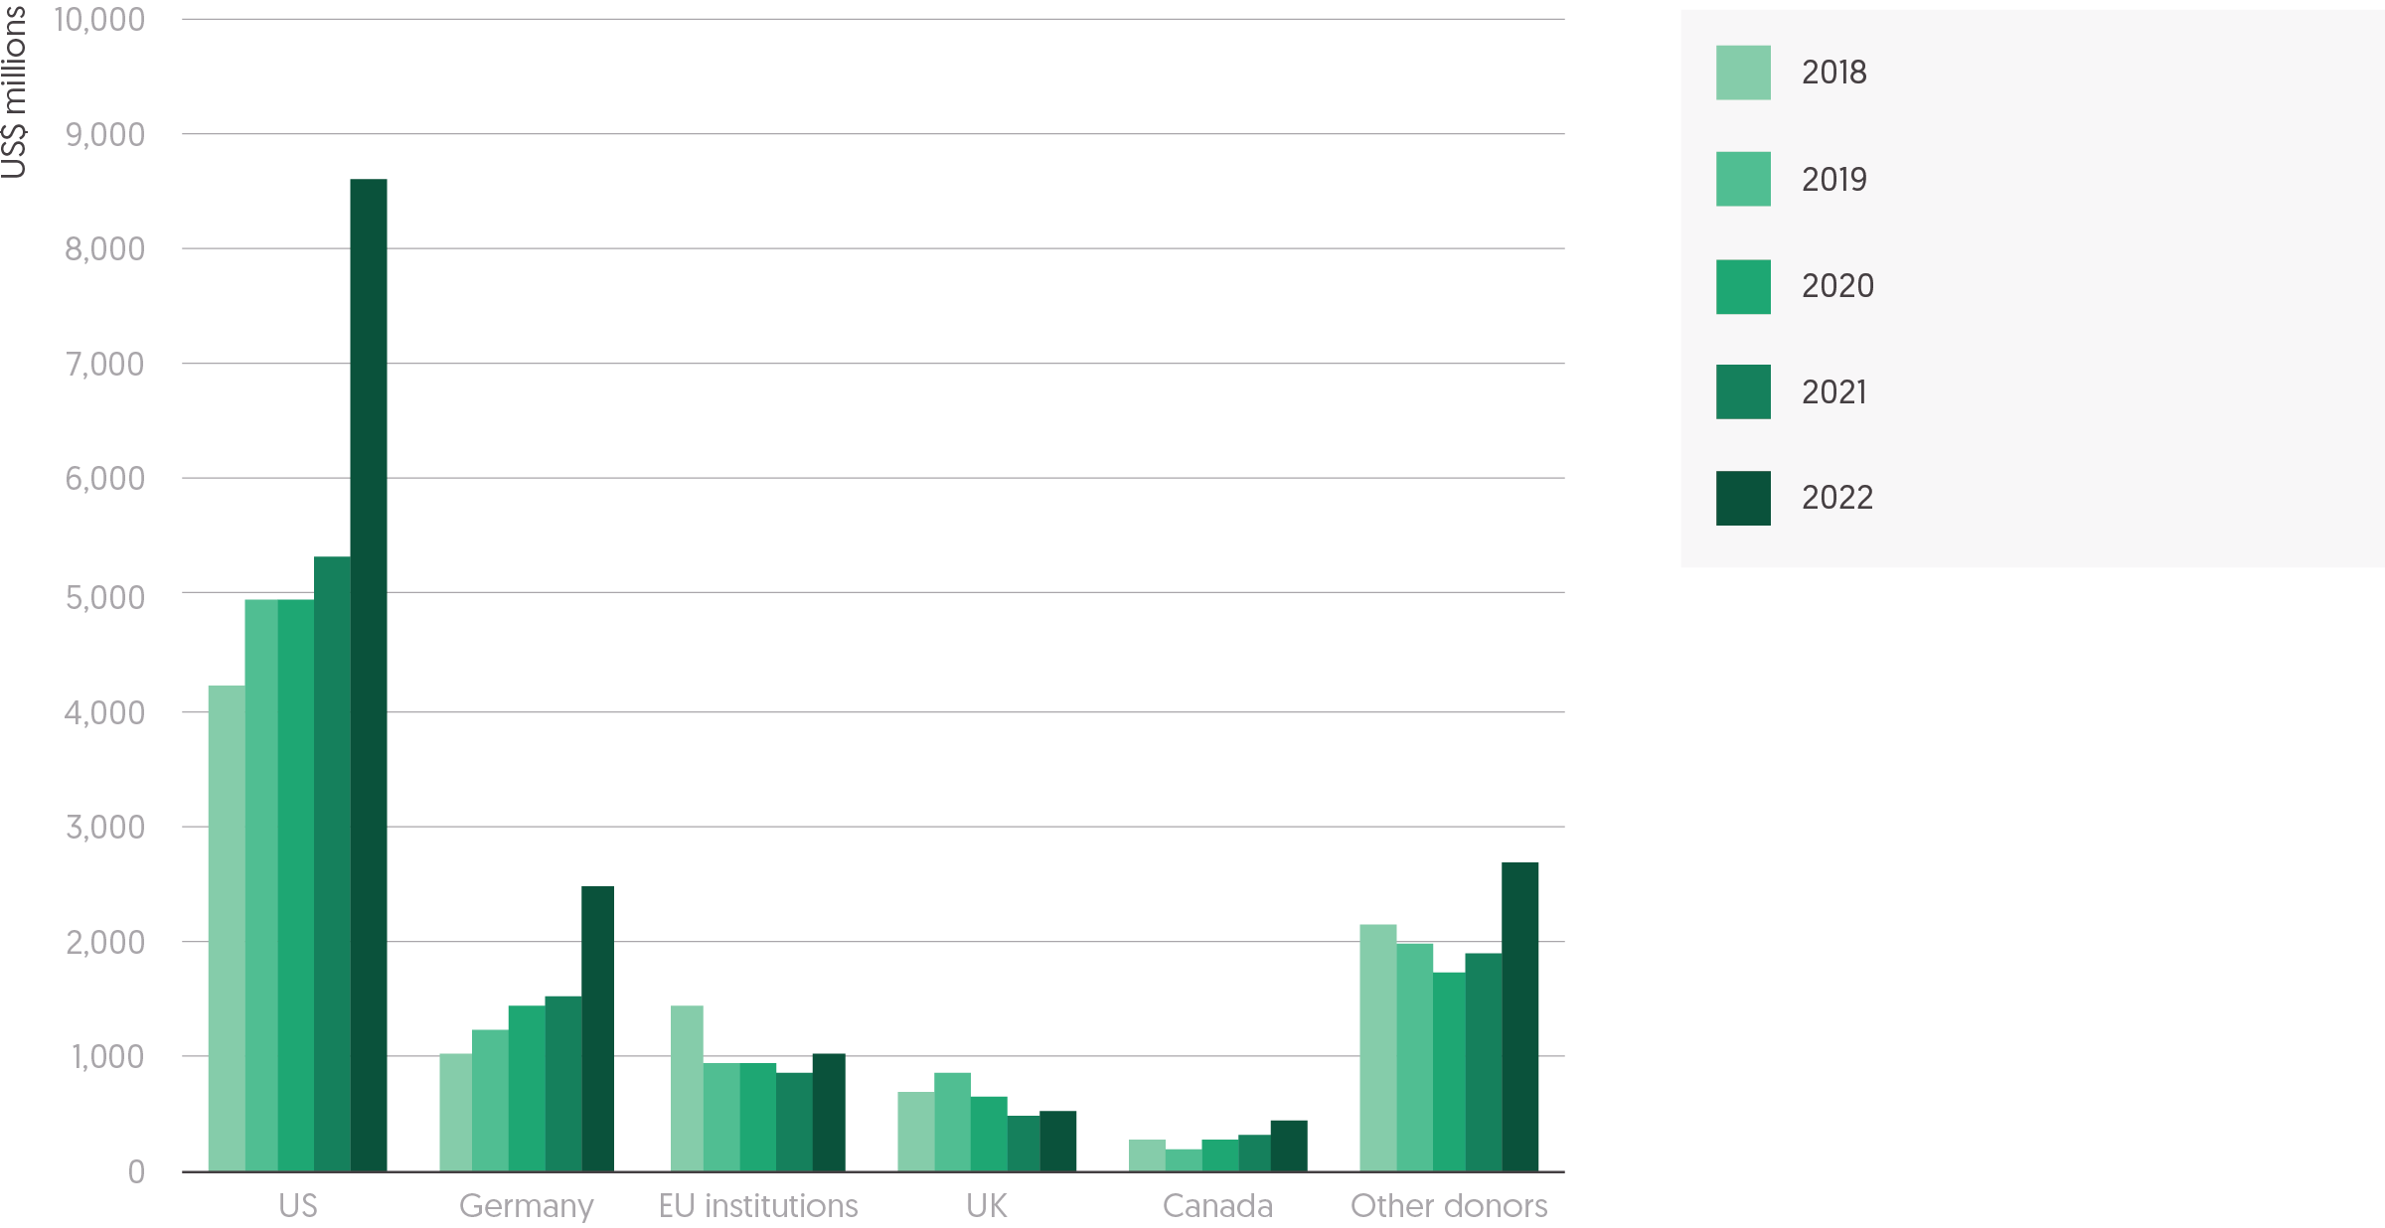

Source: Development Initiatives based on UN Office for the Coordination of Humanitarian Affairs (OCHA) Financial Tracking Service (FTS).  
Notes: Data is in constant 2021 prices.

There are a few sectors that directly address food needs, specifically food security, agriculture and nutrition. In 2022, these sectors made up two-fifths of all humanitarian funding, the largest share in the last five years. Overall funding to food sectors has risen, with increasing contributions from most of the five largest donors, with the exception of the UK. This rise is largely attributable to increased funding channelled to the crises in Ukraine and Afghanistan.

* Total funding to humanitarian food sectors (food security, nutrition and agriculture) rose sharply in 2022, reaching US$15.8 billion in funding, a 53% increase over 2021. Since 2018, the top five donors (the US, Germany, EU Institutions, the UK and Canada) have represented around 80% of all food sector humanitarian assistance.
* Between 2018 and 2022, the US has consistently been the largest donor of food sector humanitarian assistance. Since 2018, US funding has increased year-on-year in both volume and share of all food sector assistance, rising from US$4.2 billion (43%) in 2018 to US$8.3 billion (55%) in 2022.
* Germany also significantly increased the volume of its food sector humanitarian assistance in 2022, with an increase of 65% (US$1.5 billion in 2021 to US$2.5 billion in 2022).
* The UK has decreased the amount of food sector humanitarian assistance it provides since 2019, from a five-year high in 2019 of US$879 million to US$540 million, a 39% decrease reflecting shifts in overall UK ODA spending.

Overall, food sectors (food security, agriculture and nutrition) made up the largest share of UN-coordinated humanitarian appeal requirements in 2022 and are, on average, slightly better funded than other sectors, including education, health and protection.

* On average, food sector requirements in UN-coordinated appeals were 59% funded in 2022 (compared to an average of 56% for other non-food sector requirements[45]). Total food sector requirements represented 44% (US$23.1 billion) of all appeal requirements and represented 46% (US$13.6 billion) of funding. Of the largest 10 country appeals in 2022, food sectors represent US$15.4 billion of requirements (52%) of overall requirements, and US$9.5 billion (50%) of overall funding.

However, the extent to which appeals are funded varies between countries.

* Ethiopia had the second largest population facing food insecurity in 2022 and the largest share of food sector requirements (73%, US$1.4 billion), which were only 44% funded.
* Ukraine’s humanitarian response plan had the lowest share of requirements made up by food sectors (22%, US$931 million). Food sector requirements were 85% funded.

Figure 2.9: Food sector funding is less than US$100 per person per year for many of the populations facing the most severe food insecurity  
Food sector funding per person in the countries with the highest food security gaps

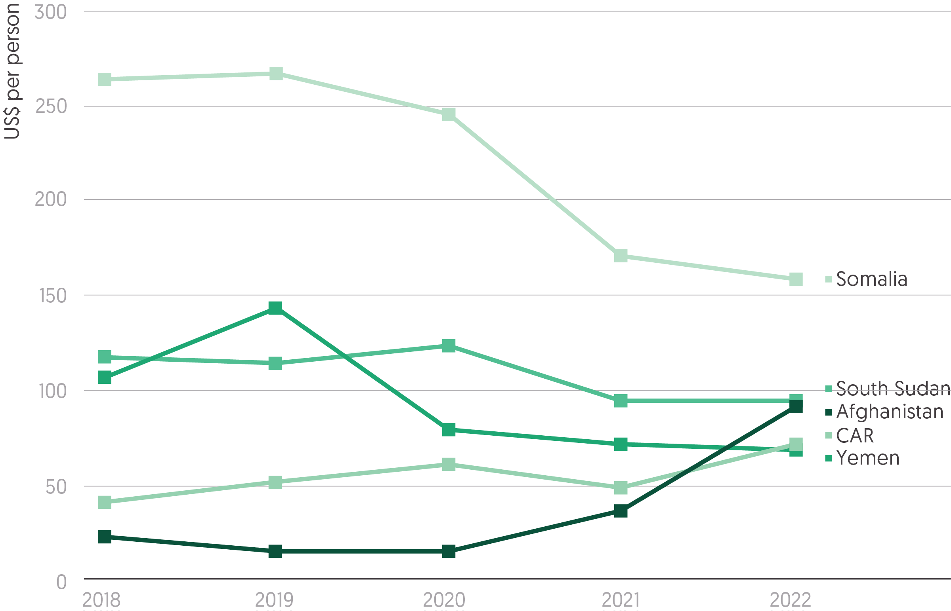

Source: Development Initiatives based on UN Office for the Coordination of Humanitarian Affairs (OCHA) Financial Tracking Service (FTS), UN country based pooled funds (CBPFs), Integrated Food Security Phase Classification (IPC)/Cadre Harmonisé (CH), and UN OCHA Humanitarian Programming Cycle (HPC).

Notes: CAR = Central African Republic. Data is in constant 2021 prices. Figures are per person living in 'crisis' (Phase 3) or higher acute food insecurity. Acute food insecurity numbers as reported/projected by year's closest IPC survey.

Alongside drought and conflict in 2022, rising food prices have made it difficult to alleviate worsening food insecurity, especially in countries experiencing protracted crises or multiple years at crisis levels of food security.[46] While the rise in the number of people facing food insecurity has been accompanied by increases in donor funding, particularly from the US, humanitarian food sector funding per person in crisis-level food insecurity is less than US$100 a year (less than $0.30 a day) for four of the five most severe food insecurity contexts.

* Somalia experienced the largest decrease in per person food sector spending (from US$266.9 to US$157.9), which also experienced the biggest change in the severity of food security (see Figure 2.7). Similarly, per person spending has fallen in Yemen (from US142.7 to US$68.6) and South Sudan (US$113.7 to US$94.5), the two countries with the most severe food insecurity over the same period.
* Other countries, however, have seen rising per person expenditure. Between 2019 and 2022/23, Central African Republic (from US$51.3 to US$71.7) and Afghanistan (from US$14.6 to US$91.3) saw large increases in their per person food sector spending.
* Per person food sector spending fell between 2019 and 2022/23 in the countries with the largest populations facing food insecurity, DRC (down 40% to US$17.8) and Ethiopia (down 10% to US$57.5). That there is less per person spending in these countries may reflect their less severe food security, but this could also be attributable to other trends such as regionalisation or donor preferences.

Insight: N4D

*N4D helps governments and their partners reduce malnutrition through evidence-based, scaled up action from local to global levels. We support nutrition leaders to share, access and operationalise learning and influence decisions and actions from the bottom up. Our current focus is on supporting local actors, in contexts of protracted crises, to lead the scale up of multisectoral actions by both humanitarian and development actors to prevent and respond to malnutrition.*

Since August 2022, N4D[47] has been supporting the Scaling Up Nutrition (SUN) Secretariat in Yemen to bring international humanitarian and development actors together with line ministries, local NGOs and other local actors in order to coordinate the scale-up of interventions across health, food and agriculture, trade, water, sanitation and education sectors. The work focuses on mobilising more development financing that addresses food insecurity and other underlying drivers of malnutrition, alongside on-going humanitarian assistance.

As highlighted in this report, rates of severe food insecurity and malnutrition in Yemen are amongst the highest in the world. However, the 2022 Humanitarian Response Plan was only 46% funded. The food security and agriculture sector received 56% of its requirements and the nutrition sector a significantly smaller proportion (38%). As in other protracted crisis situations, international financing in Yemen is predominantly short term and inadequately focused on building resilience and strengthening the capacities of local actors. Humanitarian aid made up 71% of all bilateral ODA to Yemen,[48] highlighting the limited provision of development assistance aimed at addressing underlying causes of humanitarian need and promoting more sustainable development outcomes. As a consequence, approximately 19% of the population remain at severe risk of famine and a further 34% are unable to meet basic needs without depleting their assets and increasing their vulnerability to malnutrition.[49]

More sustainable outcomes require high-level leadership from across the full range of stakeholders to ensure alignment with nationally led priorities, coordination with line ministries and increased coherence between humanitarian and development actions. The endorsement by the UN Resident and Humanitarian Coordinator of the Yemen call to action for more sustainable solutions was a significant step in building this high level commitment.[50] National and subnational governance mechanisms are being strengthened to harness the comparative advantages of humanitarian and development actors, align actions with collective outcomes and promote mutual accountability.

A stronger collective in-country voice calling for increased longer-term financing to build resilience and prevent humanitarian needs will help deliver results. However, political constraints in donor countries, including fears that aid will be diverted for political reasons or that the provision of development aid will legitimise de facto political authorities, remain as key obstacles to more and better funding. Strengthening national and local multi-stakeholder accountability mechanisms is a key element of tackling such concerns, complemented by intensive engagement with the political oversight bodies of donor agencies and supported by a strengthened evidence base on what works to drive more sustainable outcomes in protracted crisis contexts. Over the next couple of years, N4D will be joining forces with Development Initiatives to address these issues, extending the ongoing support in Yemen to two other protracted contexts and supporting local actors to influence the way in which financial assistance is provided in these situations.

# Chapter 3 – A better humanitarian system: Locally led action

## Summary

Efforts to reform the delivery of humanitarian assistance and to channel more funding to local and national actors have received substantial focus, though they have delivered limited tangible outcomes. The significant growth in humanitarian funding from donors in 2022 did not come with a similar shift in how it was delivered. In her Insight piece, Hibak Kalfan, the Executive Director of the Network for Empowered Aid Response (NEAR) network, provides a clear call to action to the international system to shift the current model to be truly centred around local communities. In 2022, there was no increase in the proportion of overall international humanitarian assistance directly provided to local and national actors – just 1.2% (US$485 million).

Instead, public donors increasingly relied on UN agencies to deliver humanitarian programming, with 61% (US$22.8 billion) of total public funding channelled to multilateral organisations, up from 52% in 2021. With this current balance of funding towards international agencies, humanitarian funding and decision-making spaces are often inaccessible, particularly for women’s rights organisations, as the Feminist Humanitarian Network highlight in their Insight piece.

Limited improvements in the reporting of funding that passes through one or more intermediary organisation means that monitoring the Grand Bargain commitment of providing 25% of global humanitarian funding ‘as directly as possible’ to local and national actors remains impossible. One area where better data on indirect funding is available is for pooled funds, which are increasingly seen as an important mechanism to meet localisation targets. In 2022, the volumes of funding allocated through UN Office for the Coordination of Humanitarian Affairs (OCHA)’s country based pooled funds (CBPFs) and the Central Emergency Response Fund (CERF) grew to a record US$1.9 billion, with 28% (US$337 million) of CBPF allocations going to local and national actors, an increase from 24% in 2017, and a preliminary 18% (US$80 million) of CERF allocations were sub-granted to local and national actors in 2021. However, collectively these pooled funds received a smaller share of total international humanitarian assistance from public donors, decreasing from a five-year high of 7.6% in 2019 to 5.4% in 2022.

Another critical aspect in enabling greater locally led humanitarian responses is to ensure that local and national NGOs have equitable access to unrestricted funding for non-project costs (i.e., overheads). Shifts in practice are occurring and some momentum for change is building, for instance through recent Inter-Agency Standing Committee (IASC) guidance on overhead practice for UN agencies and international NGOs. As Virginie Lefèvre of Amel Association International reinforces in her Insight piece, the issue is one ultimately of equality.

System reform around delivery of assistance as cash and vouchers has been more successful. Humanitarian cash and voucher assistance increased significantly by 40% to US$7.9 billion in 2022 due to the widespread use of the modality in the Ukraine crisis response and in addressing the high levels of food insecurity globally.

## How is assistance channelled and delivered?

Figure 3.1: Multilateral organisations continue to absorb the majority of international humanitarian assistance and there is a lack of transparency around subsequent recipients  
Channels of delivery of international humanitarian assistance from public donors, 2022, by first- and second-level recipients

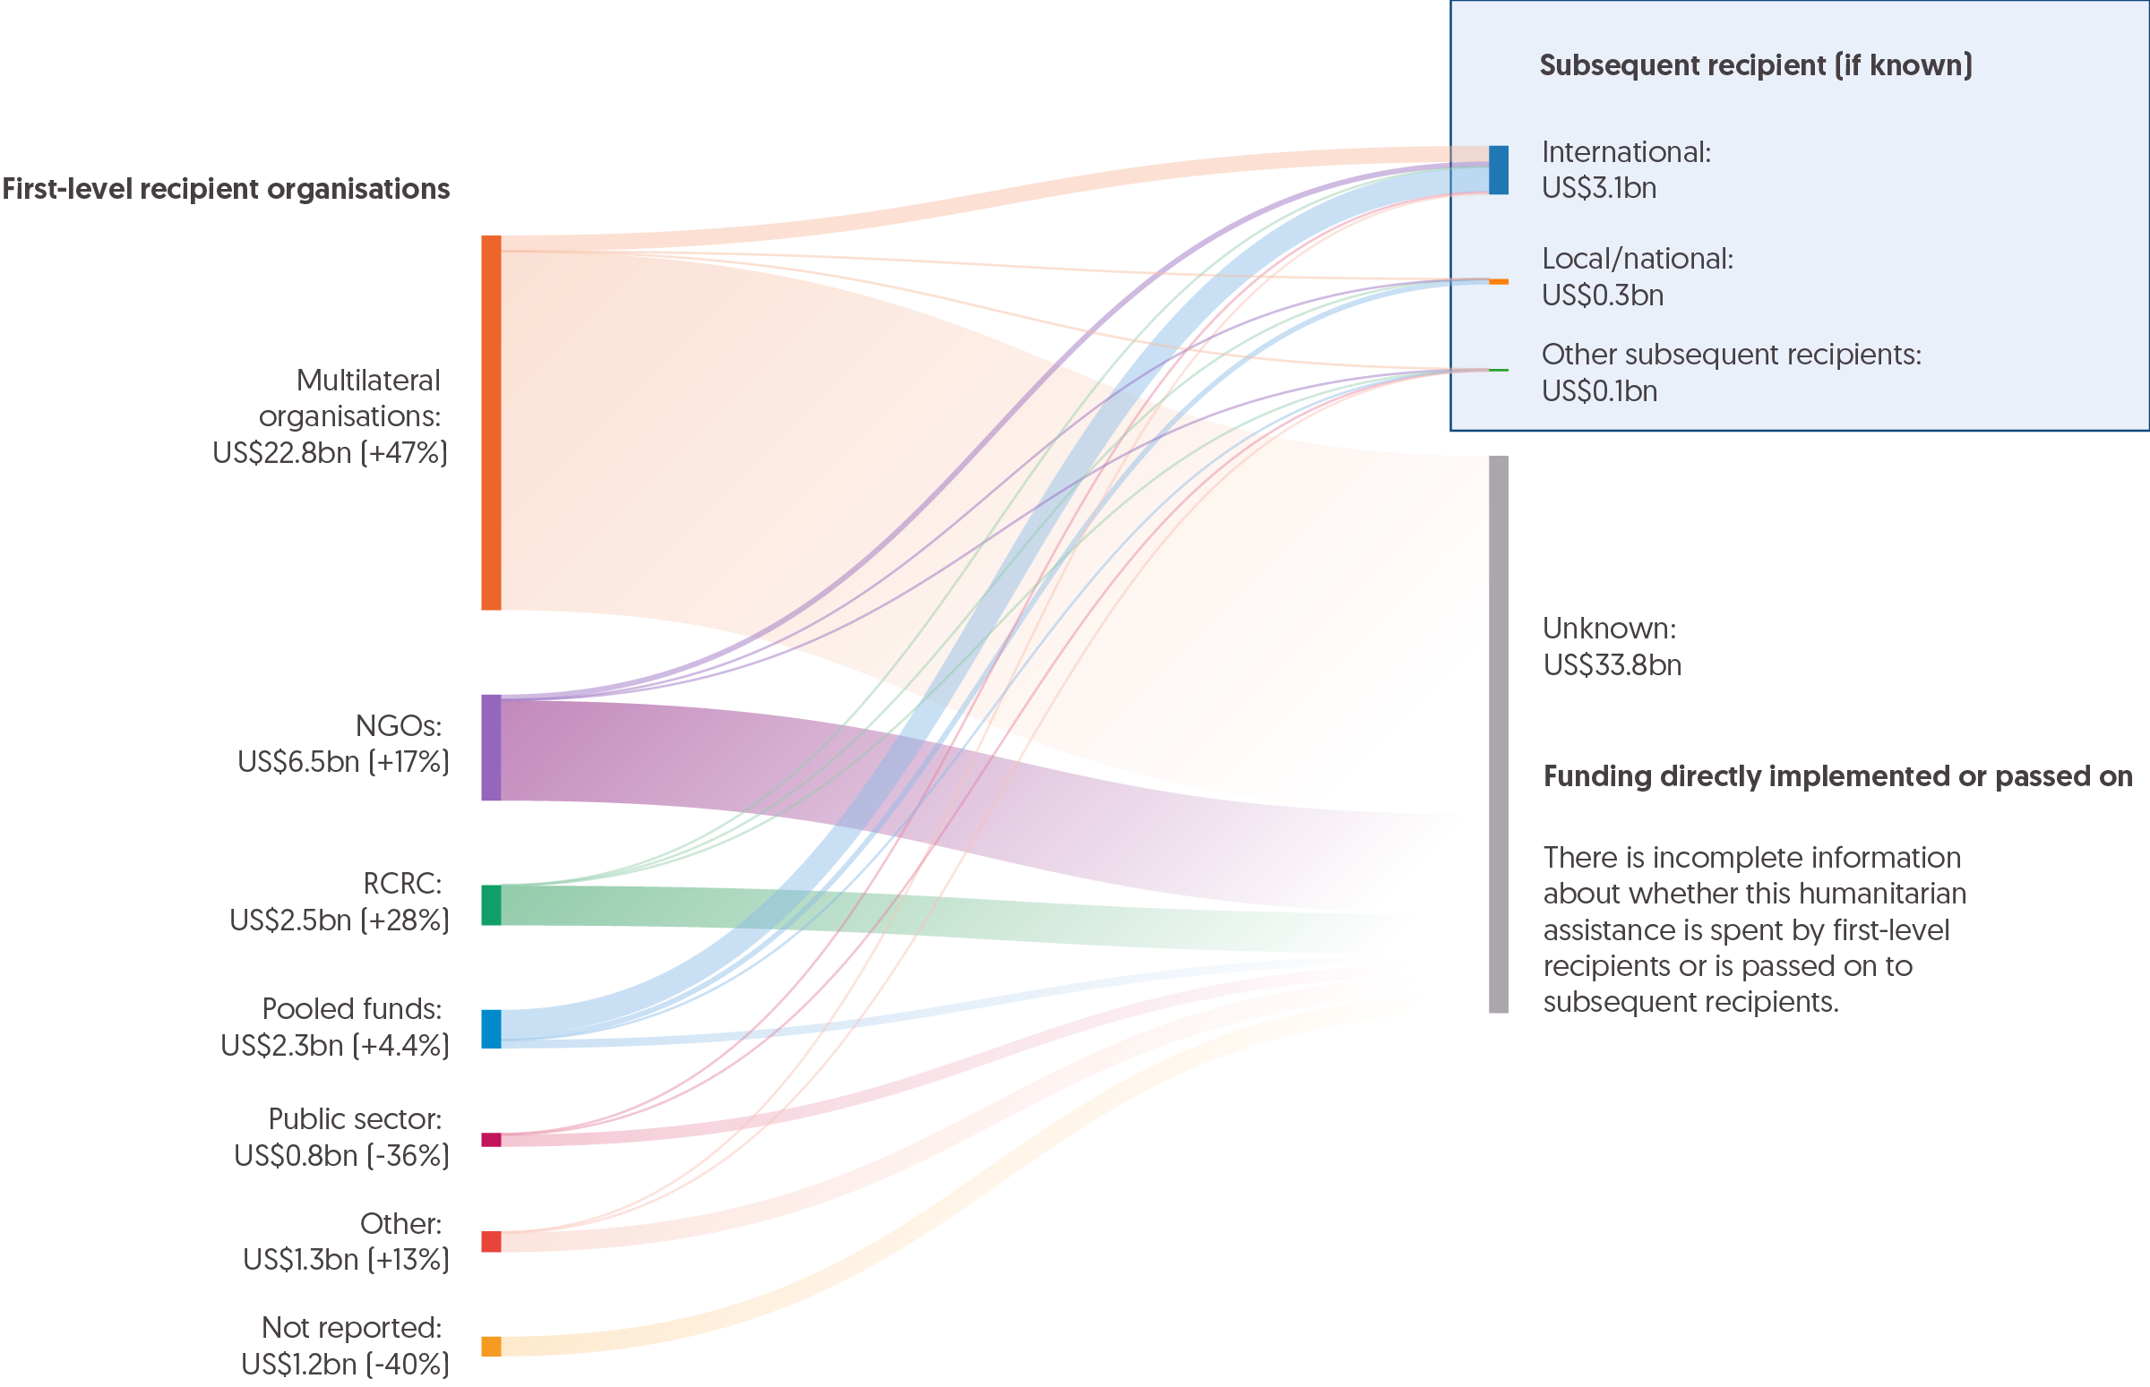

Source: Development Initiatives (DI) based on UN Office for the Coordination of Humanitarian Affairs (OCHA) Financial Tracking Service (FTS) data and country based pooled funds (CBPFs) and Central Emergency Response Fund (CERF) data hubs.

Notes: RCRC = Red Cross Red Crescent. Data is in constant 2021 prices. First-level funding (i.e., funding received directly from a donor) only captures assistance provided from governments and EU institutions, as DI's granular dataset on private humanitarian funding is only available up to 2021. 'Pooled funds' refers to funding to CERF, CBPFs and other pooled funds. 'Public sector' refers to funding to national governments and inter-governmental organisations. Private sector organisations (including academia, foundations and corporations) and undefined organisations have been merged under 'Other'. Data for subsequent recipients (i.e., funding received through one or more intermediary organisations) is taken from FTS for all organisations apart from flows from CBPFs and CERF, which are taken from respective data hubs. The 'International' category includes second-level funding to UN agencies and international NGOs. The 'Local/national' category includes second-level funding to local/national NGOs. ‘Other subsequent recipients’ includes second-level funding to RCRC, pooled funds, public sector and other categories.

Public donor funding patterns have remained very similar over the past decade, with most funding being channelled to multilateral institutions and international NGOs (INGOs). In 2022, the proportion of total public funding channelled to multilaterals grew.

* In line with the growth in total volumes of international humanitarian assistance in 2022 (see Figure 1.3, Chapter 1), funding to multilateral organisations from public donors increased by 47% (US$7.3 billion) to US$22.8 billion, from US$15.5 billion in 2021.
* Overall, funding to multilaterals accounted for 61% of total public international humanitarian assistance in 2022, an increase from 52% in 2021 and above the average of 56% over the past decade.
* NGOs continue to be the second largest recipients of international humanitarian assistance, receiving around US$6.4 billion in 2022 (17% of total direct funding), followed by Red Cross and Red Crescent (RCRC) organisations (6.6%, US$2.5 billion) and pooled funds (6.3%, US$2.3 billion, see Figure 3.4). Nearly all of this funding to NGOs (US$6.4 billion) was channelled to INGOs, with only 0.2% (US$80 million) of direct funding being channelled to local and national NGOs (see Figure 3.2).

The exact volumes and proportions of funding that pass from the first recipient to subsequent implementing partners is unknown due to incomplete and inconsistent reporting (see Box 3.1). The increase in reported indirect funding flows to UN OCHA’s Financial Tracking Service (FTS) suggests that this is slowly improving – in 2022, almost US$1.6 billion in indirect funding was reported to FTS, up from US$1.1 billion in 2021, and higher than the average of US$609 million over the last decade. A more complete picture of how funding is passed on can be seen in the UN OCHA-managed pooled funds allocations (see Figure 3.4).

## What progress has been made towards locally led humanitarian action? Funding and overheads

Insight: Hibak Kalfan, Executive Director, NEAR network

*Hibak Kalfan is the Executive Director of the Network for Empowered Aid Response (NEAR). NEAR is a network of Global South civil society organisations who have come together to reshape the global response to economic, human and environmental threats. Kalfan has more than 15 years’ experience and worked with several stakeholders in the humanitarian, media, development and government sectors in the Horn of Africa and Middle East. She began her career as the founder of The African Future (2007), a non-profit organisation hoping to improve the education and healthcare in Somalia. She has since held several positions within Internews, World Bank Group, ACTED and Relief International, among others.*

This year's GHA Report highlights the glaring disconnect between global policies and the actual humanitarian funding provided to local and national NGOs. Far from making progress, the proportion of funding allocated to these organisations is in decline.

In 2022, direct funding to local actors accounted for a mere 1.2% of overall assistance, unchanged since 2021, marking the lowest share since 2018. Despite ambitious donor intentions, direct funding for local NGOs stood at a paltry US$98 million, a stark contrast to the $39.2 billion directly received by international actors – a difference of nearly 40,000%. This disparity highlights the over reliance of donors on international actors to meet commitments, rather than embracing solutions that would allow for direct channelling of funding to local actors.

Recent large-scale crises in Pakistan, Syria, Türkiye and Afghanistan underscore the dire consequences for local actors when funding is unevenly distributed. NEAR network members have made it clear: local organisations are immediately and critically impacted by the lack of direct funding mechanisms, forcing them to rely on their own resources and whatever unrestricted funding they can secure from INGOs. Regrettably, obtaining appropriate funding to address community needs and their own requirements often takes months. Many local NGOs grapple with insufficient support for safety and assistance during disaster aftermaths, as witnessed following the earthquakes in Syria and Türkiye.

Amid the obstacles, we have seen some steps in the right direction. Within the Grand Bargain caucus on funding for localisation, co-convened by NEAR and the Grand Bargain Eminent Person’s Office with the technical support of Development Initiatives (DI), a group of signatories has agreed how to calculate funding for local actors, committing to report all funding to local actors publicly through the International Aid Transparency Initiative (IATI) or FTS, and developing individual roadmaps outlining when and how each agency and donor will achieve the 25% commitment. These steps are essential for enabling local actors to access increased volumes of humanitarian funding and better serve their communities.

NEAR and its members are fiercely working to turn global policies into tangible support for local actors by promoting transparency, accountability and innovative financing solutions. Initiatives like the locally led global Change Fund,[51] the Bulsho Fund in Somalia, and the Syria-Türkiye Solidarity Fund[52] prioritise funding for local organisations and initiatives that can swiftly and effectively address needs expressed by communities.

Numerous other initiatives exist, but achieving our vision for localisation demands sector-wide engagement. The time for rhetoric is long over, and positive steps in the last year must be built on and expanded with urgency.

Donors, the UN and INGOs must live up to their commitments on localisation and work collectively to provide equitable, effective and sustainable humanitarian support to local and national systems of response that centre communities’ needs. This demands a new model for the role of international actors at the national level, ensuring that the international humanitarian system complements local structures and approaches. The UN system must acknowledge its immense responsibility as the largest recipient of direct international humanitarian funding over the past decades (receiving 61% of total international humanitarian assistance funding in 2022) and shift its business models, becoming more transparent in its processes and overheads. Without these changes, next year’s GHA Report may again reflect a chasm between commitments to local actors and the reality they face.

Figure 3.2: Funding to local and national actors as a share of total humanitarian assistance remained very small in 2022  
Proportion and total volumes of direct and indirect funding to local and national actors, 2017–2022

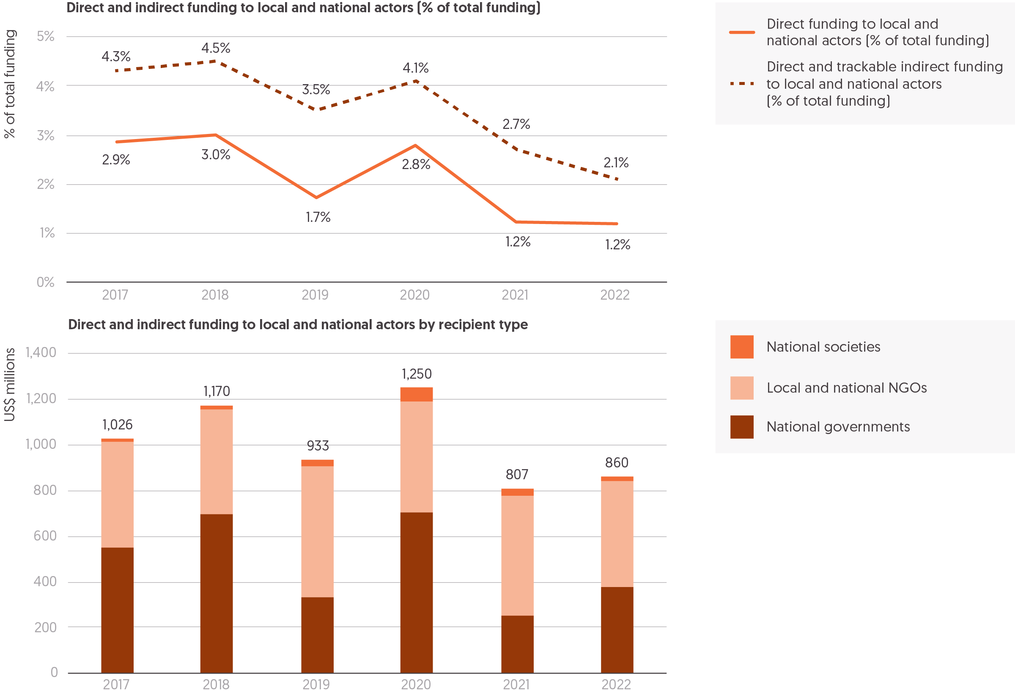

Source: Development Initiatives based on UN Office for the Coordination of Humanitarian Affairs (OCHA) Financial Tracking Service (FTS) and UN country based pooled funds (CBPFs).

Notes: Local and national actors include all local, national or local/national NGOs, determined by internal organisation coding. Southern international NGOs, which receive funding to operate within the country they are headquartered in, are included as national actors. Red Cross Red Crescent (RCRC) national societies that received international humanitarian assistance to respond to domestic crises are included in local and national actors. Similarly, international funding to national governments is considered as funding to national actors only when contributing to the domestic crisis response. Funding is shown only for flows that reported with information on the recipient organisation. Data is in constant 2021 prices.

Despite sustained advocacy from local and national actors and allies, increasing commitments from top donors, and momentum generated through the Grand Bargain,[53] efforts to increase the volumes of funding available for local and national actors continue to fall short. Only limited progress has been made to improve the transparency of funding, with data on indirect funding still not publicly reported by many actors. Tracking progress towards the 2016 Grand Bargain target of providing 25% of global humanitarian funding to local and national responders ‘as directly as possible’ therefore remains challenging. Nevertheless, available data on direct funding to local and national actors shows that little progress has been made as part of these efforts.

* In volumes, trackable humanitarian assistance to local and national actors (comprising data on direct flows plus partial data on indirect flows) totalled US$860 million in 2022, an increase of 6.6% from 2021 (US$807 million).
* Direct funding to local and national actors, as a share of total humanitarian assistance, remained static at 1.2% in 2022, while the volume (US$485 million) increased from 2021 (US$377 million) in line with the rise in total international humanitarian assistance.

Challenges remain in accurately capturing the volumes of funding channelled ‘as directly as possible’ (from donors to local and national actors through only one intermediary), due to inconsistent and incomplete reporting (see Box 3.1). 95% of all reported funds on the UN OCHA FTS in 2022 provide no information on whether they are passed on and, if so, where to. Since data is only reported on a limited portion of indirect funding, the fluctuations between indirect funding levels across years are difficult to attribute to actual changes in funding patterns rather than just changes in reporting consistency.

* Trackable indirect funding to local and national actors fell in both share and volume in 2022, from 1.4% (US$430 million) in 2021 to 0.9% (US$375 million) in 2022.
* UN CBPFs represent a significant proportion of trackable indirect funding to local and national actors;[54] this increased from US$272 million in 2021 to US$337 million in 2022. This represents 28% of all CBPF funding (see Figure 3.4).
* Given the inconsistencies in reporting, it is difficult to verify whether this drop in indirect funding represents a real drop or a reduction in reporting. A notable drop between 2021 and 2022 was a reduction in US$23 million from the World Food Programme.
* As a result, combined direct and indirect funding to local and national actors fell from 2.7% of overall assistance in 2021 to 2.1% in 2022. This suggests that it is at the lowest level since 2017, when implementation of the Grand Bargain commitments began, and is a second consecutive year-on-year decrease from 2020.

The broad patterns of direct and indirect funding are consistent year on year: direct funding is primarily provided to national and local governments, whereas the majority of indirect funding reaches national and local NGOs.

* The share of funding to national and local governments rose in 2022 to 76% of total direct funding to local and national actors, US$370 million, compared to 66% (US$250 million) in 2021. 20% was directly provided to local and national NGOs (US$98 million) compared to 28% (US$107 million) in 2021, whereas 3.6% of direct funding was provided to local and national societies (US$17 million), compared to 5.2% (US$20 million) in 2021.
* 54% of all tracked direct and indirect funding to local and national actors was channelled to local and national NGOs (US$463 million) in 2022. Of this, 79% (US$365 million) passed to local and national NGOs through at least one intermediary, with a large majority channelled through CBPFs (US$340 million).

Insight: Feminist Humanitarian Network

*The Feminist Humanitarian Network is an international network of feminist leaders committed to a transformed humanitarian system that promotes a feminist agenda. Its diverse network is currently comprised of 83 members including: grassroots and national feminist and women’s rights organisations; national and regional feminist and women’s networks; international NGOs, federations and organisations headquartered in the Global North; and individuals. Together it is working to redress power inequalities within the humanitarian system.*

Feminist and women’s rights organisations (WROs) representing crisis-affected communities play a unique role in humanitarian action at both community and national levels. Their work ensures that women’s, girls’ and gender-diverse people’s rights are protected before, during and after crises.

Their work is critical, yet largely unrecognised for its humanitarian value. WROs are systematically denied access to funding and decision-making: a reality that has direct outcomes for the women and marginalised communities they represent. This reflects the colonial and patriarchal dynamics within the current humanitarian system and demonstrates the need for a transformation driven by feminist principles: a goal the Feminist Humanitarian Network is working to achieve.

In order to shift power to actors on the frontlines of humanitarian response, it is essential that they receive significant, long-term funding directly. However, the findings of this report – that very little quality funding is reaching local and national actors, and that direct funding to local actors has fallen between 2017 and 2022 – are consistent with the experiences of WROs leading emergency responses in their communities and at a national level.

Previous research shows that donors’ multi-year commitments are impeded, and the benefits of these commitments to different actors are often misunderstood. WROs leading humanitarian action report that their work is limited by a lack of quality and multi-year funding.

Funding restrictions during crises force WROs and feminist organisations to choose between undertaking emergency response efforts *or* continuing their long-term work: work that ensures critical services for women and marginalised groups, transforms gender relations and advances women’s rights. The lack of access to quality long-term funding for WROs is a direct threat to women’s rights – both when emergency strikes and in the longer-term.

Multi-year, quality funding would allow WROs to continue their long-term work *and* respond to crises simultaneously – harnessing the catalytic potential of crises to advance their objectives more rapidly and achieve transformational shifts in gender dynamics through their humanitarian efforts.

Donors who state a commitment to feminist action and feminist foreign policies must apply feminist principles to their own funding priorities and mechanisms. This means examining the power dynamics of their own policies and processes, with the goal of meaningfully shifting power to women and their organisations in the global south.

Additionally, those with commitments to localisation must enact long-term funding strategies to ensure that WROs are equipped to take up the role currently held by international agencies as funding intermediaries. As is reflected in the findings of this report, the impact of INGOs and multilaterals continuing to act as intermediaries is significant for WROs, which are burdened with having to comply with the priorities and requirements of both the donor and the intermediary. This makes funding less accessible – as WROs must operate within the compliance and due diligence policies of at least two entities – and limits WROs’ agency to make decisions about their own work and how they can best serve the needs of their community and the women they work with.

Box 3.1: Data issues around indirect funding and reporting

Supporting greater local humanitarian leadership through increased funding is a growing global policy priority, yet donors have not been able to provide direct funding to local and national actors at any meaningful scale (see Figure 3.2). In addition, there is a large information gap around how much funding reaches local and national actors indirectly from donors, through one or more intermediaries. As was apparent from the recent discussions among members of the Grand Bargain Caucus on Funding to Local and National Actors, intermediary systems are not necessarily set up to effectively track funding to local and national actors (see Figure 3.1).

Humanitarian donors and international organisations have committed to increased transparency of funding flows, however data reported to global platforms and standards, such as UN OCHA’s FTS and IATI, is incomplete, particularly around funding passed on by UN agencies. In some cases, agencies do not have the systems in place to collate data globally on the funding they provide. This means they are often unable to extract the relevant data for public reporting platforms or to report back to individual donors how funding received was sub-granted. In turn, donors themselves are then unable to properly estimate how much of their funding reaches local actors. This lack of basic transparency around where and how funding is channelled through the humanitarian system undermines coordination, targeting and accountability at regional, subnational and national levels. Moreover, it means that it is not possible to properly monitor progress made against Grand Bargain commitments.

[Recent research tracking funding flows for the Syrian refugee response in Türkiye](https://devinit.org/resources/funding-to-local-actors-syrian-refugee-response-turkiye/) (carried out by DI in partnership with the Refugee Council of Türkiye) illustrates the importance of this indirect funding data and of disaggregating funding data by actor type (for instance refugee-led or women’s organisations). As shown in Figure 3.3, the majority (86%) of international funding for the Syrian refugee response in Türkiye in 2019 and 2020 was provided to international organisations, however much of this was then channelled to the Turkish Red Crescent and government institutions for implementation. The study – which manually collected data directly from donors and organisations – found that funding reaching local/national NGOs (L/NNGOs), both directly and indirectly, made up a very small proportion (5.3%) of total funding across both years, with even smaller fractions reaching refugee-led or women’s organisations. Moreover, almost none of the data collected on funding flows to second- and third-level recipients – just 0.3% of all funding – was captured by FTS, highlighting the widespread lack of reporting. The study also investigated the impact on L/NNGOs of receiving international funding indirectly through one or more intermediary organisations, with findings highlighting their limited ability to influence donor funding priorities and the lack of flexible, multi-year funding.

DI has been supporting partners to improve the tracking and reporting of funding to local and national actors through the Grand Bargain Caucus on Funding to Local and National Actors. Recommendations endorsed by caucus members in March 2023 include an agreement to measure direct and indirect funding to local and national actors and to report all funding to publicly available platforms.[55] It is hoped that this stimulates similar commitments among donors and international organisations beyond the caucus. With the right political will and support where needed – for example to gather and share different approaches to tracking, and assistance in improving internal data collection – certain relatively simple technical changes would provide some long-overdue transparency on how and where humanitarian finance is spent.

Figure 3.3: Mapping funding flows for the Syrian refugee response in Türkiye  
Total international grant funding to Türkiye for the Syrian refugee response, by recipients and intermediaries, and subsequent recipients (volumes), 2019–2020 in aggregate

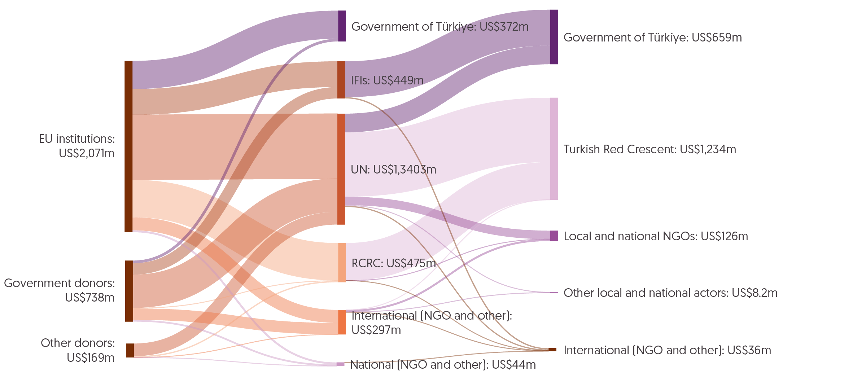

Source: Development Initiatives based on survey data provided directly by donors and intermediaries, UN Office for the Coordination of Humanitarian Affairs (OCHA)’s Financial Tracking Service (FTS), OECD Development Assistance Committee (DAC) Creditor Reporting System (CRS), International Aid Transparency Initiative (IATI) data and publicly accessible project lists for individual organisations.

Notes: IFIs = international financial institutions; RCRC = Red Cross Red Crescent. Data is in current prices. 'Other donors' category includes unknown, private individuals and organisations and other global pooled funding mechanisms. 'Other local and national actors' category includes professional associations and academic institutions. 'International (NGO and other)' category mainly includes international NGOs and other bilateral actors such as the German Agency for International Cooperation (GIZ).

Box 3.2: Overheads policy development

Local and national actors have been advocating for fairer funding practices around the sharing of overheads or indirect costs for many years. More recently this has become a central priority for policy change as part of wider reform efforts to support more locally led humanitarian response. Members of the Grand Bargain caucus on the role of intermediaries have committed to allocating overheads to local and national partners[56] and the Inter-Agency Standing Committee published guidance on the issue for its members in November 2022.[57] As a result, several international organisations have recently updated their funding policies, for example UNICEF, Trócaire and members of the Dutch Relief Alliance. Momentum is building for further change across the system in 2023.

As well as international organisations, which more often act as funders to L/NNGOs (see Figure 3.1), donors also have a responsibility to ensure that all partners involved in delivering humanitarian programming have their eligible direct and indirect costs compensated. [Recent research into current donor approaches to overheads](https://devinit.org/documents/1297/Donor_approaches_to_overheads_discussion_paper_ZBXpnak.pdf) for local actors found that this was not an issue familiar to all donors. Most rely on the pass-through policies of their UN and INGO partners and provide no regulations or guidance around how their funding – including overheads – should be provided (or shared) to sub-granted partners. Exceptions to this include the INGO funding guidelines of Canada, the UK and Denmark.

Despite this, most donors recognise the logic for both L/NNGOs and international organisations needing overhead funding, and many are currently developing relevant guidance or policies. Donors have a clear role in incentivising their partners – especially their UN partners – to develop equitable funding policies. With INGOs, DI’s recent [discussion paper](https://devinit.org/documents/1297/Donor_approaches_to_overheads_discussion_paper_ZBXpnak.pdf) emphasises the need for donors to recognise the indirect costs of both their INGO and L/NNGO partners and not inadvertently disincentivise INGOs from partnering with L/NNGOs by requesting that existing fixed rates are simply shared, without considering the financial implications. Providing an additional budget line specifically for sub-granted L/NNGOs’ overheads would be an impactful and practical way for donors to recognise the role indirect costs play in supporting the institutional development and sustainability of L/NNGOs and demonstrate their commitment to shifting toward more effective, locally driven humanitarian response.

Read DI’s [report in partnership with UNICEF and Oxfam on overhead allocation in the humanitarian sector](https://devinit.org/resources/overhead-cost-allocation-humanitarian-sector/) and our [discussion paper on donors’ current indirect cost policies and perspectives on the issue](https://devinit.org/resources/donor-approaches-overheads-local-national-partners/).

Insight: Virginie Lefevre, Head of Programs and Partnerships, Amel Association International

Virginie Lefèvre is a Jurist who has been working for the past 15 years with NGOs, particularly for the promotion and for the protection of human rights. Since 2010, she has been living in Lebanon where she is involved in the humanitarian and development sectors. She is now the Head of Programs and Partnerships at Amel Association International, a Lebanese NGO. Through her work, Virginie Lefèvre is committed to improve operations and coordination, notably within the framework of the Syrian crisis emergency and stabilisation, pandemic and Beirut Blast responses, while contributing to reflections around the international humanitarian system, South–North partnerships, localisation and access to social rights in emergencies. She is a member of the Lebanon Humanitarian and Development NGOs Forum and ICVA Boards.

Within local and national NGO (L/NNGO) discussions in Lebanon and abroad on localisation, one of the first topics raised is overhead costs, or rather the inequities they present. This is mainly because most L/NNGOs do not have a structured access to overheads, as reported by DI in their [2022 publication](https://devinit.org/resources/overhead-cost-allocation-humanitarian-sector/).

From my perspective, as a long-time advocate of localisation, this is an evident practice of inequitable and non-principled partnerships in which organisations, often local, work hard to deliver programming but are unable to recover indirect costs, while others do not directly implement but can access overheads. Contrary to other examples, the inequity here does not lie in the access to overheads but in the question often raised by our donors or partners asking, “Why do you need overhead costs?” or comments such as “You can charge all costs to the project, you do not need to recover any costs”.

In effect, when talking about the inequity in overheads, we need to take a step back from the access and focus on the need and the right of L/NNGOs to ask for this cost – as organisations and as humanitarian practitioners. Indeed, not all costs can be recovered under the project budget; core functions such as safeguarding, staff care, accountability, and so on, are costly and need dedicated resources. In the longer-term, overheads enable organisations to acquire further capacities that enable them to diversify their portfolio of fundings.

Different partners and stakeholders within the international community, including civil society organisations, agree that accessing and including overheads is crucial. However, this still remains insufficient as in practice many additional challenges arise, specifically the different percentages granted to local and international actors, or suggestions that local actors should include overheads in direct costs. Recent research carried out by DI on behalf of the IASC summarises our main challenge effectively: “the provision of overheads to L/NNGOs is inconsistent and at best ad hoc, both between and within organisations”.

Undeniably, many actors agree on the challenges, however it is currently imperative to move forward in the discussion with practical and actionable recommendations that could include ensuring that:

* All actors (donors, UN, NGOs, etc) acknowledge the need for NGOs to recover their indirect costs through overheads no matter if they are local, national or international.
* The IASC Guidance on the Provision of Overheads to Local and National Partners[58] is disseminated.
* The percentages of overheads granted by donors and partners are the same between local and international NGOs.
* Partners, when cascading funding to other L/NNGOs, are granting an equitable/proportional amount of their overheads.
* Donors are embedding an equitable approach towards overheads in their policies.
* The ‘right to fair overheads’ is known and reclaimed by local and national actors.

Finally, it is important to note that overheads are not a means to an end. They are one of the crucial funding tools enabling local and national actors in collaboration with other stakeholders to respond to the needs of the affected communities and to ensure a dignified, localised and sustainable response towards the humanitarian need.

Figure 3.4: UN OCHA’s pooled funds provided more funding to local and national actors than ever before   
CERF and CBPF allocations by partner type and share of allocations to local/national partners, 2017–2022

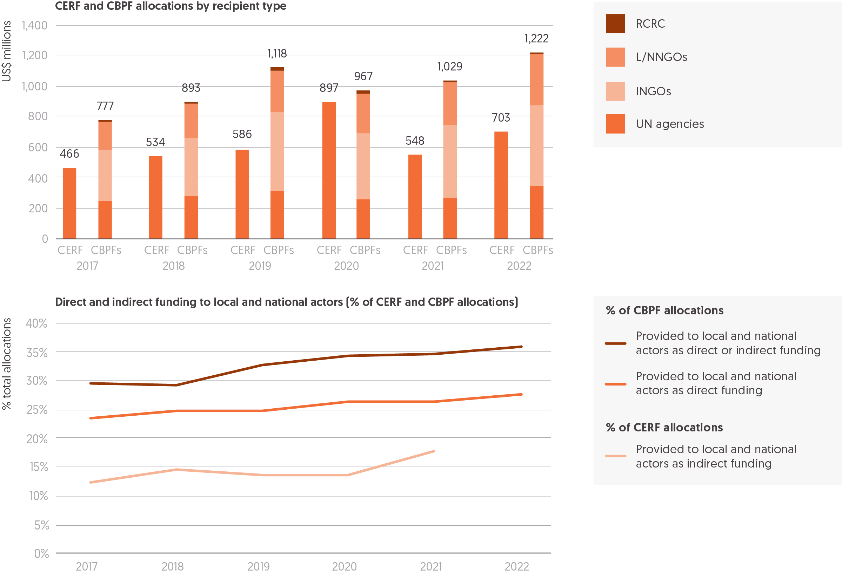

Source: DI based on country based pooled fund (CBPF) data and Central Emergency Response Fund (CERF) annual results reports.  
Notes: RCRC = Red Cross Red Crescent. The 2021 CERF data is partial, representing sub-grants for 83% of the total allocations the CERF made that year. CERF data on indirect funding in 2022 is not yet available. Data is in constant 2021 prices.

### UN OCHA pooled fund allocations to local and national actors

Pooled funds are seen as one mechanism to channel funding more quickly and effectively to frontline humanitarian responders. This includes local and national actors, and they are regarded as an important means to achieve the Grand Bargain commitment of providing at least 25% of global humanitarian funding directly to local or national actors, or through a single intermediary. UN OCHA’s CBPFs are able to directly fund local and national organisations, which in addition receive sub-grants within CBPF-funded projects. CBPFs also set a high standard on transparency of funding flows within the humanitarian system by providing data in close to real time on these allocations and sub-grants. While the CERF can only fund UN agencies, its funding is sub-granted to local and national actors. Total combined allocations by CBPFs and the CERF were the largest ever reported in 2022. The volume of funding allocated to local and national actors through CBPFs has slowly increased over recent years, and in 2022 it was the largest by volume and as a share of total allocations.

* The combined allocations by the CERF and CBPFs in 2022 were the largest reported, at US$1.9 billion, an increase of US$60 million from the previous high in 2020. 63% of these allocations were from the 20 CBPFs and 37% from the CERF, a split consistent with the average over the past 6 years.
* CBPFs allocated 28% (US$337 million) of funding to local and national actors in 2022, an increase from 24% (US$183 million) in 2017. Including funding that reached local and national actors through sub-grants from CBPF partners, this accounted for 36% of total allocations in 2022.
* The CBPFs with the highest shares of funding allocated to local and national actors were the Venezuela Humanitarian Fund (66%, US$6.3 million), the Somalia Humanitarian Fund (61%, US$43 million) and the Democratic Republic of the Congo (DRC) Humanitarian Fund (46%, US$18 million). While the share allocated to local and national actors from the Venezuela Humanitarian Fund was already high since its first round of allocations in 2021, the Somalia Humanitarian Fund saw an increase from 38% in 2017 and the DRC Humanitarian Fund from 23% in 2019. The Nigeria Humanitarian Fund managed to achieve the largest increase in its share of allocations to local and national actors over the time period, growing from 5% (US$1.3 million) in 2017 to 36% (US$9.1 million) in 2022.
* In total, the CBPFs that allocated the highest volumes of funding directly to local and national actors were the Afghanistan (US$62 million, 22%), Syria Cross Border (US$60 million, 42%) and Ukraine Humanitarian Funds (US$44 million, 23%).
* Excluding CBPFs for Jordan and Iraq, which have been reducing their operations in 2022, those with the lowest percentages of funding to local and national actors in 2022 were the Central African Republic Humanitarian Fund (7%) and the CBPFs in Sudan and South Sudan (both 12%).
* 9 of the 20 CBPFs active in 2022 allocated 25% or more of funding to local or national actors directly, the same average number across 2017 to 2022.

An increasing share of CERF funding is sub-granted to local and national actors. However, this technically does not count towards the Grand Bargain target as it is channelled through two intermediaries (CERF and subsequently UN agencies).[59]

* In 2021, 18% (US$80 million) of CERF allocations were sub-granted to local and national actors, according to preliminary data for 83% of the total allocations the CERF made that year. This has slowly increased from 13% of total allocations (US$58 million) in 2013.
* In late 2020, the CERF made its first ever allocation of US$25 million to specifically support local women-led or women’s rights organisations on gender-based violence prevention and response programming, through block grants to United Nations Population Fund (US$17 million) and UN Women (US$8 million). These grants included a condition that at least 30% of funds were granted to local women-led or women’s rights organisations.[60]
* In 2020, the CERF made its first ever NGO allocation, in response to the Covid-19 pandemic in a joint pilot with the International Organization for Migration. In total, US$25 million was allocated. Of the 26 grants awarded, 8 went to national NGOs. While support to local and national actors specifically was not a stated objective, an independent review found that the large grants and application process made the allocation far less accessible for local and national NGOs.[61]

#### UN OCHA’s pooled fund country allocations

In 2022, UN OCHA’s pooled funds allocated a combined total of US$1.9 billion; 37% of this was allocated through the CERF and 63% was allocated through 20 CBPFs.

* As in 2021, Afghanistan received the largest volume of allocations in 2022 from UN OCHA’s pooled funds (US$296 million). The Afghanistan Humanitarian Fund had the largest allocations of any CBPF that year, making up US$286 million of this amount.
* The second largest country recipient was Ukraine, which received US$255 million in 2022, up from US$15 million in 2021. Ukraine was the largest country recipient of CERF funding (US$61 million), and the Ukraine Humanitarian Fund made the second highest volume of allocations (US$194 million) globally that year. Given the Ukraine Humanitarian Fund received the highest level of donor contributions out of all CBPFs in 2022 at US$341 million, its allocation will likely be even larger in 2023.
* Syria received the third largest allocation of funding from UN OCHA’s pooled funds (US$213 million).

#### UN OCHA’s pooled funds contributions and donors

Pooled funds enable the collective commitment of resources and greater responsiveness to need. UN OCHA’s CBPFs and the CERF are a well-established part of the humanitarian response system. In 2022, CBPFs and the CERF jointly received the largest volume of contributions since 2017.

* In 2022, CBPFs and the CERF received US$2.0 billion in contributions, an increase of a third (33%) since 2017.
* This increase was mostly driven by donor contributions to CBPFs, which were the largest ever at US$1.4 billion. This volume compares to US$947 million in 2017 and is an increase of almost a quarter from 2021.
* Contributions to the CERF have remained at a similar level over the period 2017 to 2022, fluctuating between US$585 and US$683 million, except for 2019 where exceptionally high contributions from the UK drove CERF contributions to US$942 million.
* Overall, the balance of donor contributions to UN OCHA’s pooled funds has consistently shifted towards CBPFs since 2019, which made up 69% of total contributions in 2022 compared to an average of 60% in the previous five years.

Despite these high levels of contributions, UN OCHA’s pooled funds make up a decreasing share of the total international humanitarian assistance provided globally by public donors (governments and EU institutions). In part, this is explained by the small volume of support provided the US and EU institutions but whose assistance accounts for a large share of total public contributions of international humanitarian assistance.

* The proportion of total international humanitarian assistance channelled through UN pooled funds has steadily decreased, from a 5-year high of 7.6% in 2019 to 5.4% in 2022.
* Two of the largest donors that have driven increases in total international humanitarian assistance in recent years – the US and EU institutions – are small contributors to OCHA’s pooled funds relative to the size of their humanitarian budgets. The US made up only 2.7% of total contributions to CERF and CBPFs in 2022, compared to 39% of the total global assistance from public donors (see Figure 1.5, Chapter 1). EU institutions do not contribute to the CERF and only started to fund CBPFs in 2020, though so far at a small scale – around US$5 million per year.

A small number of donors provide the bulk of funding to UN pooled funds, especially Germany.

* In total, two-thirds (66%) of total funding to UN pooled funds came from just five donors (Germany, the UK, the Netherlands, Sweden and Canada).
* Germany continues to be by far the largest donor to UN OCHA’s pooled funds, contributing 29% of all funding received by the CERF and CBPFs in 2022 (US$602 million). This is similar to its share in 2021 (31%), following a large increase in its total contributions of US$159 million from 2020 to 2021.
* The UK, formerly the largest contributor to UN OCHA’s pooled funds between 2017 and 2019, has since been the second largest contributor and provided 13% of total funding in 2022 (US$268 million), compared to an average of 30% from 2017 to 2019.

### Other humanitarian pooled funds

In addition to UN OCHA-managed pooled funds, the number and size of other pooled funds have also grown in recent years. Pooled funds are seen as an effective way to shift decision-making closer to those affected by humanitarian crisis, contribute to commitments to increase funding to local and national actors and improve the flexibility, efficiency and timeliness of humanitarian funding.[62] Some pooled funds increasingly have anticipatory funding elements.

* The Disaster Response Emergency Fund (DREF), managed by International Federation of Red Cross and Red Crescent Societies, was established in 1985 and disburses funding to RCRC national societies. In 2022, the DREF, including its anticipatory pillar, disbursed US$62 million to 91 national societies through a mixture of loans and grants. Of these disbursements, over half (54%, US$33 million) were focused on responses to weather-related events including floods and drought.
* The Start Fund, the foremost NGO-managed pooled fund, disbursed US$20 million to its 55 members in 2021 of which US$4.0 million was provided directly or indirectly to local and national actors and US$3.1 million was disbursed for crisis anticipation. In 2021, Start Ready was launched, which provides pre-positioned funding for predictable crises.[63]
* The Network for Empowered Aid Response (NEAR) Change Fund was established in 2022 with the aim of supporting more locally led humanitarian responses. Being funded by a single donor (the Conrad N. Hilton Foundation), it is not technically a pooled fund. So far, the fund has disbursed US$1.5 million to NEAR members.[64]
* Other thematic pooled funds include the Women’s Peace and Humanitarian Fund (see Box 3.3), and Education Cannot Wait, which disbursed US$180 million in 2022, of which over half (59%) was provided to UN agencies, with 0.9% to national NGOs.[65]

Box 3.3 Women’s Peace and Humanitarian Fund

The UN Women’s Peace and Humanitarian Fund (WPHF) is a multi-partner trust fund mobilising urgently needed financing for local civil society organisations led by and working alongside women on the front lines to respond to crisis and build lasting peace. Established in 2016, WPHF aims to address the structural funding barriers that hold back women’s participation and leadership in crisis and conflict settings. WPHF supports local and national women-led and women’s rights organisations, as well as young women-led and youth-focused organisations, to prevent conflict, respond to humanitarian emergencies, support the protection of women and girls, and accelerate peacebuilding and recovery efforts. In addition to programmatic funding, the fund has an institutional funding stream that aims to support the sustainability and resilience of grassroots women’s organisations through core funding, and an adaptive and rapid funding mechanism to support women humanitarians respond to emerging crises.

Since its inception, WPHF has mobilized US$130 million,[66] supporting over 900 civil society organisations and women peacebuilders across 41 countries. Over 40% of funding has been allocated for humanitarian and crisis response (including Covid-19 emergency response).[67] In total, 19 donors have contributed to WPHF. The largest donor by far is Germany, which has contributed nearly half (44%, US$57 million) of all funding.[68] In 2022 alone US$44 million was generated, an increase of 15% from the previous year and representing the highest growth since its inception. This was channelled through four funding windows: the regular funding cycle organised around six peace and humanitarian outcomes, the Covid-19 emergency response window, the WPHF rapid response window for women’s participation in peace processes and the implementation of peace agreements, and the window for women human rights defenders. In 2022, 76% of WPHF allocations were provided to local and subnational organisations. Close to half (44%) of the organisations that received funding from WPHF in 2022 are first-time recipients of UN funding.[69]

## What progress has been made towards delivering cash and voucher assistance?

Figure 3.5: Global transfer volumes of humanitarian cash and voucher assistance saw their largest increase on record in 2022  
Total humanitarian cash and voucher assistance transfer values, 2017–2022

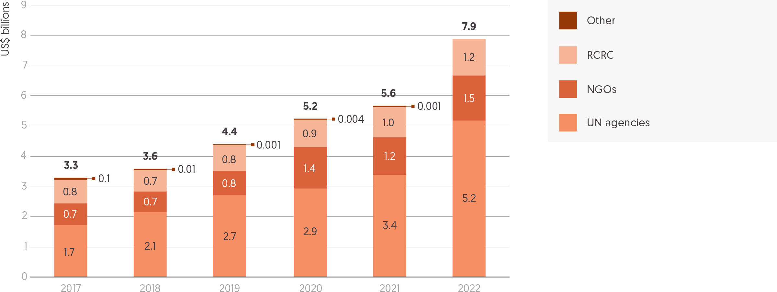

Source: Development Initiatives based on data collected by the CALP Network from implementing partners and supplemented with UN Office for the Coordination of Humanitarian Affairs (OCHA) Financial Tracking Service (FTS) data.  
Notes: RCRC = Red Cross and Red Crescent Movement. Data for 2022 is preliminary as data for some organisations has not yet been provided or is partial. Double counting of cash and voucher assistance programmes that are sub-granted from one implementing partner to another is avoided where data on this is available. Transfer values for funding captured on FTS are estimates based on the average ratio of transfer values to overall programming costs for organisations with available data. Data is not available for all included organisations across all years. Data is in current prices.

The Grand Bargain has helped to focus attention on the importance of humanitarian cash and voucher assistance (CVA) as a means to provide choice and greater agency to those experiencing humanitarian crisis. With consistent growth in the volumes provided over the past six years, the increased use of CVA is commonly cited as successful example of humanitarian system reform.[70] In 2022, the use of CVA accelerated in response to the Ukraine conflict and the globally rising levels of food insecurity. Despite the rapid growth in global volumes of international humanitarian assistance that year, CVA accounted for a slightly higher share of the total funding provided. This seventh consecutive year-on-year increase in 2022 was the largest on record.

* Preliminary data on global humanitarian CVA shows that the volume transferred to people affected by crises rose to US$7.9 billion in 2022, an increase of 40% from 2021.
* According to self-reports by implementing agencies, the large-scale use of CVA in the Ukraine crisis response was the most commonly cited reason behind those increases. In Ukraine alone, US$1.2 billion of multi-purpose cash assistance (MPCA) was transferred to crisis-affected people in 2022.[71] Other reasons were the suitability of CVA to respond to the global food crisis and growing CVA programmes in Afghanistan.
* The large-scale MPCA response to the Ukraine crisis also contributed to the continued shift towards cash as the preferred delivery modality, making up 81% of total CVA globally (with 19% provided as vouchers). This is compared to the average of 72% as cash and 28% as vouchers from 2017 to 2021.
* Data on overall CVA programming costs was only available for around 12% of the total global volumes of humanitarian CVA transfers. Applying the same average ratio of transfer costs to overall CVA programming costs (79%) to those for which data was unavailable, the global estimated volume of CVA programming – including both the transfer value and the associated programming costs – reached US$9.9 billion in 2022.
* CVA made up an estimated 20% of international humanitarian assistance in 2022. This is only marginally higher than in 2021 (18%),[72] as global volumes of international humanitarian assistance also increased significantly in 2022 (see Figure 1.3, Chapter 1). Recent research suggests that according to implementing organisations’ own CVA targets, there is potential for at least 30% up to 50% of all international humanitarian assistance to be delivered through CVA.[73]

UN agencies continued to deliver the majority of humanitarian CVA in 2022 and saw the most significant increases in transfer volumes that year.

* UN agencies provided two-thirds (US$5.2 billion, 66%) of the global total of humanitarian CVA transfer volumes to crisis-affected populations in 2022. This is the highest share for comparable data since 2017, compared to an average of 58% between 2017 and 2021. Overall, CVA transfer volumes from UN agencies increased by more than half (53%).
  + UNICEF more than doubled its volume of humanitarian CVA transfers in 2022 to US$725 million, of which the Ukraine response made up around 40%.
  + The Office of the United Nations High Commissioner for Refugees (UNHCR) increased its volume of humanitarian CVA transfers by 46% in 2022 to US$977 million, with the largest CVA operations in the Middle East and countries affected by the Ukraine crisis.[74]
  + World Food Programme increased its volume of humanitarian CVA transfers by 43% to around US$3.3 billion, partly due to scaled-up CVA responses to crises in Somalia, Ukraine and Afghanistan.
* NGOs also increased their volumes of humanitarian CVA transfers in 2022, by 23% (to US$1.5 billion), as did organisations that are part of the RCRC Movement, by 20% (to US$1.2 billion):
  + Of NGOs with available data, the International Rescue Committee (IRC) experienced the greatest increase in CVA transfer volumes to US$80 million in 2022, more than double the 2021 amount. This was mainly thanks to IRC’s capacity to quickly scale-up MPCA programming in Ukraine, Poland and Afghanistan.
  + Within the RCRC Movement, the International Committee of the Red Cross experienced a particularly large increase in CVA transfer volumes, which more than tripled to US$333 million in 2022.

Despite these large increases in the global volumes of humanitarian CVA, DI research has found that publicly available and timely data on where, for what and by whom CVA is transferred to recipients remains sparse, with the exception of a few humanitarian crises.[75] This has important implications for the humanitarian policy agenda to increase funding to and visibility of local and national actors:

* While more implementing organisations have been able to report on the volume of sub-grants they provide for the delivery of CVA – amounting to US$291 million in 2022[76] – this data is not publicly available and thereby limits visibility of actors facilitating the CVA delivery, which often are local and national actors.
* The growing share of CVA implemented by UN agencies in 2022 also points to the emerging tension between humanitarian commitments to increase the use of CVA and to localise humanitarian funding,[77] as funding for the implementation of CVA remains largely concentrated among international actors.

Read [DI’s comprehensive assessment of the state of tracking CVA during humanitarian crises](https://devinit.org/resources/tracking-cash-voucher-assistance/).

# Chapter 4 – Beyond humanitarian funding: Addressing cycles of crises

## Summary

In long-term, protracted crisis situations,[78] the complex and interrelated risks posed by conflict, socioeconomic fragility and climate change often lead to increased humanitarian need, and make it challenging to recover from crisis and build resilience. Coordinated humanitarian, development, peacebuilding and climate-related finance and programming is essential to help communities weather future shocks.

Yet, examining official development assistance (ODA) shows a reduction in the amount of development assistance received by countries facing long-term crisis. Between 2017 and 2021, the volume and proportion of development assistance received by those countries reduced (by US$0.6 billion; from 50% to 48%), while the volume and proportion of total aid received as humanitarian assistance increased – reaching 41% in 2021, compared to an average of 37% over the past five years, suggesting an increased reliance on humanitarian assistance.

As the accelerating impacts of climate change drive and exacerbate humanitarian crises, the intersection between humanitarian response and initiatives supported by climate finance is becoming increasingly important. The targeting of ODA allocated for climate finance and funding for disaster risk reduction (DRR) can be critical in supporting response, recovery and resilience-building to a crisis, preserving development gains and reducing overall vulnerability to successive humanitarian impacts. As Start Network highlight in their Insight piece, acting early in advance of shocks through anticipatory action like DRR is key.

The overall picture is of small volumes of climate finance and DRR to countries experiencing crisis. People in countries experiencing protracted crisis alongside a high level of climate vulnerability receive a lower proportion of their total ODA as climate finance, less finance from multilateral climate funding mechanisms like the Green Climate Fund, and less per capita multilateral climate finance than others. Since 2003, people in the most climate-vulnerable countries and experiencing protracted crisis have received just over US$1 per person of country-allocable funding from multilateral climate funds, little more than a fifth of the amount received by people in the most climate vulnerable countries not experiencing protracted crisis (US$4.88). In his Insight piece, Harjeet Singh of Climate Action Network argues that the UN climate change system has so far been able to provide meaningful support for those most impacted by the climate crisis.

Furthermore, for the first time in four years, following steady rises between 2018 and 2020, the total volume of ODA for the purpose of DRR decreased in 2021 (the latest year for which data is available).

## The triple nexus. What is the mix of humanitarian, development and peace funding reaching countries in crisis?

Figure 4.1: HRP countries in protracted crisis increasingly relied on humanitarian assistance in 2021  
ODA from DAC members for development, humanitarian (including Covid-19 control) and peace to protracted HRP contexts, 2017–2021

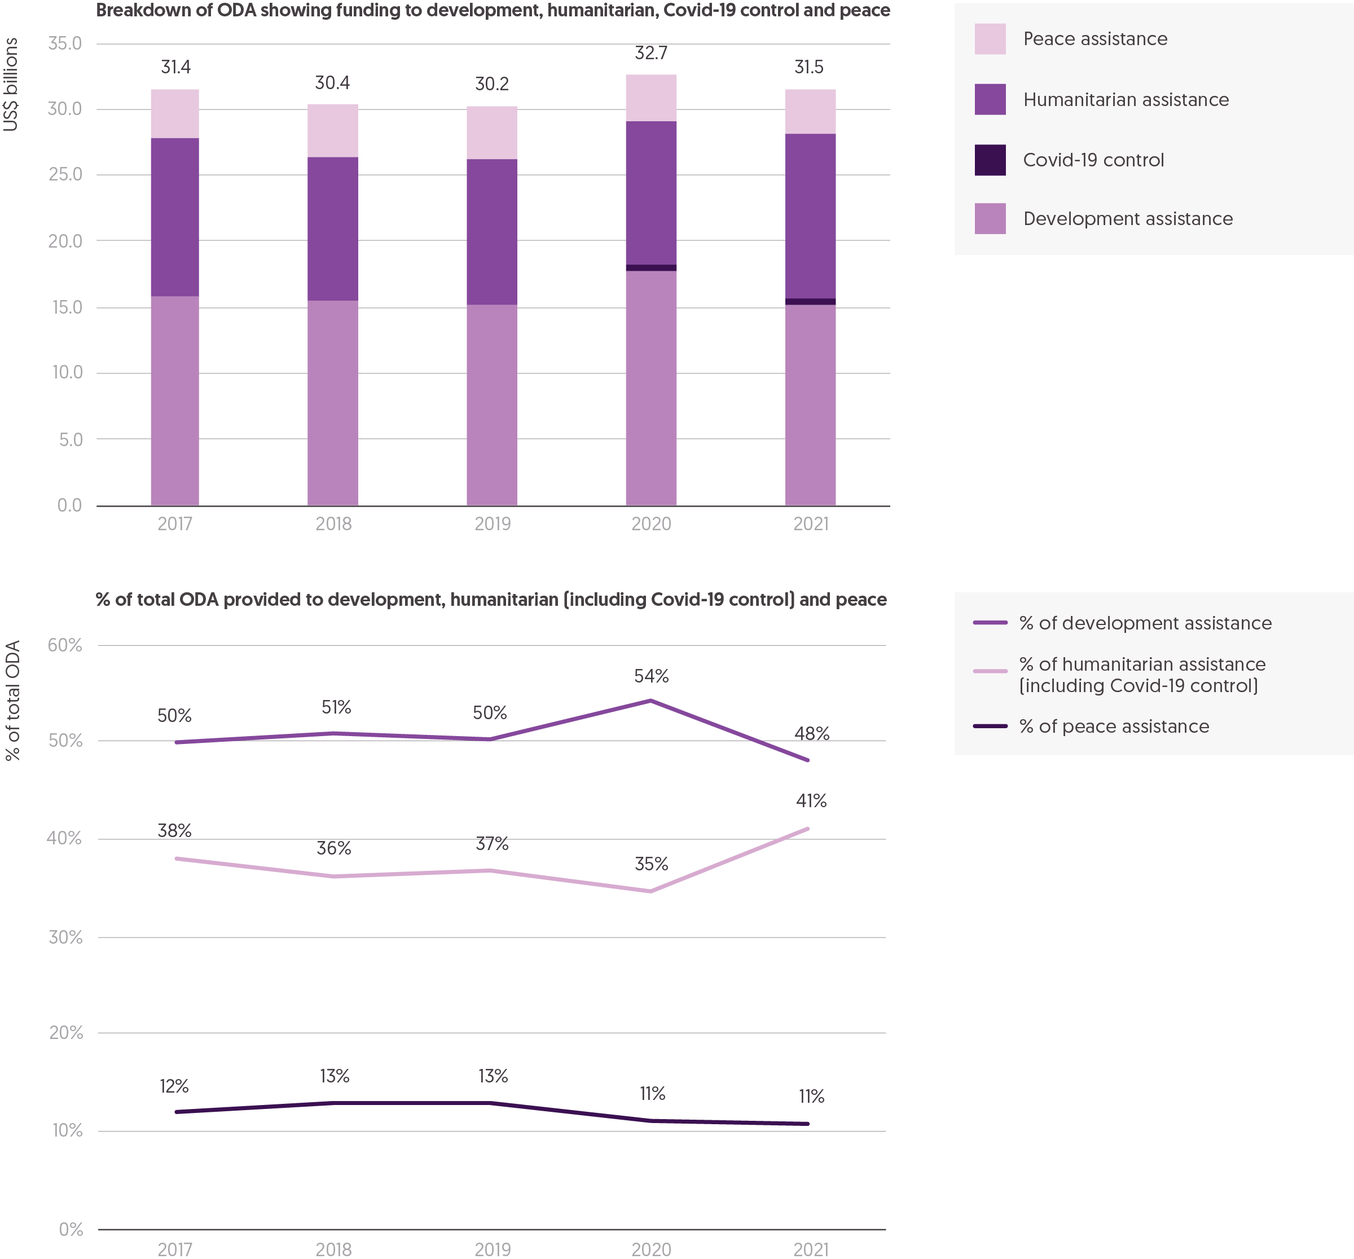

Source: Development Initiatives based on Organisation for Economic Co-operation and Development (OECD) Development Assistance Committee (DAC) Creditor Reporting System (CRS) and UN Office for the Coordination of Humanitarian Affairs (OCHA) Global Humanitarian Overview data.  
Notes: HRP = humanitarian response plan; ODA = official development assistance. Data is in constant 2021 prices. See the methodology section in Development Initiatives’ research paper ‘Leaving no crisis behind with assistance for the triple nexus’[79] for more detail on how ODA was classified into the categories displayed in the graph.

In parallel with humanitarian assistance responding to needs in crisis contexts, development and peace financing are fundamental to addressing the root causes of crises, upholding basic services and building resilience. To ensure complementarity and the appropriate balance of interventions between the three sectors, the Organisation for Economic Co-operation and Development (OECD) Development Assistance Committee (DAC) Recommendation on the Nexus emphasises a focus on always supporting the prevention of crises, fostering development wherever possible and humanitarian action only when necessary.[80] The number of countries experiencing protracted humanitarian crisis continues to grow (see Figure 1.2, Chapter 1), with 92% of country-allocable humanitarian funding targeted to these countries in 2022 (see Figure 2.4, Chapter 2). Yet, most of these countries have not seen a notable transition from humanitarian to longer-term development assistance. Such a shift could contribute to addressing some of the underlying socioeconomic causes of crises, alongside investments in peacebuilding, as well as addressing the impacts of climate change that increasingly contribute to humanitarian crisis (see ‘What climate finance is reaching countries in crisis?’ later in this chapter). There is a need for better coherence and coordination of these streams of finance, with the intersection of humanitarian assistance and climate finance increasingly important.

Looking at overall ODA, over the past five years countries experiencing protracted humanitarian crisis have seen the volume and proportion of the total ODA they receive as development assistance reduce. Analysis of the balance of financing for humanitarian, development and peace objectives[81] of ODA flows in 2021 across 30 countries with humanitarian response plans (HRPs) that year – of which 21 were experiencing protracted crises – suggests the following trends:

* The share of total country-allocable ODA from DAC donors targeting this group of protracted crisis countries reached a five-year low of 31% in 2021, down from 33% in 2019. This group of countries was therefore more strongly affected by the decline in the share of country-allocable ODA out of total ODA than other countries that receive aid.
* Potentially inconsistent with the DAC Recommendation on the Nexus, protracted crisis countries increasingly relied on humanitarian assistance,[82] receiving a five-year high of 41% of the total funding received from DAC members in 2021 compared to an average of 37% between 2017 and 2021.
* Over the same period, the volume and proportion of development assistance received by countries facing long-term crisis reduced (by US$0.6 billion and from 50% to 48%).
* In most recent data, from 2020 to 2021, development assistance from DAC members to those contexts decreased by US$2.5 billion (from 54% of total ODA received by those countries to 48%), while funding for humanitarian assistance (including Covid-19 control) increased by US$1.6 billion.
* ODA supporting peace objectives reached a five-year low of 11% in 2021, down from 13% in 2019, decreasing from US$3.9 billion to US$3.5 billion.

Despite this recent shift in the balance of aggregate funding to this group of protracted crises, the mix of humanitarian, development and peace funding from DAC members to individual crises has varied significantly over time. In some countries, the drastic changes in the resource mix of international assistance point to insufficient donor coordination, underlining the need for country-specific and evidence-based nexus financing strategies that enable a contextually appropriate implementation of the DAC Recommendation on the Nexus.

* For Afghanistan, the share of development assistance fell from 66% in 2017 to 38% in 2021. This was due to the combination of significantly higher levels of humanitarian funding in 2021 in response to rising needs and a reduction in development funding following sanctions in reaction to the Taliban seizing power. The rapid decline in development assistance for healthcare, for instance, contributed to the collapse of Afghanistan’s aid-dependent health sector.[83]
* The resource mix for international assistance to Iraq also changed leading up to its transition from humanitarian to a longer-term development response. Its HRP closed at the end of 2021 (see ‘Was humanitarian funding sufficient? Appeals, donors and total assistance’, Chapter 1); volumes of humanitarian assistance received declined between 2017 and 2021. However, this was not accompanied by a corresponding increase in development assistance, which was below 2017 levels in 2021. As a result, Iraq received less international assistance overall in 2021 than over the previous four years.

Further analysis is needed to unpack the impact of this increasing reliance of humanitarian assistance in crisis settings. For this, transparent data on the different humanitarian–development–peace funding streams at national and subnational levels is needed. This would help to inform the successful development and implementation of country-specific nexus financing strategies that ensure the correct balance of funding streams for the context.

The following sections unpack this wider picture of ODA funding to countries experiencing crisis and examine finance that can support specific areas of preparation and resilience building for shocks, in particular those related to climate change. They look at the ODA finance allocated for climate change mitigation and adaptation and funding for DRR.

Read the [recent report produced by DI and SIDA which analyses the balance of humanitarian, development and peace financing in crisis settings](https://devinit.org/resources/leaving-no-crisis-behind-assistance-triple-nexus-humanitarian-development-peace-funding/).

## What climate finance is reaching countries in crisis?

‘Climate finance’ includes a range of public and private, national and international sources targeted at reducing the causes and effects of climate change. The term is most frequently used as shorthand for the US$100 billion annual international commitment in the 2015 Paris Agreement to help the countries most vulnerable to climate change impacts[84] to reduce emissions (mitigation) and respond to accelerating impacts (adaptation). For countries experiencing protracted crisis and those with high vulnerability to climate impacts, international climate finance provides an important resource for lessening the impacts of climate-driven and climate-related crises. See [Figure 2.6 in the *Global Humanitarian Assistance Report 2022*](https://devinit.org/b0a2ed#b0003a99)for a conceptual diagram explaining climate finance flows.

In the context of growing numbers of countries facing protracted crises and increased exposure to multiple dimensions of risk, the impacts of climate change are driving new crises and exacerbating pre-existing humanitarian needs. Funding requirements linked to extreme weather are as much as eight times higher than they were 20 years ago.[85] Despite increasing numbers of climate-related crises, countries are not receiving enough coordinated finance by any measure to prepare for and alleviate the worst impacts of shocks.

Climate finance provided as ODA comes from bilateral government donors and multilateral climate finance initiatives. There are a number of these dedicated initiatives designed to facilitate the US$100 billion annual commitment and help low-income countries address the challenges of climate change.[86] [Current data informing our understanding of climate finance flows](https://devinit.org/resources/climate-finance-accounting-and-accountability/) is limited and in some cases possibly misleading,[87] however it is evident the US$100 billion target has yet to be met and overall climate finance remains insufficient.[88] Existing finance is usually directed towards high-value mitigation and adaptation projects often focused on infrastructure. The benefit of these projects may not be fully understood for households and communities. Additionally, these projects often have long delays between approvals and disbursements, which means immediate needs may not be addressed.[89]

Innovative and coordinated sources of finance are required to address the growing humanitarian finance gap, as well as to align the international agendas for climate, development and humanitarian action. While the goals of climate finance and humanitarian response overlap in seeking a reduction in the incidence and scale of climate impacts, they have different mechanisms and distinct forms of financing, resulting in poor coordination and significant gaps in coverage.

Reducing the worst impacts of climate change on the most vulnerable people requires recognising where climate objectives can and should align with an understanding of humanitarian need. Climate funders are often considered to be risk averse, requiring a stable infrastructure and secure contexts, but there is evidence to demonstrate that this risk is largely perceived, rather than actual, and can be overcome by strong partnerships with local and national actors.[90]

Additional finance for Loss and Damage (L&D) – meant to avert, minimise and address the adverse and unavoidable effects of climate change – could be one way to help these communities and fill existing gaps in the support they receive. However, this funding should be new and additional, as well as aligned with climate justice (see Harjeet Singh’s Insight piece, later in this chapter). Even with L&D finance, however, climate finance needs to be comprehensively tracked and transparently measured to ensure it is meeting the needs of those most vulnerable to climate impacts.

Read more from DI on [how inadequate reporting and tracking of climate finance data leads to reduced donor accountability](https://devinit.org/resources/climate-finance-accounting-and-accountability/).

Figure 4.2: Countries highly vulnerable to climate impacts that also experience protracted crisis have received around US$1 per person from multilateral climate funds between 2003–2022   
Multilateral per capita climate finance to countries experiencing protracted crisis and/or high vulnerability climate impacts

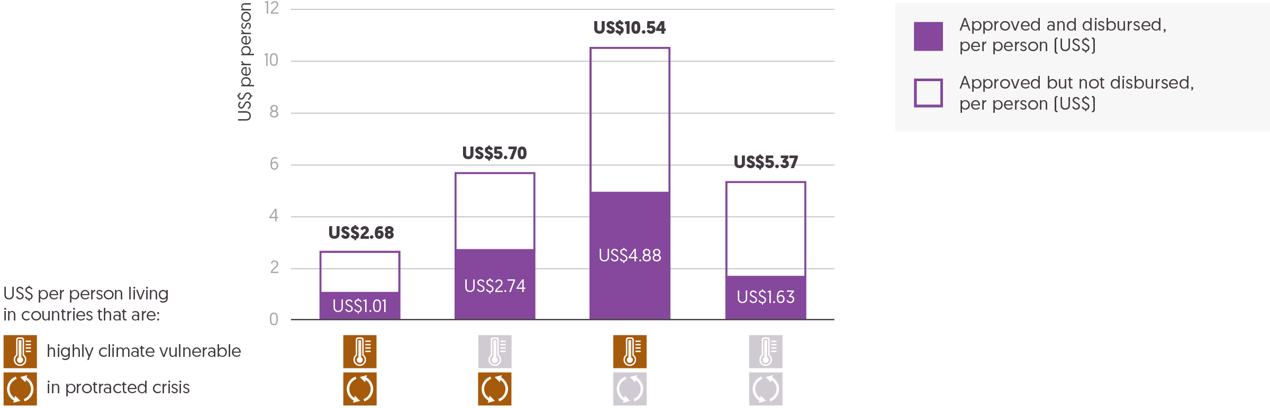  
Source: Development Initiatives based on Climate Funds Update, UN Office for the Coordination of Humanitarian Affairs (OCHA) Humanitarian Programme Cycle (HPC), UN High Commissioner for Refugees (UNHCR) and UN World Population Prospects.

Notes: Data is in constant 2021 prices. Only country-allocable funding is included.

Multilateral funds including the Green Climate Fund, which serves as the primary multilateral mechanism for climate finance, have provided very low levels of per capita climate finance since 2003. People in countries experiencing protracted crisis and with a high level of climate vulnerability have received less of this finance than others. Per capita, countries experiencing protracted crisis that are also highly vulnerable to climate change receive less multilateral climate finance than other highly vulnerable countries.

* The share of approved multilateral climate finance disbursed since 2003 in the countries most vulnerable to climate change but not in protracted crisis is just less than half (46%). In those most climate-vulnerable and experiencing protracted crisis, this share drops to 38%.
* Countries least vulnerable to climate change and not experiencing protracted crisis have had one-third (30%) of all multilateral climate finance disbursed since 2003.

Since 2003, the total amount disbursed per capita of multilateral climate finance to all countries is less than US$5.

* Over the last 20 years (since 2003), people in the most climate-vulnerable countries and who are also experiencing protracted crisis have received around US$1 per person of country-allocable funding from multilateral climate funds.
* Conversely, people in the most climate-vulnerable countries not experiencing protracted crisis have received almost five times this amount of country-allocable multilateral climate finance (US$4.88 per person).

Figure 4.3: In the countries most vulnerable to climate impacts, climate finance represents a smaller proportion of ODA than the global average

Climate finance to the countries most vulnerable to climate impacts

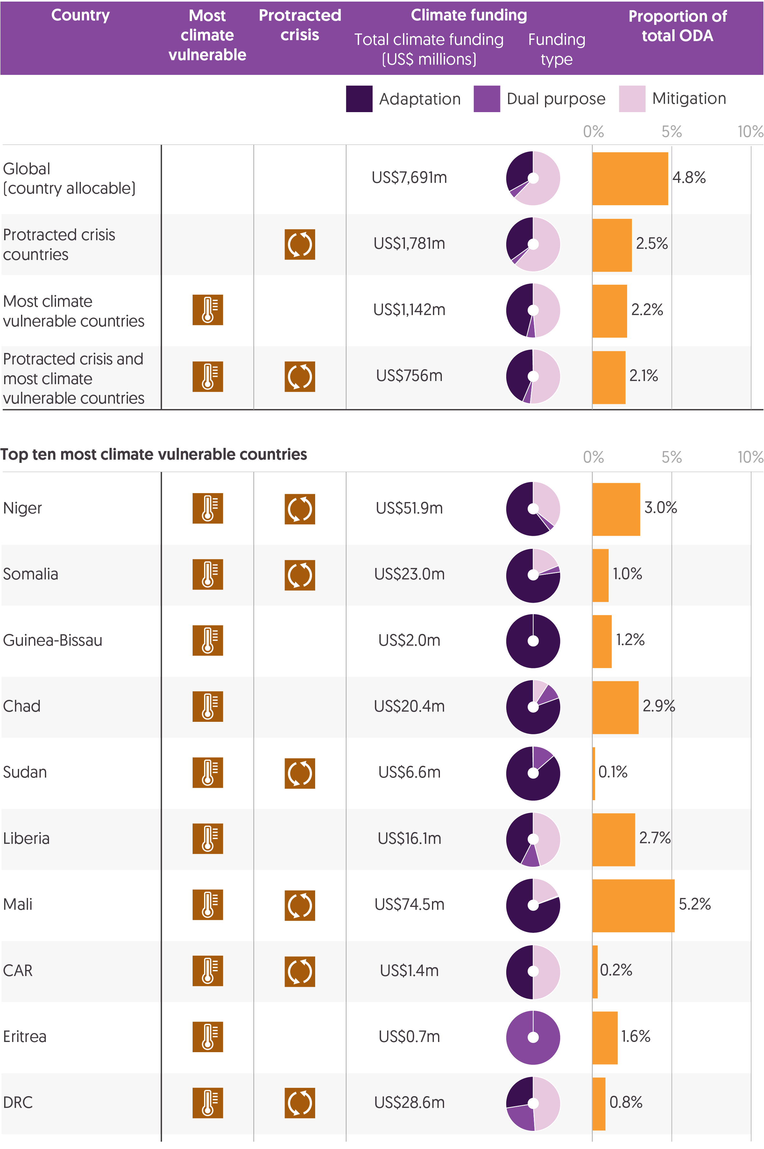  
Source: Development Initiatives based on Organisation for Economic Co-operation and Development (OECD) Development Assistance Committee (DAC) Creditor Reporting System (CRS), Notre Dame Global Adaptation Initiative, UN Office for the Coordination of Humanitarian Affairs (OCHA) Humanitarian Programme Cycle (HPC) and UN High Commissioner for Refugees (UNHCR).

Notes: CAR = Central African Republic; DRC = Democratic Republic of the Congo. Data is in constant 2021 prices. Adaptation and mitigation funding are defined as ODA marked as ‘principal’ with the climate change adaptation (CCA) or climate change mitigation (CCM) marker respectively. Climate vulnerability class is based on ND-GAIN resilience quintiles.

Between 2018 and 2021, the amount of climate finance overall increased, but it decreased both to countries with high levels of vulnerability to climate impacts and to those experiencing crisis.[91] Determining the sufficiency of climate finance in the context of humanitarian need requires an understanding of globally and nationally determined priorities, including the US$100 billion commitment, alongside a comprehensive picture of vulnerability, affected population size, levels of humanitarian need, and other intersecting streams of finance. Rarely are these factors addressed comprehensively through coordinated targeting of different streams of finance.

Climate finance should be new and additional over other ODA commitments, but the use of the Rio Marker tagging system obscures whether this ‘additionality’ is achieved.[92] Yet, looking at volumes of climate finance in relation to climate vulnerability or protracted crisis context illuminates very little about whether climate finance is sufficiently contributing to a decrease in humanitarian need. There currently exists no climate finance to specifically address accelerating impacts at the household level and volumes continue to fall extremely short of the US$100 billion commitment.[93]

Instead, measuring climate finance as a share of total ODA, especially when compared to global averages, can suggest some relationship between volumes, vulnerability and effective targeting. A share of ODA greater than the average in countries with high levels of vulnerability to climate change might suggest effective targeting, but a more detailed understanding of the projects funded by that climate finance and their ability to alleviate humanitarian need is required. The share of ODA represented by climate finance in countries experiencing protracted crisis and high levels of climate vulnerability is below the global average.

* In 2021, the average share of ODA represented by country-allocable climate finance globally was 4.8% (climate finance was the largest share of ODA in Brazil, at 27.0%). The average share of ODA climate finance represented in countries experiencing protracted crisis was 2.5% (US$1.8 billion), two-fifths the size of the share of ODA climate finance represented in countries not in protracted crisis (6.6%, US$5.9 billion).
* However, in 2021, countries with high vulnerability to climate impacts received even less: the share of ODA this climate finance represented was 2.2% (US$1.1 billion), less than half that of the global average. In general, countries for which the climate finance represented greater than a 10% share of ODA did not have high levels of vulnerability to climate impacts.[94]
* In countries that both were experiencing protracted crisis and had high vulnerability to climate impacts, climate finance represented a 2.1% share of ODA (US$756 million).
* Of the 10 countries most vulnerable to climate in 2021, Mali (5.2%), Chad (2.9%) and Niger (3.0%) had the highest share of climate finance as a proportion of total ODA, though volumes of climate finance to these countries varied widely (Mali, US$75 million; Chad, US$20 million; and Niger, US$52 million). Both Mali and Niger were experiencing protracted crisis in 2021.
* The countries most vulnerable to climate are all located in Africa and six of them (Niger, Somalia, Sudan, Mali, Central African Republic and Democratic Republic of the Congo (DRC)) are experiencing protracted crisis. Climate finance varies in both volume and proportion of ODA for these countries but, with the exception of Mali, is significantly less than the global average.

Current adaptation finance is estimated to fall at least 5–10 times short of what is needed to prepare low-income countries for accelerating climate impacts. In both volume and delivery, it is seriously hindered by a global ‘polycrisis’ in many places.[95] The US$100 billion commitment to climate finance covers both mitigation and adaptation as equally important activities. Adaptation finance is particularly critical in helping to reduce the impacts of crisis by preparing communities to withstand the shocks associated with climatic changes, such as through ecosystem-based adaptations or innovative, resilience-building finance mechanisms.[96]

Mitigation projects like energy transitions often account for greater funding but can provide substantial co-benefits when adaptation activities are factored in.[97] An effective mix of this financing should be aligned to nationally determined contributions,[98] which are developed by national governments and oriented around the state of greenhouse gas emissions and adaptation efforts, and would consider existing or potential humanitarian needs such as those related to food security, clean water or safe housing.

However, looking only at the volumes of this finance at the national level gives a limited picture of effective mitigation and adaptation,[99] which relies on understanding what is being financed subnationally, in which locations projects are supported, and their purpose – information that is not always available. In addition to the volume of funding available, access to finance and support in the delivery of the technical assistance are also important. Yet local actors often face significant barriers in this regard.[100] This leaves key sectors unsupported, unable to build institutional capacity and ultimately vulnerable to compounding risks and multiple crises.

Read DI’s factsheet on [climate-related funding flows to African countries](https://devinit.org/resources/climate-adaptation-finance-africa-key-facts/).

Aside from a slight trend in the five countries most vulnerable to climate impacts, there was no relationship between country-level vulnerability and the proportions of adaptation and mitigation finance received. On average, countries experiencing protracted crisis do not receive a significantly higher proportion of adaptation or mitigation finance than others.

* In 2021, country-allocable global mitigation finance (US$4.8 billion) was double global adaptation finance (US$2.5 billion). A smaller share of climate finance (US$357 million) was tagged as dual purpose (for both mitigation and adaptation), suggesting some overlap in activities that reduce emissions and respond to accelerating impacts. There may also be some overlap between climate finance and DRR.
* The five countries most vulnerable to climate change impacts received more adaptation than mitigation finance, but this trend is not consistent across other countries or related to risk level.
* With the exception of DRC, countries most vulnerable to climate impacts experiencing protracted crisis receive more adaptation than mitigation finance. DRC had a higher volume of mitigation (US$14 million) than adaptation (US$7.8 million) finance.

Insight: Harjeet Singh, Climate Action Network

*Harjeet Singh is a global expert on the issues of climate impacts, migration, and adaptation. He has supported countries across the world on tackling climate change, coordinating emergency response and disaster resilience programmes. He is the Head of Global Political Strategy at Climate Action Network International and serves as Global Director – Engagement and Partnerships at the Fossil Fuel Non-Proliferation Treaty Initiative. He is a member of the United Nations’ Technical Expert Group on Comprehensive Risk Management under the Warsaw International Mechanism for Loss and Damage. Harjeet co-founded Satat Sampada, a social enterprise that promotes sustainable environmental solutions such as organic food and farming in India and beyond.*

According to the most recent World Meteorological Organization report,[101] it is near certain that the period between 2023–2027 will be the hottest five-year period recorded. As greenhouse gas emissions continue to rise, and coupled with a naturally occurring El Niño event, the annual average near-surface global temperature will be more than 1.5°C above pre-industrial levels for at least one year in the next five. The Intergovernmental Panel on Climate Change (IPCC) Synthesis Report from March 2023[102] showed that while the window of time to avert the worst of the climate crisis is closing, every effort must be made to slash greenhouse gas emissions by half by 2030 to secure a liveable planet.

For those on the frontlines of the climate crisis, every fraction of a degree of warming means increased vulnerability to extreme events such as heatwaves, storms, floods, wildfires and rising seas. For instance, studies show that the ongoing drought in East Africa, the worst in 40 years, was made 100 times more likely because of climate change.[103] Millions of people have been displaced in the region and are on the brink of famine. Similarly, the unprecedented floods in Pakistan last year, affecting over 30 million people, have left a long-lasting humanitarian crisis with millions still displaced and suffering from disease, poverty and hunger.     
  
This shows the extent to which climate change remains the strongest driver of humanitarian crises, particularly for the poorest countries. These interlocking crises threaten to widen existing inequality, undo many gains made on poverty alleviation and food security, and exacerbate conflict and violence.

It is therefore critical that the humanitarian and climate justice communities work together to understand how best to prevent and address the fallout from climate disasters and ensure assistance reaches those most impacted on time.

In the Paris Agreement, responding to ‘loss and damage’ is considered a ‘third pillar’ of climate action. The recent IPCC reports show that as fossil fuel emissions continue to rise, more and more people will face the hard limits of adaptation and experience devastating climate impacts.

The costs of addressing loss and damage resulting from climate change in developing countries is estimated to range from US$290 billion to US$580 billion by 2030.[104] Despite setting up a Loss and Damage mechanism in 2013, the UN climate change system has so far been unable to help those least responsible for – but most impacted by – the climate crisis.

After 30 years of struggle to demand climate justice, a significant breakthrough was achieved last year to establish a Loss and Damage Fund at the COP27 climate conference in Sharm El-Sheikh, Egypt.

As I explained to UN OCHA, the Loss and Damage Fund should make a significant and ambitious contribution to combat climate change by focusing exclusively on addressing Loss and Damage, that is helping developing countries in their relief, recovery and rehabilitation efforts in the aftermath of a climatic event.[105]

It must be established as an operating entity acting as the third pillar of the Financial Mechanism of the United Nations Framework Convention on Climate Change (UNFCCC), which also serves the Paris Agreement. As both a coordination and financing mechanism, it should be the primary vehicle to coordinate, mobilise and channel new, additional, adequate and predictable financial resources to address Loss and Damage for developing countries and affected communities and people.

The Transitional Committee set up to implement the COP27 decision must complete its mandate of establishing the institutional arrangements, modalities and governance mechanisms for the Fund as well as defining the elements of the new funding arrangements.

Currently the humanitarian system, which is part of the existing funding support for the most vulnerable communities, is overwhelmed due to increasing frequency and severity of extreme weather events and the lack of resources that have limited its actions to mostly immediate response, not long-term recovery, reconstruction and rehabilitation. It has not been able to respond to slow-onset events such as sea level rise, melting glaciers and increasing pace of desertification, and it does not address non-monetised impacts such as loss of language, culture and biodiversity.

The humanitarian community must join the climate justice community in advocating for an ambitious outcome at COP28 in Dubai this December, which results in a coherent and coordinated response to address the climate-induced loss and damage at the required scale, speed and adequacy while ensuring access and justice to the most vulnerable.

This piece was compiled with the assistance of Dharini Parthasarathy.

## How much DRR finance is reaching countries in crisis?

Within the increased focus on anticipatory action,[106] international finance for DRR is a critical component in ensuring that development gains are preserved and the impacts from a disaster do not worsen vulnerability or compound existing crises. Recent discussions around the importance of DRR have focused on the increasing impacts of climate change, but DRR responds to a breadth of natural hazards in addition to those that are climate driven. It heavily emphasises disaster protections and government coordination beyond climate adaptations, such as early warning systems, risk mapping and disaster management training.[107] DRR has often been criticised for a focus on sudden and immediate hazards, but finance is also meant to cover slow-onset disasters, such as drought.[108]

International DRR finance is provided by bilateral and multilateral donors, either as grants or loans. There was a significant rise in the volumes of DRR finance between 2018 and 2022 from the 10 largest donors of DRR. This rise accompanied milestones such as the completion of the Midterm Review for the Sendai Framework for Disaster Risk Reduction (2015–2030) in 2023, the implementation of national and local DRR strategies, and the commitment to L&D finance at the UNFCCC conference in November 2022. While the quantity and quality of finance data has improved (with better reporting against the OECD DAC’s DRR marker), challenges remain to a comprehensive understanding of the impact of finance responding to climate and environmental risk, vulnerability and disaster.

Intersecting UN agendas (Sustainable Development Goals, the UNFCCC Paris Agreement and United Nations Office for Disaster Risk Reduction Sendai Framework)[109] and tracking of financial flows indicate some overlap and duplication between DRR and climate adaptation finance (see Figure 4.6). A full understanding of disaggregated risk (including by type, severity and extent subnationally), volume of finance and affected population size – information that is not available in all contexts – is critical for determining whether DRR is effective, especially in places experiencing crisis and without the necessary soft and hard infrastructure to implement DRR-related interventions.[110]

Read more from DI on [how critical funding gaps in addressing climate change impacts must be filled to ensure the resilience of vulnerable communities and countries](https://devinit.org/resources/filling-the-gap-addressing-climate-driven-crises-pakistan/).

Figure 4.4: Increases in funding from many of the top donors did not counterbalance decreases from other large donors of DRR

Largest funders to DRR, 2017–2021

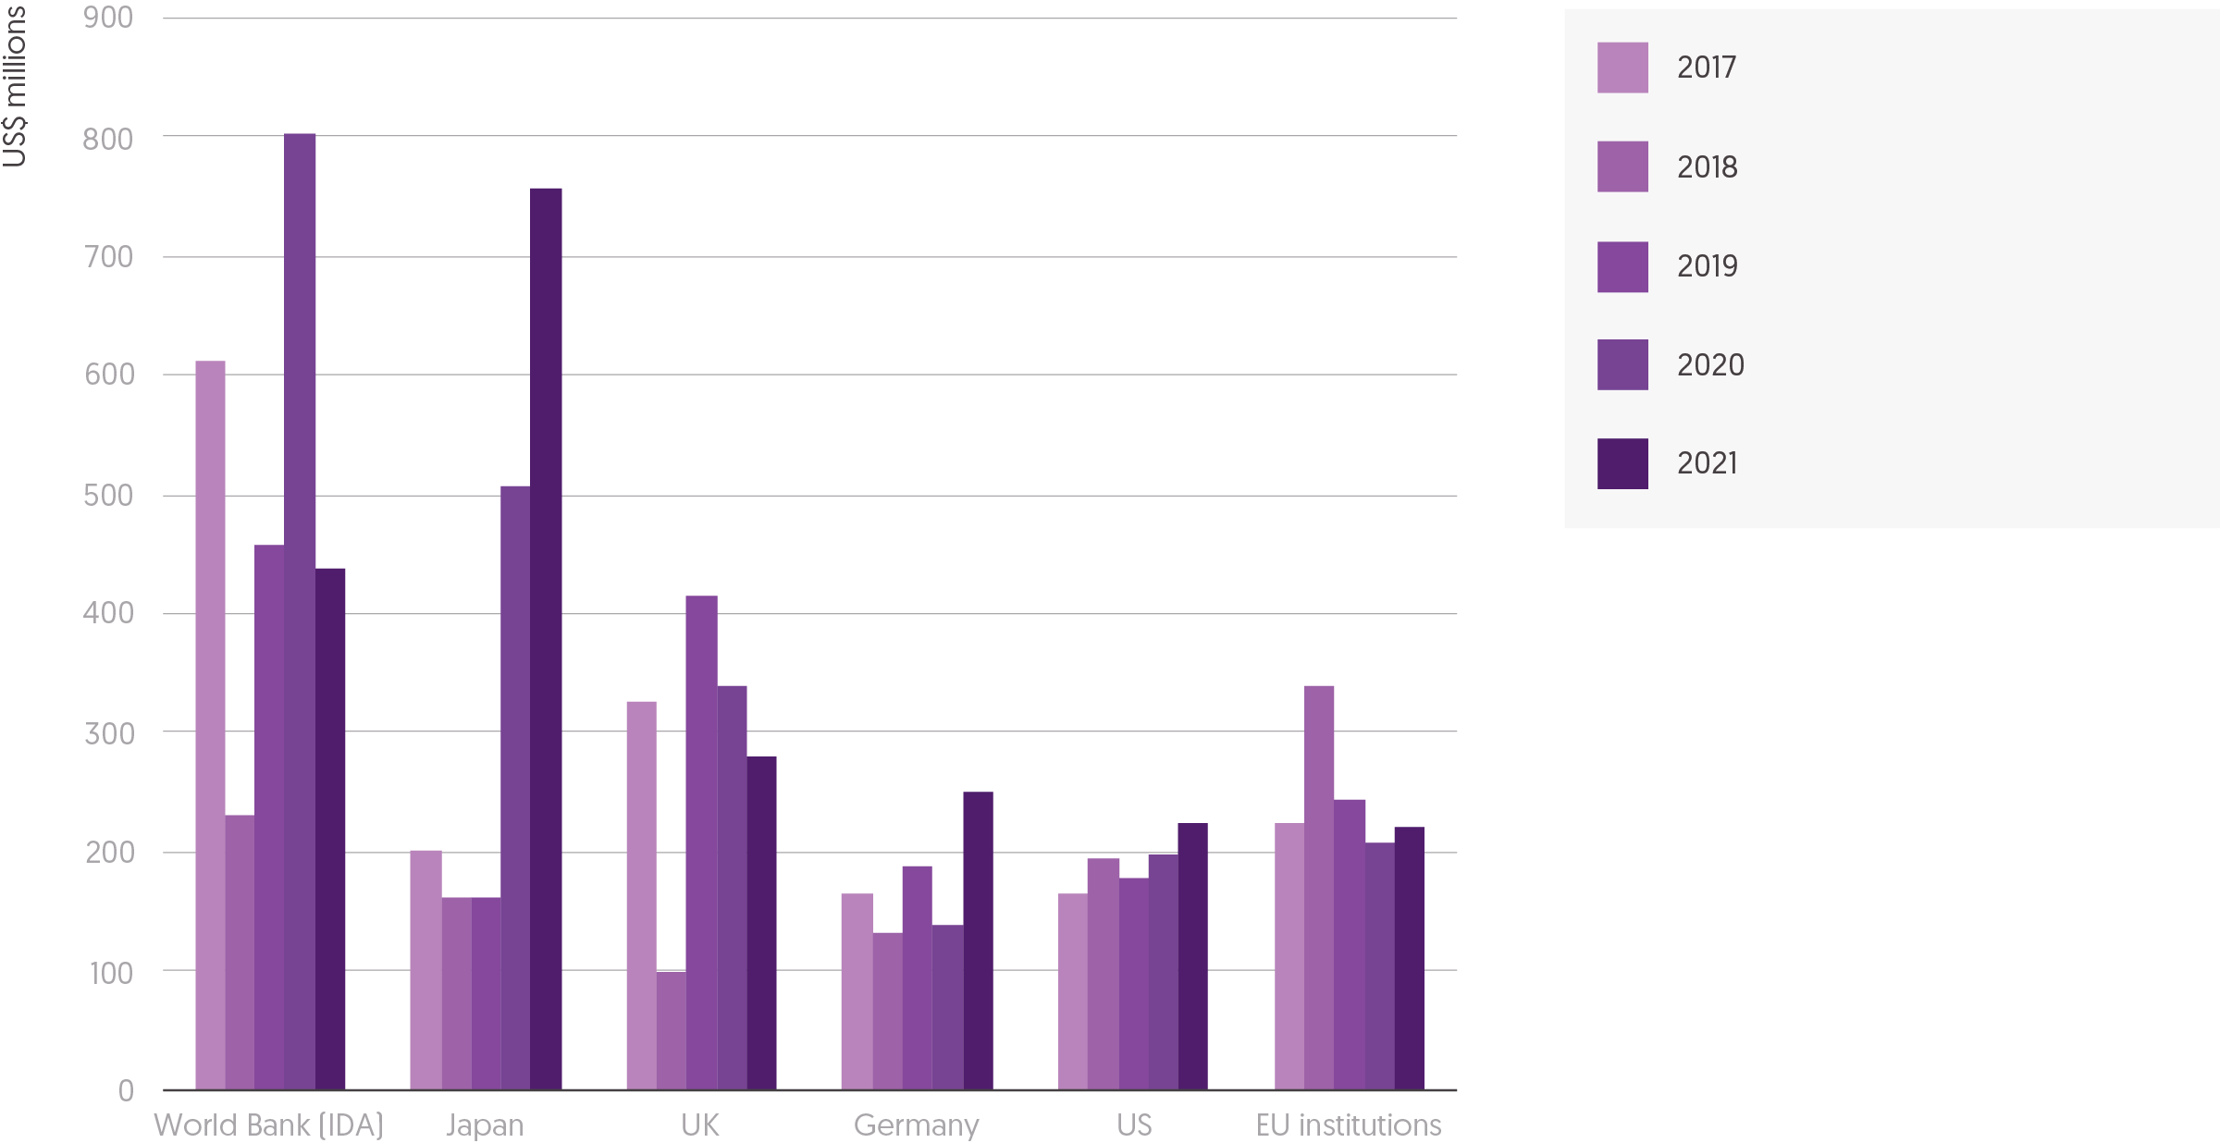Source: Development Initiatives based on Organisation for Economic Co-operation and Development (OECD) Development Assistance Committee (DAC) Creditor Reporting System (CRS).

Notes: IDA = International Development Association. Data is in constant 2021 prices. Disaster risk reduction (DRR) is defined as ODA under the DRR purpose code, marked as 'principal’ with the DRR marker, or identified by a tailored keyword search. DRR data excludes Covid-19-relevant flows and private development finance.

There has been a total of US$13.2 billion in DRR-related finance since reporting against the Sendai Framework began in 2017. For the first time in four years, following steady rises between 2018 and 2020, the total volume of ODA for the purpose of DRR decreased in 2021 (the latest year for which data is available).

* In 2021, the total ODA for the purpose of DRR from all donors decreased by 5% to US$3.0 billion.[111] This fall was the result of substantial decreases in bilateral ODA for the purpose of the DRR from the UK (down 20% to US$281 million) and other donors outside the top 10 (down 30% to US$123 million), alongside a return to 2019 levels of funding from the World Bank (down 45% to US$438 million).[112] Increases in funding from 7 of the 10 largest donors were not overall sufficient to counterbalance these reductions.
* The amount of ODA for the purpose of DRR provided by the UK has decreased by 32% (US$133 million) since 2019. This is consistent with reductions in the UK’s overall ODA expenditure in the same period and is notable in a context where other top 10 donors are increasing their contributions.
* Despite a decrease in funding, the UK remained one of the five largest bilateral donors of ODA for the purpose of DRR in 2021 (US$281 million), alongside Japan (US$758 million), Germany (US$250 million), the US (US$223 million), and France (US$170 million). The single largest year-on-year increase (80%, US$111 million) in 2021 was from Germany.
* From 2016–2021, Japan was the largest donor of ODA for the purpose of DRR, responsible for almost 13% (US$2.0 billion) of total spend during that period and US$290 million more than the second highest donor, the UK. In 2021, Japan was the largest donor and increased its year-on-year funding to DRR by nearly 50%, from US$507 million to US$758 million. Since 2019, Japan has consistently increased the amount of DRR finance it provides, most of which has gone to a handful of historically preferred partners, including Indonesia and Philippines.
* Multilateral donors contributed 31% (US$943 million) of the total ODA for the purpose of DRR in 2021, nearly half of which (46%, US$438 million) was from the World Bank. The Midterm Review of the Sendai Framework for Disaster Risk Reduction found that, while international and development financing institutions are increasing investments in resilience and risk transfer mechanisms, their approach to DRR remains incoherent and disconnected.[113]

In countries with a high debt burden, DRR provided as loans can contribute to cycles of crisis where recipient governments focus on servicing debt, which limits the resources that they have available to support affected populations.

* In 2021, 43% (US$1.3 billion) of the total ODA for the purpose of DRR was provided as loans. This is higher than the share of total ODA provided as loans (28%, US$61.8 billion) and since 2019 has increased 10 percentage points from 33%.

Effective DRR finance can support communities to identify risk and adequately prepare for disaster, lessening the impacts of crisis. In the last six years, large volumes of ODA for the purpose of DRR have gone to countries with high levels of identified risk to natural hazards, without factoring in additional risks such as socioeconomic fragility or the lack of institutional capacity and existing infrastructure,[114] such as Indonesia (US$1.1 billion), Philippines (US$505 million), Bangladesh (US$758 million) and Pakistan (US$628 million).

* In 2021, the top five recipients of ODA for the purpose of DRR were Indonesia (US$623 million), Vietnam (US$142 million), Pakistan (US$109 million), Bangladesh (US$104 million) and Philippines (US$103 million). All five of these countries had a high level of identified risk to natural hazards.
* With the exception of Bangladesh, the countries above experienced increases in the amount of funding they received from 2020 to 2021 (Indonesia, +81%; Vietnam, +22%; Pakistan, +19%; and Philippines, +102%). Bangladesh experienced a 17% decrease in the amount of funding it received over the same period. It is also notably the only country in the top five both at high risk for natural hazards and with a low coping capacity.

Countries with the highest levels of risk to disaster, when risk is determined as a combined measure of risk to natural hazards and low coping capacity, do not consistently receive large volumes of ODA for the purposes of DRR and are unable to completely realise the potential benefits of DRR infrastructure.[115] Therefore measuring risk to natural hazards alone cannot fully illustrate how effective DRR finance targeting is. Over half of these high-risk countries experienced a decrease in the amount they received as DRR finance.

* Of the top 10 countries at the highest risk for disaster, only 3 – Somalia, Pakistan and Bangladesh – were among the top 10 recipients of ODA for the purpose of DRR in 2021. In addition to the increase experienced by Pakistan and the decrease experienced by Bangladesh (noted above), Somalia experienced a year-on-year increase in its amount of DRR finance (by 43% to US$75 million in 2021).
* A further 6 of the top 10 countries at the highest risk for disaster experienced decreases in the amount of ODA for the purpose of DRR in 2021, the largest of which were: Madagascar (down 87% to US$3.2 million), Haiti (down 38% to US$22 million), Papua New Guinea (down 37% to US$1.6 million) and Myanmar (down 36% to US$9.9 million).
* As with climate finance, the volumes of international DRR finance alone are an insufficient determinant of DRR’s effectiveness. Looking at volumes as a share of ODA alongside levels of risk can offer some indication of targeting but must also factor in donor priorities and the scale and impacts of recent disasters. In regions covering small island developing states (SIDS) DRR represents the largest share of ODA. These regions include the Melanesia region (37% of ODA), the Caribbean region (20% of ODA) and the Micronesia region (12% of ODA). The Melanesia region includes the Solomon Islands, which is one of the top 10 countries at risk for disaster and for which DRR represented 0.8% (US$1.9 million) of ODA, suggesting that regional financing may also offer some indication of effective DRR.
* In 2021, the average share of ODA represented by DRR finance globally was 1.5% (DRR was the largest share of ODA in Indonesia, at 23%). The average share of ODA DRR represented in countries at highest risk for disaster was 0.6% (US$368.7 million).

Figure 4.5 Most DRR funding goes to countries in the Far East Asia or South of the Sahara regions.   
Country-allocable DRR funding by donor and recipient region, 2021

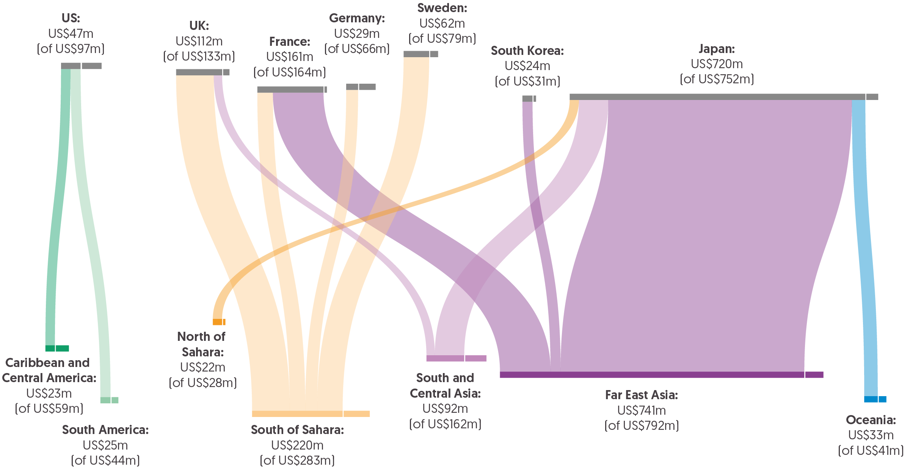

Source: Development Initiatives based on Organisation for Economic Co-operation and Development (OECD) Development Assistance Committee (DAC) Creditor Reporting System (CRS).  
Notes: Only total flows over $20m shown. Data is in constant 2021 prices. Disaster risk reduction (DRR) is defined as ODA under the DRR purpose code, marked as 'principal’ with the DRR marker, or identified by a tailored keyword search. DRR data excludes Covid-19-relevant flows and private development finance.

There is no consistent explanation for the variations in DRR finance, including sudden versus slow-onset disasters, reporting milestones or donor priorities. Volumes of finance can suggest a concentrated response to a certain kind of natural hazard or historically preferred partnerships. Some recipients, specifically those receiving funding from Japan, have experienced large increases in the volumes of DRR for the purpose of ODA since 2018. The result of this is that a third of all DRR finance is concentrated in one region and in just a handful of countries.

* In 2021, countries in the Far East Asia region[116] accounted for a third (US$961 million) of all ODA for the purpose of DRR.
* The top recipients overall of DRR in 2021 included Indonesia (US$623 million), Philippines (US$103 million) and Bangladesh (US$104 million), all at high levels of risk to natural hazards. Japan was responsible for over two-thirds of funding to these countries (81%, 70%, and 91%, respectively).
* Between 2019 and 2021, funding from Japan increased 371% (US$597 million), an amount almost equal to the increases in funding for the same period to Indonesia (+US$585 million), Philippines (+US$32 million) and Bangladesh (+US$13 million).

Figure 4.6: The proportion of DRR finance is greater than that of climate change adaptation finance, in some cases many times over   
DRR and CCA funding to countries at the greatest risk of natural hazards and with low coping capacity

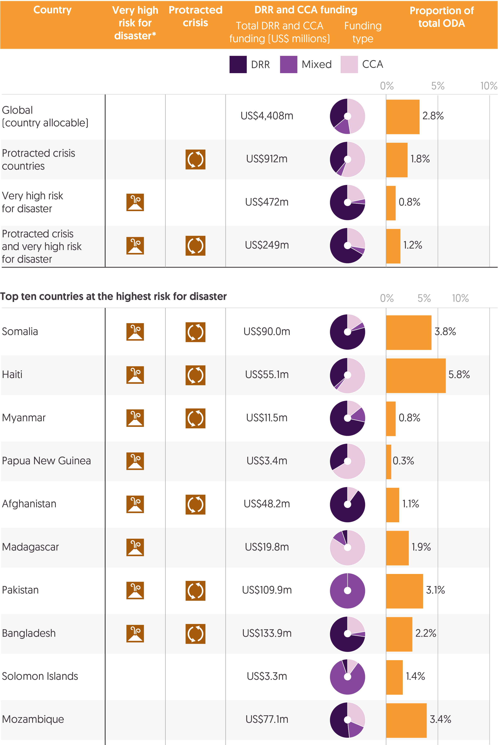

Source: Development Initiatives based on Organisation for Economic Co-operation and Development (OECD) Development Assistance Committee (DAC) Creditor Reporting System (CRS), INFORM Index for Risk Management, UN Office for the Coordination of Humanitarian Affairs (OCHA) Humanitarian Programme Cycle (HPC) and UN High Commissioner for Refugees (UNHCR).

Notes: Data is in constant 2021 prices. Climate change adaptation (CCA) is defined as ODA marked as ‘principal’ with the CCA marker. Disaster risk reduction (DRR) is defined as ODA under the DRR purpose code, marked as 'principal’ with the DRR marker, or identified by a tailored keyword search. Climate risk class is based on INFORM natural hazards and coping capacity score quintiles. DRR data excludes Covid-19-relevant flows and private development finance.

DRR can contribute to a country’s capacity to manage the risk of disasters driven or made more severe by climate change. It therefore has a complementary role to climate change adaptation finance, though both their combined volumes and the share of ODA they represent can only serve as a rough proxy for effective targeting and resilience building. A comprehensive picture would require a thorough understanding of the types of projects both forms of finance support in each location, alongside nationally determined priorities, the objectives for relevant global agendas, the size of the impacted populations and a more detailed picture of risks, vulnerabilities and their drivers. As it is for countries that are most vulnerable to climate change (see Figure 4.3), volumes of ODA for the purpose of climate change adaptation are very small in countries with the highest levels of risk to disaster, especially when those volumes are compared to DRR spending. This suggests that two key anticipatory flows meant to make communities more resilient to climate change impacts not only are insufficient but also may not be working in concert to stem the worst of these impacts.

* In 8 of the 10 countries at the highest risk for disaster in 2021, where overall volumes of both ODA for the purpose of DRR and climate change adaptation remain low, the proportion of DRR finance is greater than that of climate change adaptation finance (and in some cases many times over).
* DRR finance in Somalia, which is both at highest risk for disaster and one of the countries most vulnerable to climate impacts, is four times greater than climate change adaptation finance (US$75 million versus US$19 million). In Myanmar, DRR finance is 3 times greater (US$9.9 million versus US$3.5 million); in Afghanistan, 6.5 times greater (US$44 million versus US$6.6 million), and in Pakistan, where climate-related floods impacted nearly 33,000 people in 2022, a startling 43 times greater (US$109 million versus US$2.5 million).

In crisis-affected countries, where existing vulnerabilities and risk are exacerbated by accelerating climate impacts, it is crucial to prioritise finance for DRR and climate change adaptation. This funding helps these vulnerable countries to prepare for climate impacts and protect their development progress. By examining the proportion of DRR and climate change adaptation finance compared to overall ODA, we can assess the level of support provided for these activities in countries receiving this assistance. Countries experiencing protracted crisis, regardless of risk to disaster and level of climate vulnerability receive less DRR and climate adaptation finance than other countries.

* ODA for both the purposes of DRR and climate change adaptation makes up a greater share of ODA (4.8%) in countries not experiencing protracted crisis. In protracted crisis countries, ODA for both the purposes of DRR and climate change adaptation accounts for 1.8 % of ODA.

The gap in the average share of ODA suggests unmet need in countries experiencing protracted crisis, which will be more vulnerable to intersecting dimensions of risk and cycles of crisis. Clear financial tracking is imperative to understand whether and how finance is supporting these countries to meet the objectives of both DRR and climate change funding, is new and additional, and is adequately responding to climate change impacts.

* Some DRR and climate change adaptation is reported as both forms of finance. This dual-purpose spending suggests that projects can overlap between global frameworks and that climate impacts require a multisectoral response. Projects that are reported as both DRR and CCA, for example some large infrastructure projects, could require specific and facilitating contexts, which would explain why this overlap is greater in countries not experiencing protracted crisis. However, climate finance should be new and additional to other ODA spend and as such should not overlap with DRR flows. This dual-purpose spending calls into question the true additionality of climate finance. In 2021, an increasing amount (US$922 million, up from US$418 million in 2020) of bilateral ODA was tagged as both DRR- and climate change adaptation-related, and this spending was significantly greater in countries not experiencing protracted crisis (US$882 million compared to US$40 million).
* The Green Climate Fund (GCF) and the Global Environment Facility (GEF), both UN mechanisms established for environmental and climate spending, provide DRR finance (combined US$70 million in 2021).[117]

DRR finance is part of a suite of options, including climate finance and humanitarian funding, that can support response, recovery and resilience-building to a crisis, preserve development gains, and reduce overall vulnerability to successive impacts. Research suggests that the finance can be transformative when local and national actors are involved and when a clear understanding of disaster risk is mainstreamed at all government levels and across sectors.[118] In fragile and conflict-affected states with low coping capacity, the impacts of a disaster are exacerbated by smaller amounts of ODA for the purpose of DRR, suggesting the benefits of a joined-up approach to global development agendas and sufficient anticipatory action continue to fail to be realised.

Insight: Christina Bennett, Start Network

*Start Network is a membership organisation of 80 local, national and international humanitarian civil society organisations operating across six continents. Its aim is to achieve a locally led humanitarian system that centres communities affected by and at risk of crisis as agents of change, in order to save more lives, uphold dignity and protect people from loss and harm. Start Network contributes to the ambitions of the Sendai Framework for Disaster Risk Reduction by shifting when and how its member organisations, and communities themselves, approach disaster response, wherever possible acting before a crisis happens.*

In the case of quick-onset crises (such as cyclones, flood, hurricanes and heatwaves), the window of opportunity to act ahead of an event is only a few days; in more cyclical crises, such as seasonal drought, that window can be as long as six months. Across all of these contexts, it is crucial to combine targeted activities in the specific window of opportunity with the ongoing and the systematic use of DRR mechanisms and operational preparedness to create the enabling environment for anticipatory action to succeed.[119]

This ‘anticipatory’ approach involves three key components: pre-identifying and modelling risks through strong analytics, pre-positioning and pooling of funds, and pre-planning through detailed contingency plans developed by local organisations or governments and involving at-risk communities themselves. Anticipatory actions are triggered when specific risk thresholds are met, such as insufficient rainfall or extreme temperature rise.

Successful anticipatory action relies on investments in multi-hazard early warning systems and in access to risk information by local organisations and governments. Risks need to be fully understood and modelled through the ongoing and systematic collection of data related to the specific risks, vulnerabilities and impacts different hazards may have on the population. Continuous monitoring of hazards needs to be in place to allow the population to be alerted and warned. Early warning public messaging needs to be timely and clear, contain usable information, and reach deep into communities to enable local organisations to act.

Start Network members help to ensure these activities are led by local organisations and informed by local knowledge and expertise by working through its network of hubs, coalitions of local, national and international civil society organisations that share expertise and good practice, drive the design of contingency plans, shape community resilience plans, and support longer-term DRR activities.

Although the evidence base for this approach is emerging, anecdotal evidence suggests that the impact of such an approach is clear. For example, Start Network members in Pakistan, through its Pakistan Hub, developed a specific risk finance system for heatwaves over a period of two years, to improve in-country capacity and prepare local actors to properly manage the risk and intervene ahead of the crisis. The risk system included detailed community-informed contingency plans around heatwaves ahead of the hottest months. When these heat triggers were met in three regions between June and July 2022, Start Network released funds to jump start the hub’s pre-planned activities.

DRR and anticipatory action are essential in the humanitarian sector and play a significant role in mitigating the negative impact of disasters on vulnerable communities experiencing crisis. By taking a proactive approach towards disaster prevention, these tools can help save lives, minimise disaster impact, build resilience, promote sustainable development, and improve the livelihoods of those experiencing crisis. As such, it is essential that the humanitarian sector and governments continue to invest and implement this framework to ensure that vulnerable communities are protected and disasters are mitigated before they occur.

Chapter 5 – Methodology and definitions

## What is humanitarian assistance?

Humanitarian assistance is intended to save lives, alleviate suffering and maintain human dignity during and after human-made crises and disasters associated with natural hazards, as well as to prevent and strengthen preparedness for when such situations occur. Humanitarian assistance should be governed by the key humanitarian principles of humanity, impartiality, neutrality and independence. These are the fundamental principles of the international Red Cross and Red Crescent Movement, which are reaffirmed in UN General Assembly resolutions and enshrined in numerous humanitarian standards and guidelines.

In this report, when used in the context of financing data, international humanitarian assistance refers to the financial resources for humanitarian action spent outside the donor country. Our calculations of international humanitarian assistance are based on what donors and organisations report as such and do not include other types of financing to address the causes and impacts of crises, which we refer to as crisis-related financing.

There is no universal obligation or system for reporting expenditure on international, or indeed domestic, humanitarian assistance. The main reporting platforms for international humanitarian assistance are the Organisation for Economic Co-operation and Development (OECD) Development Assistance Committee (DAC) and the Financial Tracking Service (FTS) of the UN Office for the Coordination of Humanitarian Affairs (OCHA). Increasingly, data on humanitarian activities is also published according to the International Aid Transparency Initiative Standard.[120] OECD DAC members are obligated to report their humanitarian assistance to the DAC systems as part of their official development assistance (ODA), in accordance with definitions set out by the DAC.[121] Some other governments and most major multilateral organisations, including several of the largest private philanthropic foundations, also voluntarily report to the DAC.

The FTS is open to all humanitarian donors and implementing agencies to voluntarily report contributions of internationally provided humanitarian assistance according to a set of inclusion criteria determined by the Inter-Agency Standing Committee.[122]

The analysis of international humanitarian assistance in the *Global Humanitarian Assistance Report 2023* draws largely on data reported to the FTS and the OECD DAC. Between these two sources, there is variation in inclusion criteria for humanitarian assistance, as well as volumes reported, so we aim to consistently explain and cite the data sources used. In this GHA report, we have compared the preliminary DAC and FTS data on humanitarian funding by donor in 2022 to capture the most comprehensive data possible, as explained in more detail below. Since the 2018 report, we have included humanitarian funding reported to FTS that has been provided by OECD DAC members as assistance to countries not eligible for ODA. We also use other sources to calculate international humanitarian assistance, including reports from UN agencies and non-governmental organisations (NGOs) on private humanitarian funding and data from the Central Emergency Response Fund on contributions from public donors; data sources and methodologies for these are also clearly marked and explained.

## Cash

Our global estimate of humanitarian assistance provided in the form of cash and vouchers in 2022 is based on data collected from 29 organisations by the CALP Network and supplemented with FTS data. For 2022, 98% of the total global value of humanitarian cash and voucher assistance (CVA) is based on survey data and around 2% supplemented with FTS data for implementing agencies that did not complete surveys on their volumes of CVA. Similarly, in the previous five years over 90% of the data on global volumes of humanitarian cash and voucher assistance was based on survey data and 10% or less on FTS data. The methodology used for this analysis is outlined in greater detail in Development Initiatives’ recent research on [tracking cash and voucher assistance](https://devinit.org/resources/tracking-cash-voucher-assistance/)*.*[123]This methodology was further improved upon for this report by including funding reported to FTS for projects under humanitarian response plans, for which 50% or more of the project budget was allocated for cash and/or voucher assistance.

## Channels of delivery

We use ‘channels of delivery’ to describe the first and subsequent levels of organisations receiving funding for the delivery of humanitarian assistance – multilateral agencies, NGOs (both international and local/national), the public sector and the international Red Cross and Red Crescent Movement – whether they deliver the assistance themselves or pass it on to partner organisations. Our data on channels of delivery in Figure 3.1 (Chapter 3) comes from the FTS.

## Climate-related ODA

This data includes all ODA disbursements reported to the OECD DAC Creditor Reporting System (CRS) and marked with a relevant Rio marker by DAC members, multilateral organisations and other government donors that voluntarily report to the OECD DAC. The two Rio markers can be used to report the relevance of any ODA funding in terms of:

* Mitigation, where a project contributes to stabilising greenhouse gas concentrations in the atmosphere by promoting efforts to reduce or limit greenhouse gas emissions or enhance greenhouse gas sequestration
* Adaptation, where a project seeks to reduce the vulnerability of human or natural systems to current and/or expected impacts of climate change.

We include ODA marked as principal only for both markers.

## Country and region naming conventions

Country and region naming conventions used throughout this report are based on those used by the OECD DAC or the UN. Region naming conventions are based on those used by the OECD. The conventions used do not reflect a political position of Development Initiatives.

## Deflators

Where appropriate in performing analyses of financial trends, we adjust for inflation by applying deflators in constant 2021 prices by source location of the funding. We use US$ gross domestic product deflators from the OECD DAC for DAC members and EU institutions and calculate these deflators from International Monetary Fund Economic Outlook April 2023 data for other countries. In the limited cases where data was missing from both of these sources, we estimate deflators based on the historical average real and nominal growth of gross domestic product based in US$. For financial flows that have a multilateral source, we deflate using the ODA-weighted average DAC deflator from the OECD. Consistent with our annual methodology, data in the *Global Humanitarian Assistance Report 2022* was shown in constant 2020 prices, so totals may vary between reports.

## Dimensions of vulnerability, fragility and risk

We focus on three intersecting dimensions facing people in need in our analyses: climate vulnerability, socioeconomic fragility and conflict risk. We use country-level data for each of those dimensions.

We classify countries’ climate vulnerability using data from the Notre Dame Global Adaptation Initiative (ND-GAIN) vulnerability index. We identify people living in countries ranked in the top quintile of this index as having high climate vulnerability. People living in countries with no index data are assumed not to have high vulnerability.

The classification of socioeconomic fragility is based on the OECD States of Fragility framework 2020. Country-level socioeconomic fragility is calculated as the average of the framework’s first principal components of social, political and economic fragility dimensions. We identify people living in countries in the top quintile of this index as having high socioeconomic fragility. Countries with no index data are assumed not to have high fragility.

Our classification of high-intensity conflict risk uses information from the Conflict Barometer 2022 (of the Heidelberg Institute for International Conflict Research). Country-level conflict intensity is taken as the maximum of any sub-state, intra-state, and inter-state conflict intensity scores. People living in countries with a conflict score of 4+ (high-intensity, violent conflict) are identified as those with high-intensity conflict risk. People living in countries with no conflict data are assumed not to have high-intensity conflict risk.

## Disaster risk reduction-related ODA

For our analysis of ODA for the purpose of disaster risk reduction (DRR) in 2021 (see ‘How much DRR finance is reaching countries in crisis?’, Chapter 4), we include the following funding flows as reported to the OECD DAC CRS:

* Funding reported with the purpose code 43060 ‘Disaster risk reduction’
* Funding reported as principal under the ‘Disaster risk reduction’ marker, expressing DRR as principal objective of the associated activity
* Additional funding with DRR as principal objective as expressed by the project information reported to the CRS (this additional funding was identified by Development Initiatives through a search for DRR keywords in the project titles and descriptions of CRS entries; the output of the keyword search was then manually screened for relevance to DRR).

ODA in 2020 to the newly added ‘Covid-19 control’ purpose code that has also been marked as relevant to DRR has been excluded from this analysis, to focus on the risk reduction for natural hazards and to avoid conflating that with pandemic risk.

## Exchange rates

To convert original currency values into US$ values, we use exchange rates from the OECD DAC for currencies of DAC members, UN operational exchange rates for other currencies, and supplement with World Bank Development Economics Vice Presidency alternative conversion factors where these are not available. The UN operational exchange rates are also used by UN OCHA FTS.

## Food insecurity

Acute food insecurity classification data is from the Integrated Food Security Phase Classification / Cadre Harmonisé (IPC/CH), supplemented by UNOCHA’s Humanitarian Programming Cycle (HPC). From IPC/CH, we classify people living in ‘crisis’, i.e. Phase 3 or higher, as being acutely food insecure. From UNOCHA HPC, we classify those in need of humanitarian assistance under the food security sector as being acutely food insecure. Acute food insecurity numbers and phases are as reported or projected by the data year’s most comprehensive IPC/CH survey or UNOCHA HPC appeal year.

Country-level food insecurity phases are calculated based on IPC/CH’s methodology of the highest phase experienced by at least 20% of the population. For countries with only UNOCHA HPC data, we estimate whether the country-level phase is either above or below equivalent Phase 3 (3-, 3+) based on the number of people in need under the food security sector.

For a trend comparison at a country level, we use data from before the Covid-19 pandemic (2017/18/19), against the most recent data year available (2022/23). Data for 2023 is preliminary, relying on partial data, projections from IPC/CH and forward-looking estimates from UNOCHA. These estimates are subject to change, both at a country level and in terms of which countries are assessed.

Food insecurity severity is calculated based on an adapted Foster-Greer-Thorbecke (FGT; α=1) index that weights higher phases of food insecurity to produce a comparable index of severity.

## Funding for local and national actors

Our analysis of direct and indirect funding to local and national actors in Figures 3.1 and 3.2 (Chapter 3) uses data from FTS alongside data from the UN OCHA country-based pooled funds (CBPFs) data hub. FTS data is coded according to a set of organisational categories outlined below. We then combine this FTS data with data available from CBPFs on the funds’ direct funding to local and national actors, which uses the funds’ own classifications of recipients that might differ from the definitions below. For our own coding process of FTS data, we use the following categories of local and national non-state actors and national and subnational state actors, as defined by the Inter-Agency Standing Committee Humanitarian Financing Task Team in its *Localisation Marker Definitions Paper*.[124]

* National NGOs/civil society organisations (CSOs): national NGOs/CSOs operating in the aid-recipient country in which they are headquartered, working in multiple subnational regions, and not affiliated to an international NGO. This category can also include national faith-based organisations.
* Local NGOs/CSOs: local NGOs/CSOs operating in a specific, geographically defined, subnational area of an aid-recipient country, without affiliation to an international NGO/CSO. This category can also include community-based organisations and local faith-based organisations. We combine this category with national NGOs in our analyses.
* Red Cross/Red Crescent National Societies: national societies based in and operating within their own aid-recipient countries.
* National governments: national government agencies, authorities, line ministries and state-owned institutions in aid-recipient countries, such as national disaster management agencies. This category can also include federal or regional government authorities.
* Local governments: subnational government entities in aid-recipient countries exercising some degree of devolved authority over a specifically defined geographic constituency, such as local/municipal authorities.
* Additionally, international NGOs based in aid-recipient countries are classified as national NGO/CSO in our analysis of funding to local and national actors when carrying out operations in the country in which they are headquartered.

## International humanitarian assistance

Our estimate of total international humanitarian assistance is the sum of that from private donors and from government donors and EU institutions (see Figure 1.3, Chapter 1). Our calculation of international humanitarian assistance from government donors up to 2021 is the sum of:

* ‘Official’ humanitarian assistance (OECD DAC donors)
* International humanitarian assistance from OECD DAC donors to countries not eligible for ODA from the FTS
* International humanitarian assistance from donors outside the OECD DAC using data from the FTS.

Our ‘official’ humanitarian assistance calculation comprises:

* The bilateral humanitarian expenditure of OECD DAC members, as reported to the OECD DAC database under Table 1
* The multilateral humanitarian assistance of OECD DAC members.

The multilateral humanitarian assistance of OECD DAC members consists of three elements.

* The unearmarked ODA contributions of DAC members to 10 key multilateral agencies engaged in humanitarian response: the Food and Agriculture Organization, IOM, the UN Development Programme, UNFPA, UNHCR, UN OCHA, UNICEF, UNRWA, WFP and WHO, as reported to the OECD DAC under Table 2a and the CRS. We do not include all ODA to the Food and Agriculture Organization, IOM, the UN Development Programme, UNFPA, UNICEF, WHO and WFP but apply a percentage to take into account that these agencies also have a ‘development’ mandate. These shares are calculated using data on humanitarian expenditure as a proportion of the total received directly from each multilateral agency.
* The ODA contributions of DAC members to some other multilateral organisations (beyond those already listed) that, although not primarily humanitarian-oriented, do report a level of humanitarian aid to OECD DAC Table 2a. We do not include all reported ODA to these multilateral organisations but just the humanitarian share of this.
* Contributions to the UN Central Emergency Response Fund that are not reported under DAC members’ bilateral humanitarian assistance. We take this data directly from the UN Central Emergency Response Fund website.

When presenting the international humanitarian assistance of individual OECD DAC countries that contribute to the EU budget, we show in Figure 1.5 (Chapter 1) an imputed calculation of their humanitarian assistance channelled through the EU institutions, based on their ODA contributions to the EU institutions. We do not include this in our total international humanitarian assistance and response calculations or in our ranking of donor contributions to avoid double counting, given the EU institutions are also presented as donor separately.

Our estimate for official humanitarian assistance in 2022 compares preliminary data by donor between DAC and FTS to reflect the most comprehensive data available. Where humanitarian assistance reported to FTS was greater than official humanitarian assistance based on DAC data as defined above, we used FTS data. Where humanitarian assistance reported to FTS was greater than bilateral humanitarian assistance based on DAC data only, we used FTS data plus imputed multilateral humanitarian assistance based on DAC data. Otherwise, we used an estimate of official humanitarian assistance based on DAC data only. For our analysis of funding by donor on FTS we used the flow year for paid contributions and the destination usage year for commitments to try and capture funding in the year it was or expected to be disbursed.

Türkiye is captured and shaded differently in Figures 1.5 and 1.6 (Chapter 1) because the humanitarian assistance that it voluntarily reports to the DAC largely comprises expenditure on hosting Syrian refugees within Türkiye. We do not include Türkiye’s spending on Syrian refugees in Türkiye in our total international humanitarian assistance and response calculations elsewhere in the report, as these include only amounts directed internationally by donors.

In this year’s report, we use data from the FTS on volumes of international humanitarian assistance by recipient countries for 2022 data, which will become available in the OECD DAC CRS in December 2023 or later. FTS data was downloaded on 28 April 2023.

## People in need and people targeted for assistance

We drew estimates of people in need (PiN) from the UN OCHA Humanitarian Programme Cycle (HPC), supplemented by INFORM/ACAPS. Our analysis of PiN by country uses the maximum out of HPC final-year estimates for country-level humanitarian response plans (HRPs), and out of the highest value of PiN by country from INFORM/ACAPS. To avoid double-counting, we do not include PiN as estimated for flash appeals (FAs) or regional response plans (RRPs) for countries where a country-level HRP already exists. Figures for 2023 are preliminary, with data extracted 28 April 2023. 2017 and earlier PiN figures reflect the total people receiving humanitarian assistance under inter-agency coordinated response plans only.

For our analyses of PiN and and PiN disaggregated by sex and age, we used HPC final-year estimates for country-level HRPs to ensure consistency and comparability.

Our analysis of people targeted for assistance in countries with UN-coordinated response plans in Figure 2.2 (Chapter 2) is based on data from UN OCHA’s Humanitarian Action data portal on HRPs, FAs, RRPs or other UN-coordinated response plans. This was supplemented with information from response plan documents for response plans with missing data on the number of people targeted for assistance.

## Private funding

We request financial information directly from humanitarian delivery agencies (including NGOs, multilateral agencies and the Red Cross and Red Crescent Movement) on their income to create a standardised dataset on private humanitarian funding received by them. Where direct data collection is not possible, we use publicly available annual reports and audited accounts. For the most recent year, our dataset includes:[125]

* A large sample of NGOs that form part of representative NGO alliances and umbrella organisations such as Save the Children International, and several large international NGOs operating independently
* Private contributions to IOM, UNHCR, UNICEF, UNRWA, WFP and WHO
* The International Federation of Red Cross and Red Crescent Societies and the International Committee of the Red Cross.

Our private funding calculation comprises an estimate of total private humanitarian income for all NGOs, and the private humanitarian income reported by six UN agencies, the International Federation of Red Cross and Red Crescent Societies and the International Committee of the Red Cross. To estimate the total private humanitarian income of NGOs globally, we calculate the annual proportion that the NGOs in our dataset represent of NGOs reporting to UN OCHA FTS. The total private humanitarian income reported to us by the NGOs in our dataset is then scaled up accordingly.

Data is collected annually, and new data for previous years may be added retrospectively.

Our 2022 private funding calculation is an estimate based on data on eight organisations that, combined, receive a large share of global private humanitarian funding year on year, pending data from our full dataset. These are: Médecins Sans Frontières, Plan International, the International Committee of the Red Cross, the International Federation of Red Cross and Red Crescent Societies, Christian Aid, UNHCR, UNICEF and World Relief. These organisations made up 57% of the global total private humanitarian funding we calculated based on the above methodology in 2021. We estimate global total private humanitarian in 2022 by adding the actual, aggregate increase in private humanitarian funding received by these eight organisations compared to 2021 to the global total private humanitarian funding we calculated for 2021. This assumes that on balance, the aggregate private humanitarian funding for all other organisations without available 2022 data remained stable since the previous year. This 2022 figure is therefore a conservative estimate, given all eight organisations with available 2022 data saw their private humanitarian funding increase, in some cases significantly.

## Protracted crisis countries

Our definition of protracted crisis countries includes countries with five or more consecutive years of UN-coordinated appeals, as of the year of analysis. The types of appeals and response plans used to determine this classification are outlined in ‘UN-coordinated appeals’.

We have chosen this approach to give an indication of the countries that have consistently, for a number of years, experienced humanitarian needs at a scale that requires an international humanitarian response. Those needs can be limited to specific geographical regions or populations (such as forcibly displaced people).

## Rounding

There may be minor discrepancies in some of the totals in our charts and infographics, and between those in the text, because of rounding.

## UN-coordinated appeals

We use this term to describe all humanitarian response plans and appeals wholly or jointly coordinated by UN OCHA or UNHCR, including strategic response plans, humanitarian response plans, flash appeals, joint response plans, regional refugee response plans and other plans. We use data from UN OCHA FTS and UNHCR for our financial analysis of UN-coordinated appeals in Figure 1.4 (Chapter 1).

Data sources

|  |  |
| --- | --- |
| Name of source | Link |
| **ACAPS** | <https://api.acaps.org/> |
| **Climate Funds Update**  Climate Funds Overview Data Dashboard | <https://climatefundsupdate.org/data-dashboard/> |
| **Heidelberg Institute for International Conflict Research** | <https://hiik.de/data-and-maps/datasets/?lang=en> |
| **INFORM**  Index for Risk Management  INFORM Severity Index | <https://drmkc.jrc.ec.europa.eu/inform-index>  https://drmkc.jrc.ec.europa.eu/inform-index/INFORM-Severity |
| **Integrated Food Security Phase Classification** | [www.ipcinfo.org/](http://www.ipcinfo.org/) |
| **Internal Displacement Monitoring Centre**  Global Internal Displacement Database | <https://www.internal-displacement.org/database/displacement-data> |
| **International Aid Transparency Initiative Datastore** | <https://datastore.iati.cloud/home> |
| **International Monetary Fund**  World Economic Outlook Database | <https://www.imf.org/en/Publications/WEO> |
| **Notre Dame Global Adaptation Initiative (ND-GAIN)**  ND-GAIN country index | <https://gain.nd.edu/> |
| **Organisation for Economic**  **Co-operation and Development (OECD)**  OECD.Stat Extracts  Development finance data  OECD States of Fragility Platform  OECD Creditor Reporting System  OECD Stats Extracts Development Assistance Committee Tables – GNI  OECD Stats Extracts Development Assistance Committee Tables - Deflators | <https://stats.oecd.org/>  [www.oecd.org/dac/financing-sustainable-development/development-finance-data/](http://www.oecd.org/dac/financing-sustainable-development/development-finance-data/)  <https://www3.compareyourcountry.org/states-of-fragility/overview/0/>  <https://stats.oecd.org/index.aspx?DataSetCode=CRS1>  <https://stats.oecd.org/index.aspx?DataSetCode=TABLE1>  https://stats.oecd.org/index.aspx?DataSetCode=DACDEFL |
| **Syria Regional Refugee and Resilience Plan**  3RP Financial Dashboards | <https://www.3rpsyriacrisis.org/dashboards/> |
| **UN High Commissioner for Refugees**  Population Statistics Reference Database  Mid-Year Trends, Global Trends reports  Refugee funding tracker | <http://data.unhcr.org>  <http://popstats.unhcr.org/en/time_series>  <https://reporting.unhcr.org/>  <https://refugee-funding-tracker.org> |
| **UN Office for the Coordination of Humanitarian Affairs**  Central Emergency Response Fund Data Hub  Financial Tracking Service  Country Based Pooled Funds Data Hub Humanitarian Programme Cycle API | <https://cerf.data.unocha.org/>  <https://fts.unocha.org>  <https://cbpf.data.unocha.org/>  <https://humanitarianaction.info/>  <https://api.hpc.tools/docs/v2/> |
| **UN Relief and Works Agency for Palestine Refugees in the Near East**  UNRWA in Figures reports | [www.unrwa.org/resources/about-unrwa](http://www.unrwa.org/resources/about-unrwa) |
| **World Bank**  World Development Indicators  IDA country allocations for FY17–21 | <https://datacatalog.worldbank.org/dataset/world-development-indicators>  <https://ida.worldbank.org/en/financing> |
| **World Food Programme**  Cash-Based Transfers and Commodity Vouchers Dashboard | <https://unwfp.maps.arcgis.com/apps/dashboards/5e403a8944104b328117c67ae4afa11e> |

# About this report

The Global Humanitarian Assistance (GHA) Report provides a world-leading, data-driven assessment of the global financing landscape for humanitarian response.

Published annually since 2010, the report is comprehensive and independent, highlighting key issues and emerging trends for those working to improve the financing response to crises.

New for this year are short insight pieces from humanitarian thought-leaders representing public donors, international NGOs and local actors working on the front line of crises, and bringing unique perspectives informed by DI’s data.

The report presents the immediate challenges facing humanitarian response in the context of longer-term trends. It shows how humanitarian needs changed in 2022 and the repercussions for 2023 – in the face of escalating food insecurity, the compounding impacts of climate change and the continued fallout from the war in Ukraine.

Our unique analysis provides the figures for the total amount of international humanitarian assistance contributed last year, including key changes and trends in the behaviour of public donors, as well as private donors. We provide novel insights into how much funding is going to countries affected by crisis and how this has changed over time.

We look at what progress has been made against commitments to reform humanitarian finance through the Grand Bargain, analysing how donors and funding intermediaries are, and are not, fulfilling commitments to provide more and better-quality funding to local actors, and more cash and voucher assistance.

We also look at how finance beyond humanitarian funding is reaching countries impacted by or vulnerable to crises.

The report examines the flows of official development assistance (for development, humanitarian and peacebuilding responses) reaching countries affected by crisis. This includes financing addressing the impacts of climate change and funding for disaster risk reduction.

Development Initiatives (DI) unlocks the power of data to enable policies and investments that improve the lives of people experiencing poverty, inequality and crisis.

Our mission is to work closely with partners to ensure data-driven evidence and analysis are used effectively in policy and practice to end poverty, reduce inequality and increase resilience.

While data alone cannot bring about a better world, it is a vital part of achieving it. Data has the power to unlock insight, shine a light on progress and empower people to increase accountability.

Our Global Humanitarian Assistance (GHA) programme analyses resource flows and programming targeting people at risk of and affected by crises, promoting data transparency and access to information through our research and publications – including our annual GHA reports. For further details on the content of this report, and to ask questions or provide comments to its authors, please [contact us by email](mailto:gha@devinit.og) (gha@devinit.org) or [visit our website](https://developmentinitiatives-my.sharepoint.com/personal/emmaw_devinit_org/Documents/devinit.org).

The GHA programme is funded by the governments of Canada, Denmark, the Netherlands.

Content produced by Development Initiatives is licensed under a Creative Commons Attribution BY-NC-ND 4.0 International license, unless stated otherwise on an image or page. We encourage dissemination of our work provided a reference is included. While the authors have made every effort to ensure that the information in this report is correct at time of publication, Development Initiatives does not assume liability for the accuracy of the data or consequences of its use: it represents DI’s analysis and interpretation of the available data. The opinions expressed by guest authors in the insight boxes are their own and do not necessarily reflect DI’s views. Maps used in the report do not imply expression by DI concerning the legal status or reality of borders or territories.

Designed by Steve Green at Definite.design and Tim Harcourt-Powell, freelance designer.

Development Initiatives is the trading name of Development Initiatives Poverty Research Ltd, registered in England and Wales, Company No. 06368740, and DI International Ltd, registered in England and Wales, Company No. 5802543. Registered Office: First Floor Centre, The Quorum, Bond Street South, Bristol, BS1 3AE, UK.

# Notes

1. EU institutions, as defined by the OECD DAC, includes the European Commission (and all sub-entities including DG ECHO and DG INTPA), the European External Action Service, and the European Investment Bank. For more detail see: <https://www.oecd-ilibrary.org/sites/c0ad1f0d-en/index.html?itemId=/content/component/5e331623-en&_csp_=b14d4f60505d057b456dd1730d8fcea3&itemIGO=oecd&itemContentType=chapter>
2. 'Protracted crises’ refer to countries which have had UN-coordinated country response plans or country components of regional response plans for at least five consecutive years in 2022.
3. EU institutions, as defined by the OECD DAC, includes the European Commission (and all sub-entities including DG ECHO and DG INTPA), the European External Action Service, and the European Investment Bank. For more detail see: <https://www.oecd-ilibrary.org/sites/c0ad1f0d-en/index.html?itemId=/content/component/5e331623-en&_csp_=b14d4f60505d057b456dd1730d8fcea3&itemIGO=oecd&itemContentType=chapter>
4. This is based on Development Initiatives’ methodology combining both DAC and FTS data. Using only preliminary DAC data, the proportion of international humanitarian assistance of total ODA in 2022 is 12%, though this data on humanitarian funding is likely to be revised upwards in December 2023.
5. Up to date information on funding and requirements of UN-coordinated response plans in 2023 tracked by FTS is available at: https://fts.unocha.org/appeals/overview/2023
6. This figure represents requirements for all IFRC emergency appeals active in 2022, including requirements for appeals that were opened in previous years and still active in 2022, and appeals that might continue into the future.
7. The appeal coverage for 2022 was calculated against all requirements and funding received by the end of 2022. This differs from the approach taken to calculate the appeal coverage in previous years, as explained in note above.
8. This figure represents ICRC total contributions received against annual appeal requirements.
9. International Committee of the Red Cross, 2023. An update on ICRC’s financial situation. Available at: <https://www.icrc.org/en/document/update-icrc-financial-situation> (accessed 22 May 2023)
10. Türkiye is not included in this analysis because the humanitarian assistance it voluntarily reports to the DAC is largely expenditure on hosting Syrian refugees within Türkiye, and so not strictly comparable with the international humanitarian assistance from other donors.
11. The OECD DAC directives on reporting in-donor refugee costs issued in 2017 laid out the following criteria for this funding to be counted as ODA: costs are only eligible to be counted as ODA for up to 12 months from the date of application for asylum or of entry; only specific cost categories qualify as ODA, mostly relating to temporary sustenance and education. See: OECD, 2017. Clarifications to the statistical reporting directives on in-donor refugee costs. Available at: <https://www.oecd.org/dac/financing-sustainable-development/refugee-costs-oda.htm>
12. Figures are calculated from UNHCR 2022 mid-year data on asylum applications, UNHCR data from the end of 2022 on refugee numbers from Ukraine in Europe and preliminary DAC data on in-donor refugee costs. Comparable data for Ukrainian refugees is currently only available for European countries. Per person figures do not reflect actual annualised costs, which would account for the date of arrival of refugees, due to limited entry date data.
13. EU institutions, as defined by the OECD DAC, includes the European Commission (and all sub-entities including DG ECHO and DG INTPA), the European External Action Service, and the European Investment Bank. For more detail see: <https://www.oecd-ilibrary.org/sites/c0ad1f0d-en/index.html?itemId=/content/component/5e331623-en&_csp_=b14d4f60505d057b456dd1730d8fcea3&itemIGO=oecd&itemContentType=chapter>
14. A country with a protracted crisis is defined as one that has had UN-coordinated country response plans or country components of regional response plans for at least five consecutive years in 2022.
15. ALNAP, 2022. The state of the Humanitarian System, pp. 306. Available at: <https://www.alnap.org/help-library/2022-the-state-of-the-humanitarian-system-sohs-%E2%80%93-full-report-0>
16. UN OCHA, 2017. [World Humanitarian Data and Trends](https://www.un-ilibrary.org/content/books/9789213629376). Available at: <https://www.un-ilibrary.org/content/books/9789213629376>
17. ALNAP, 2022. The state of the Humanitarian System. Available at: <https://www.alnap.org/help-library/2022-the-state-of-the-humanitarian-system-sohs-%E2%80%93-full-report-0>
18. The total number of people in need as per data sourced directly from UN OCHA in countries with UN-coordinated appeals is less than the total, global number of people in need represented in Figure 2.1, which draws on a wider range of data sources and independent assessments beyond only those countries with UN response plans.
19. Assessment, Analysis, Planning and Monitoring Knowledge Management Platform, 2020. Response Analysis and Prioritization Guidance – 2021. Available at: [https://assessments.hpc.tools/km/response-analysis-and-prioritization-guidance-2021?_gl=1*73nu6s*_ga*NzE1NDQzNzE1LjE2ODE4Mjg3NjY.*_ga_E60ZNX2F68*MTY4MTgyODc2Ni4xLjEuMTY4MTgyOTcxMC42MC4wLjA](https://assessments.hpc.tools/km/response-analysis-and-prioritization-guidance-2021?_gl=1*73nu6s*_ga*NzE1NDQzNzE1LjE2ODE4Mjg3NjY.*_ga_E60ZNX2F68*MTY4MTgyODc2Ni4xLjEuMTY4MTgyOTcxMC42MC4wLjA)
20. 2023 figures are preliminary at the time of writing. Past experience shows that these figures are likely to be revised upwards then downwards over the course of the year, depending on the growth of existing crises, or the advent of new crises in 2023.
21. UN OCHA, 2023. Myanmar Humanitarian Response Plan 2023 (January 2023). Available at: <https://myanmar.un.org/en/216732-myanmar-humanitarian-response-plan-2023-january-2023>
22. UN OCHA, 2023. République démocratique du Congo Plan de réponse humanitaire 2023 (February 2023). Avalable at: <https://fts.unocha.org/appeals/1113/summary>
23. According to OCHA: “clusters are groups of humanitarian organizations, both UN and non-UN, in each of the main sectors of humanitarian action, e.g. water, health and logistics. They are designated by the Inter-Agency Standing Committee (IASC) and have clear responsibilities for coordination”. Humanitarian Response, 2020. What is the Cluster Approach? Available at: <https://www.humanitarianresponse.info/en/coordination/clusters/what-cluster-approach>
24. ALNAP, 2022. The state of the Humanitarian System. Available at: <https://www.alnap.org/help-library/2022-the-state-of-the-humanitarian-system-sohs-%E2%80%93-full-report-0>
25. Valid Evaluations and the Institute of Development Studies, 2022. Inter-Agency Humanitarian Evaluation of the Yemen Crisis. Available at: <https://www.unocha.org/sites/unocha/files/Yemen%20IAHE%20Final%20Report_July_13_2022_English.pdf>
26. Inter-Agency Standing Committee Information Management Working Group, 2016. Humanitarian Population Figures*.* Available at: <https://www.humanitarianresponse.info/sites/www.humanitarianresponse.info/files/documents/files/humanitarianprofilesupportguidance_final_may2016.pdf>
27. KonTerra Group and Itad, 2022. Inter-Agency Humanitarian Evaluation of the COVID-19 Humanitarian Response. Available at: <https://interagencystandingcommittee.org/inter-agency-humanitarian-evaluations/inter-agency-humanitarian-evaluation-covid-19-humanitarian-response>
28. Care, Tufts Univ, UN Women, 2023. Sex, age (and more) still matter: Data collection, analysis, and use in humanitarian practice. Available at: <https://reliefweb.int/report/world/sex-age-and-more-still-matter-data-collection-analysis-and-use-humanitarian-practice-0>
29. Care, Tufts Univ, UN Women, 2023. Sex, age (and more) still matter: Data collection, analysis, and use in humanitarian practice. Available at: <https://reliefweb.int/report/world/sex-age-and-more-still-matter-data-collection-analysis-and-use-humanitarian-practice-0>
30. The 18 countries with available data are: Afghanistan, Bangladesh, Burundi, Cameroon, Central African Republic, Democratic Republic of the Congo, Ethiopia, Kenya, Lebanon, Mali, Nigeria, Pakistan, South Sudan, Sudan, Syrian Arab Republic, Ukraine, Venezuela and Yemen.
31. United Nations Department for Economic and Social Affairs, Population Division, 2022. World Population Prospects 2022. Available at: <https://population.un.org/wpp/Download/Standard/Population/>
32. United Nations Department for Economic and Social Affairs, Population Division, 2022. World Population Prospects 2022. Available at: <https://population.un.org/wpp/Download/Standard/Population/>
33. United Nations Department for Economic and Social Affairs, Population Division, 2022. World Population Prospects 2022. Available at: <https://population.un.org/wpp/Download/Standard/Population/>
34. United Nations Department for Economic and Social Affairs, Population Division, 2022. World Population Prospects 2022. Available at: <https://population.un.org/wpp/Download/Standard/Population/>
35. “The aim is to aspire to achieve a global target of 30 per cent of humanitarian contributions that is nonearmarked or softly earmarked”. From The Grand Bargain, 2016. A Shared Commitment to Better Serve People in Need, pp. 12. Available at: <https://interagencystandingcommittee.org/system/files/grand_bargain_final_22_may_final-2_0.pdf>
36. Country-allocable humanitarian funding is earmarked at the country or subnational level, meaning it is possible to identify the destination country for the funding flow. It excludes multi-country, regional and global funding provided by donors, including unearmarked funding to UN agencies and other multilateral organisations.
37. UNHCR, 2022. Global Trends, Forced Displacement in 2021. Available at: <https://www.unhcr.org/media/40152>
38. Internal Displacement Monitoring Centre, 2023. Global Report on Internal Displacement, pp. 2. Available at: <https://www.internal-displacement.org/global-report/grid2023/>
39. Internal Displacement Monitoring Centre, 2023. Global Report on Internal Displacement, pp.3. Available at: <https://www.internal-displacement.org/global-report/grid2023/>
40. Internal Displacement Monitoring Centre, 2023. Global Report on Internal Displacement, pp.9. Available at: <https://www.internal-displacement.org/global-report/grid2023/>
41. Data is taken from the most recent year available; some country food insecurity assessments span the end and beginning of consecutive years.
42. As measured by the Integrated Food Security Phase Classification (IPC) acute food insecurity Phases 1–5. The number of people at IPC Phases 3, 4 and 5 (crisis, emergency and catastrophe/famine) is a primary metric in tracking food insecurity and, along with other data sources such as humanitarian needs assessments, is used throughout this report as the definition of ‘food insecurity’.
43. Development Initiatives, 2022. The food insecurity gap and protracted humanitarian crisis. Available at: <https://devinit.org/resources/food-insecurity-gap-protracted-humanitarian-crisis/>
44. A food insecurity gap can be calculated for any population with adequate food insecurity data – both nationally and subnationally – using IPC acute food insecurity Phases 1–5. A population with a greater relative proportion of people facing more severe food insecurity will report a higher gap than a population with a lower than average severity of food insecurity. A gap of 0% indicates that no one is facing IPC Phase 3 or higher, and 100% indicates that everyone is facing Phase 5. Most countries when assessed return a value of 5–20% for their national gap, while the most severely food insecure subnational regions may score over 50%.
45. Includes funding against all other OCHA sector requirements, including Multi-sector and Unspecified.
46. World Food Programme, 2022. World Food Day: Soaring prices, soaring hunger. Available at: <https://www.wfp.org/stories/world-food-day-soaring-prices-soaring-hunger>
47. Nutrition and Development. https://www.n4d.group/
48. According to OECD DAC data, Available at: <https://public.tableau.com/views/OECDDACAidataglancebyrecipient_new/Recipients?:embed=y&:display_count=yes&:showTabs=y&:toolbar=no?&:showVizHome=no> (accessed 23 May 2023)
49. Integrated Food Security Phase Classification, 2022. Yemen: Acute Food Insecurity Projection Update October – December 2022. Available at: <https://www.ipcinfo.org/ipc-country-analysis/details-map/en/c/1156028/?iso3=YEM>
50. Nutrition and Development, 2023. Scaling Up Nutrition in Yemen – Sustainably. Available at: https://www.n4d.group/wp-content/uploads/2023/02/CTA_-26-Jan_Eng-signed.pdf
51. NEAR. The Change Fund. Available at: <https://www.near.ngo/the-change-fund>
52. NEAR. Syria-Türkiye Solidarity Fund. Available at: <https://www.near.ngo/syriatrkiye-solidarity-fund-mechanism>
53. Inter-Agency Standing Committee, 2023. Caucus on funding for localisation – Endorsement of the three recommendations by the caucus members and outcome document – March 2023. Available at: <https://interagencystandingcommittee.org/grand-bargain-official-website/caucus-funding-localisation-endorsement-three-recommendations-caucus-members-and-outcome-document>
54. Here indirect funding just refers to funding passed from a country based pooled fund (CBPF) to a local and national actor, with the CBPF identified as an intermediary. It therefore excludes funding passed from a CBPF to an international actor and then to a local or national actor. See figure 3.4 for analysis on CBPFs.
55. Inter-Agency Standing Committee, 2023. Caucus on funding for localisation – Endorsement of the three recommendations by the caucus members - March 2023, <https://interagencystandingcommittee.org/grand-bargain-official-website/caucus-funding-localisation-endorsement-three-recommendations-caucus-members-march-2023#:~:text=On%2030%20March%202023%2C%20the,put%20forward%20by%20the%20caucus> (accessed 14 April 2023)
56. Inter-Agency Standing Committee, 2022. Caucus on the role of intermediaries - Final outcome document, August 2022. Available at: <https://interagencystandingcommittee.org/grand-bargain-official-website/caucus-role-intermediaries-final-outcome-document-august-2022>
57. Inter-Agency Standing Committee, 2022. IASC Guidance on the Provision of Overheads to Local and National Partners. Available at: <https://interagencystandingcommittee.org/humanitarian-financing/iasc-guidance-provision-overheads-local-and-national-partners>
58. Inter-Agency Standing Committee, 2022. IASC Guidance on the Provision of Overheads to Local and National Partners. Available at: <https://interagencystandingcommittee.org/humanitarian-financing/iasc-guidance-provision-overheads-local-and-national-partners>
59. Grand Bargain and Development Initiatives, 2023. Caucus on funding for localisation – Collective monitoring and accountability framework. Available at: <https://interagencystandingcommittee.org/grand-bargain-official-website/caucus-funding-localisation-collective-monitoring-and-accountability-framework>; Inter-Agency Standing Committee, 2018. Definitions Paper. Available at: <https://interagencystandingcommittee.org/system/files/hftt_localisation_marker_definitions_paper_24_january_2018.pdf>; Grand Bargain, 2017. Categories for tracking funding flows. Available at: <https://interagencystandingcommittee.org/grand-bargain/categories-tracking-funding-flows>
60. UN, 2021. 2021 CERF Annual Results Report. Available at: <https://cerf.un.org/sites/default/files/resources/CERFAnnualResultsReport2021.pdf>
61. Poole L., 2021. Independent review Central Emergency Response Fund (CERF) COVID-19 NGO allocation. Available at: <https://cerf.un.org/sites/default/files/resources/CERF%20Review%20COVID%20NGO%20Allocation%20.pdf>
62. Norwegian Refugee Council, 2022. Pooled funds: the new humanitarian silver bullet? Available at: <https://www.nrc.no/globalassets/pdf/reports/pooled-funds/nrc_pooled-funds_the-new-humanitarian-silver-bullet_report.pdf>
63. Start Network, 2022. Annual report and accounts, 2021. Available at: <https://start-network.app.box.com/v/AnnualReport2021>
64. NEAR. The Change Fund. Available at: <https://www.near.ngo/the-change-fund> (accessed 15 May 2023)
65. The UNICEF Transparency Portal, Education Cannot Wait: <https://open.unicef.org/funding-flows?year=2022&fund_type=ECW%20Fund>. Accessed on 8 May 2023.
66. Women’s Peace and Humanitarian Fund, 2022. Annual Report, 2021. Available at: <https://mptf.undp.org/sites/default/files/documents/2022-05/wphf_consolidated_annual_report_2021_2.pdf>
67. Data is from 2016–2022 and based on approved grants to date.
68. United Nations MPTF Office Partners Gateway. Women’s Peace and Humanitarian Fund. <https://mptf.undp.org/fund/gai00> (accessed 12 May 2023)
69. Women’s Peace and Humanitarian Fund, 2022. Annual Report, 2021. Available at: <https://mptf.undp.org/sites/default/files/documents/2022-05/wphf_consolidated_annual_report_2021_2.pdf>
70. ODI, 2022. The Grand Bargain in 2021: An independent review. Available at: <https://odi.org/en/publications/the-grand-bargain-in-2021-an-independent-review/>
71. This is according to data from the Humanitarian Data Exchange, last updated on the 17 February 2023, on who does what and where in terms of multi-purpose cash in the Ukraine. HDX. Ukraine: Multi-Purpose Cash (MPC) Who Does What, Where (4W/5W). Available at: <https://data.humdata.org/dataset/ukraine-multi-purpose-cash-mpc-who-does-what-where-4w-5w>
72. This percentage has been revised downwards from the 19% shared in previous publications as global volumes of humanitarian assistance were revised upwards in the OECD DAC 2021 full data release in December 2022.
73. Humanitarian Outcomes, Development Initiatives and CALP Network, 2022. Increasing the use of humanitarian cash and voucher assistance. Available at: <https://www.calpnetwork.org/publication/increasing-the-use-of-humanitarian-cash-and-voucher-assistance/>
74. UNHCR, 2023. UNHCR and cash assistance: 2022 annual report. Available at: <https://www.unhcr.org/media/65098>
75. Development Initiatives, 2022. Tracking cash and voucher assistance. Available at: <https://devinit.org/resources/tracking-cash-voucher-assistance/>
76. This data represents sub-grants for the implementation of humanitarian CVA reported by implementing organisations that combined represent about half of the total global value of humanitarian CVA transfer volumes in 2022.
77. Humanitarian Outcomes, Development Initiatives and CALP Network, 2022. Increasing the use of humanitarian cash and voucher assistance. Available at: <https://www.calpnetwork.org/publication/increasing-the-use-of-humanitarian-cash-and-voucher-assistance/>
78. 'Protracted crises’ refer to countries which have had UN-coordinated country response plans or country components of regional response plans for at least five consecutive years in 2022.
79. Available at: https://devinit.org/resources/leaving-no-crisis-behind-assistance-triple-nexus-humanitarian-development-peace-funding/
80. OECD, 2023. DAC Recommendation on the OECD Legal Instruments Humanitarian-Development-Peace

    Nexus. Available at: <https://legalinstruments.oecd.org/public/doc/643/643.en.pdf>
81. The full analysis findings, produced with support from Saferworld and funded by the Swedish International Development Cooperation Agency, are available at: https://devinit.org/resources/leaving-no-crisis-behind-assistance-triple-nexus-humanitarian-development-peace-funding/
82. This includes ODA for the Covid-19 response, which is separate from the humanitarian sector codes on the OECD DAC, as all of those countries were under the 2020 Covid-19 Global Humanitarian Response Plan.
83. Tao N.P.H., et al. ‘Healthcare collapse in Afghanistan due to political crises, natural catastrophes, and dearth of international aid post-COVID’, Journal of Global Health, 13, 2023, 03003.
84. For a classification of parties and their obligations to UNFCCC agreements, see: United Nations Climate Change. Parties & Observers. Available at: <https://unfccc.int/parties-observers>
85. Oxfam, 2022. Footing the Bill: Fair finance for loss and damage in an era of escalating climate impacts. Available at: <https://www.oxfam.org/en/research/footing-bill-fair-finance-loss-and-damage-era-escalating-climate-impacts>
86. ODI. Climate Funds Update. Available at: <https://odi.org/en/about/our-work/climate-funds-update/> (accessed 15 May 2021)
87. Development Initiatives, 2022. Climate finance: Accounting and accountability. Available at: <https://devinit.org/resources/climate-finance-accounting-and-accountability/>
88. Oxfam, 2022. Climate Finance Short-changed: The real value of the $100 billion commitment in 2019-2020 Available at: <https://policy-practice.oxfam.org/resources/climate-finance-short-changed-the-real-value-of-the-100-billion-commitment-in-2-621426/>
89. Development Initiatives, 2022. Filling the gap: Addressing climate driven crisis in Pakistan. Available at: <https://devinit.org/resources/filling-the-gap-addressing-climate-driven-crises-pakistan/>
90. Mercy Corps, 2023. Breaking the Cycle: Unlocking Climate Finance for Fragile States. Available at: <https://www.mercycorps.org/en-gb/research-resources/breaking-the-cycle>
91. Globally, country-allocable climate finance increased by 14% between 2018 and 2021, whereas it decreased by 7% for countries with high vulnerability and by 11% for countries facing crisis.
92. Development Initiatives, 2022. Climate finance: Accounting and accountability. Available at: <https://devinit.org/resources/climate-finance-accounting-and-accountability/>
93. Oxfam, 2022. Climate Finance Short-changed: The real value of the $100 billion commitment in 2019-2020 Available at: <https://policy-practice.oxfam.org/resources/climate-finance-short-changed-the-real-value-of-the-100-billion-commitment-in-2-621426/>
94. In 2021, 12 countries received more than 10% of their ODA as climate finance; just one of these (India) was classified as having ‘high’ climate vulnerability.
95. UN Environment Programme, 2022. Adaptation Gap Report 2022. Available at: <https://www.unep.org/resources/adaptation-gap-report-2022>
96. UN Environment Programme. Climate adaptation. Available at: <https://www.unep.org/explore-topics/climate-action/what-we-do/climate-adaptation> (accessed 15 May 2023)
97. UN Environment Programme, 2022. Adaptation Gap Report 2022. Available at: <https://www.unep.org/resources/adaptation-gap-report-2022>
98. United Nations Climate Change. Nationally Determined Contributions (NDCs). <https://unfccc.int/process-and-meetings/the-paris-agreement/nationally-determined-contributions-ndcs> (accessed 15 May 2021)
99. Oxfam, 2022. Climate Finance Short-changed: The real value of the $100 billion commitment in 2019-2020 Available at: <https://policy-practice.oxfam.org/resources/climate-finance-short-changed-the-real-value-of-the-100-billion-commitment-in-2-621426/>
100. McQuistan C., 2023. This is a watershed year for loss and damage, but will we grasp the opportunities? Available at: <https://www.bond.org.uk/news/2023/05/this-is-a-watershed-year-for-loss-and-damage-but-will-we-grasp-the-opportunities/>
101. World Meteorological Organization, 2023. Global temperatures set to reach new records in next five years. Available at: <https://public.wmo.int/en/media/press-release/global-temperatures-set-reach-new-records-next-five-years>
102. IPCC, 2023. AR6 Synthesis Report Climate Change 2023. Available at: <https://www.ipcc.ch/report/sixth-assessment-report-cycle/>
103. World Weather Attribution, 2023. Human-induced climate change increased drought severity in Horn of Africa. Available at: <https://www.worldweatherattribution.org/human-induced-climate-change-increased-drought-severity-in-southern-horn-of-africa/>
104. Markandya A. and González-Eguino M. ‘Integrated Assessment for Identifying Climate Finance Needs for Loss and Damage: A Critical Review’, In: Loss and Damage from Climate Change, pp 343–362. <https://link.springer.com/chapter/10.1007/978-3-319-72026-5_14>
105. UN OCHA, 2022. Loss and Damage Fund at last, but win is in the details. Available at: https://www.unocha.org/story/loss-and-damage-fund-last-win-details
106. See, for instance, Mark Lowcock’s (former United Nations Under-Secretary General for Humanitarian Affairs and Emergency Relief Coordinator) Casement Lecture: <https://reliefweb.int/report/world/under-secretary-general-humanitarian-affairs-and-emergency-relief-coordinator-mark-0>
107. United Nations Office for Disaster Risk Reduction. Chart of the Sendai Framework for Disaster Risk Reduction 2015-2030. Available at: <https://www.preventionweb.net/files/44983_sendaiframeworkchart.pdf>
108. ODI, 2019. Pursuing disaster risk reduction on fractured foundations. Available at: <https://cdn.odi.org/media/documents/12879.pdf>
109. Development Initiatives, 2023. Trends in DRR finance. Forthcoming.
110. Some of the data and analysis used in this chapter draws on, or repurposes, previously published work by Development Initiatives. Where relevant, specific Development Initiatives resources have been cited.
111. Bilateral and multilateral donor ODA reported to the OECD DAC Creditor Reporting System.
112. In 2020, the World Bank IDA Catastrophe Deferred Drawdown Option (Cat DDO) disbursed US$290 million in DRR-relevant non-Covid-19 disaster risk management liquidity; this compares to US$72 million in 2019.
113. United Nations Office for Disaster Risk Reduction, 2023. The Report of the Main findings and recommendations for the midterm review of the implementation of the Sendai Framework for Disaster Risk Reduction 2015-2030. Available at: <https://www.undrr.org/publication/report-main-findings-and-recommendations-midterm-review-implementation-sendai-framework>
114. Based on INFORM’s natural hazard index alone, the countries with the highest risk were Philippines, Bangladesh, Japan, Myanmar, Indonesia, India, China, Pakistan, Vietnam and Peru.
115. Countries are grouped using a combination of INFORM’s natural hazard and coping capacity indicators, with countries scoring 6.9 or higher grouped as ‘very high’, countries scoring between 4.7 and 6.8 grouped as ‘high’, countries scoring between 2.8 and 4.6 grouped as ‘medium’, and countries scoring 2.7 or lower grouped as ‘low’. In 2021, the countries with the highest combined coping capacity and natural hazard risk were: Somalia, Haiti, Myanmar, Papua New Guinea, Afghanistan, Madagascar, Pakistan, Bangladesh, Solomon Islands and Mozambique.
116. Country region grouping based on OECD DAC Creditor Reporting System codelist: <http://www.oecd.org/dac/financing-sustainable-development/development-finance-standards/dacandcrscodelists.htm>
117. United Nations Environment Programme. Global Environment Facility. Available at: <https://www.unep.org/about-un-environment/funding-and-partnerships/global-environment-facility> (accessed 6 April 2023); Climate Funds Update. Green Climate Fund. Available at: <https://climatefundsupdate.org/the-funds/green-climate-fund> (accessed 6 April 2023)
118. Davison C. ‘The country trailblazing the fight against disasters’, BBC Future Planet, 2022. Available at: <https://www.bbc.com/future/article/20220719-how-bangladesh-system-fights-cyclones-climate-disasters> (accessed 6 April 2023) and Development Initiatives, 2019. Tracking subnational government investments in disaster risk reduction in Kenya. Available at: <https://devinit.org/resources/county-drr-budget-tracking-kenya>
119. This brief video explains how Start Network’s anticipation platform, Start Ready, works: <https://www.youtube.com/watch?v=zt6qKL7-I_A> (Accessed 01/06/2023)
120. Guidance on how to publish humanitarian data to the IATI standard is available at: <https://iatistandard.org/en/guidance/standard-guidance/humanitarian/>
121. OECD DAC definitions and reporting guidelines can be found at: OECD, Development finance standards, [www.oecd.org/dac/financing-sustainable-development/development-finance-standards](http://www.oecd.org/dac/financing-sustainable-development/development-finance-standards) (accessed 24 May 2023)
122. UNOCHA FTS, 2004 (updated 2017). Criteria for inclusion of reported humanitarian contributions into the Financial Tracking Service database, and for donor / appealing agency reporting to FTS. Available at: <https://fts.unocha.org/sites/default/files/2020-10/26.01.17_-_criteria_for_inclusion_-_2017_updated_annex_i.pdf>
123. Available at: https://devinit.org/resources/tracking-cash-voucher-assistance/
124. Inter-Agency Standing Committee Humanitarian Financing Task Team, 2018*.* HFTT localisation marker definitions paper 24. Available at: <https://interagencystandingcommittee.org/humanitarian-financing-task-team/documents-public/hftt-localisation-marker-definitions-paper-24>
125. We may not have data reported for each organisation in every year. For some NGO alliances, we may have collected data from only one member organisation, therefore treated here as independent.